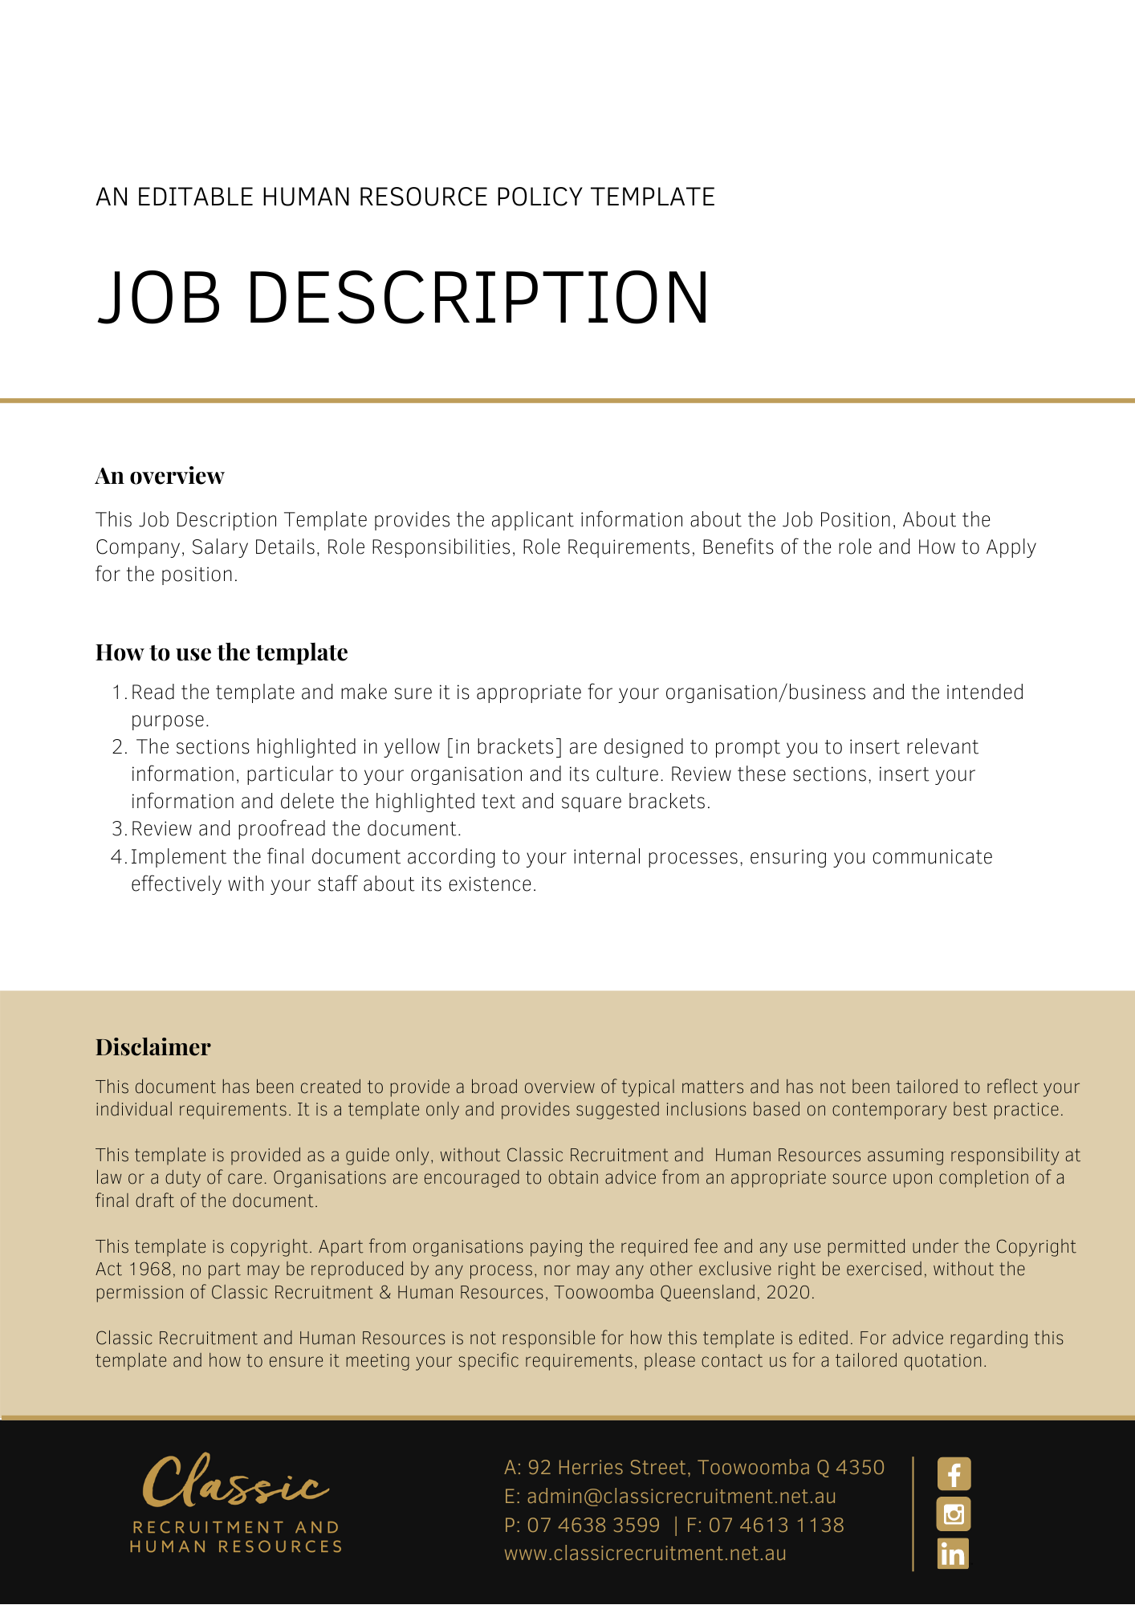

[Insert Company Logo]

[Insert Job Position]
[Delete After Reading: Make your job title big, bold, and specific. Do not use internal or creative titles that might be confusing or difficult to find when searching. The role should be easily identifiable to your target talent pool.]

About [Company Name] [Delete After Reading: 50-60 words]

[Delete After Reading: Write a couple of sentences introducing your company to the applicant. This should be a very top line overview of who you are and what you do. Your employer branding can come into play at this point, as you identify your values and mission.]

[Delete After Reading: E.g., Green Thumb Garden Centre is a one stop gardening shop. Our locations stock a range of plants, pots, and gardening tools - and each is complete with a tranquil cafe. We are on a mission to make gardening fun for everyone, and our goal is to be the #1 gardening retail group in Australia by 2022.]

About the Role [Delete After Reading: 50-60 words]

[Delete After Reading: Your role intro should capture in a snapshot what the role is about. Include an overview of responsibilities and the key goals of the position.]

[Delete After Reading: E.g., We are seeking a Digital Marketing Coordinator to support our marketing team across social media, search, and email marketing. Reporting to the Digital Marketing Manager, the Digital Marketing Coordinator will play a key role in making sure that our customers are up to date with our new products, sales, and news.]

Salary Details [Delete After Reading: 20-30 words]

[Delete After Reading: It is a good idea to include a salary range for your position. 3 out of 5 job applicants say compensation details are the most important part of a job listing . Include the salary range and super details, plus any commission or bonus scheme information.]

[Delete After Reading: E.g. The salary range for this position is $55,000 - $60,000 pa. + 9.5% superannuation.]

Responsibilities [Delete After Reading: 50-100 words]

[Delete After Reading: Now’s the time to get specific about the day-to-day activity of the role. Use dot points to save on your word count and make responsibilities clear.]

[Delete After Reading: E.g.
- Day-to-day management of social media channels (Facebook, Instagram, Twitter)
- Community management
- Building Google Adwords and search campaigns
- Assisting our Direct Marketing Manager in the creation of email campaigns
- Assisting our E-Commerce team in maintaining our website
- Assisting the marketing team with administrative tasks]

Requirements [Delete After Reading: 50-100 words]

[Delete After Reading: This part of the ad should capture any necessary certifications or experience. Use dot points to spell out the requirements. Do not be afraid to mark some requirements as optional or bonus to make your job ad appealing to more candidates with various experience.]

[Delete After Reading: E.g.
- Bachelor’s Degree in marketing or a related field
- Google Adwords Certification
- 1+ years’ experience in digital marketing
- Demonstrated knowledge of Facebook, Instagram, and Twitter
- Experience using Mailchimp (Bonus)
- Experience using Adobe Photoshop (Bonus)
- A love of plants and gardening (a must!)]

Benefits [Delete After Reading: 50-70 words]

[Delete After Reading: Apart from salary, benefits are an incredibly important appeal factor for your job ad! Talk about the work perks that make your workplace unique and a fantastic place to be.]

[Delete After Reading: E.g.
We love our Green Thumb team! Our team perks include;
- 30% staff discount at all Green Thumb outlets (inc. our cafes)
- Flexible working options
- Free fruit in the office (grown on our own trees!)
- Quarterly celebrations
- A bonus day off on your birthday]

How to Apply [Delete After Reading: 50 words]

[Delete After Reading: Of course, you will need to include the information about how to apply! Spell this out very clearly for your applicant, or risk receiving lots of inconsistent applications. State exactly what you would like your applicant to send with their application and provide the best contact address for questions.]

[Delete After Reading: E.g. To apply, please submit [or email] a CV and cover letter of no more than one page, explaining why you think you would be a great candidate for the role.

If you have any questions about the role, please contact Janine at - janine@greenthumb.com.au]

Company Wins [Delete After Reading: 50 words]

[Delete After Reading: At the end of the ad, you want to really hammer home what a fantastic business you are. A great way to do this is to list any accolades the company has clocked up over the years.]

[Delete After Reading: E.g. Awarded Silver in the Australian Garden Retail Awards 2020 ‘Best Garden Centre’
Voted ‘Best Gardening Business’ by Gardening Australia in 2018 + 2017
Included in Broadsheet Sydney’s ‘Top 5 Sydney Garden Centres’]

Document Control
This Job Description will be reviewed on a regular basis and approved by the [Insert Position (e.g. CEO/Director/Owner)].

Implementation date | Author | Approved by | Date of next review
[Date] | [Name] | [Position] | [Month, Year]

