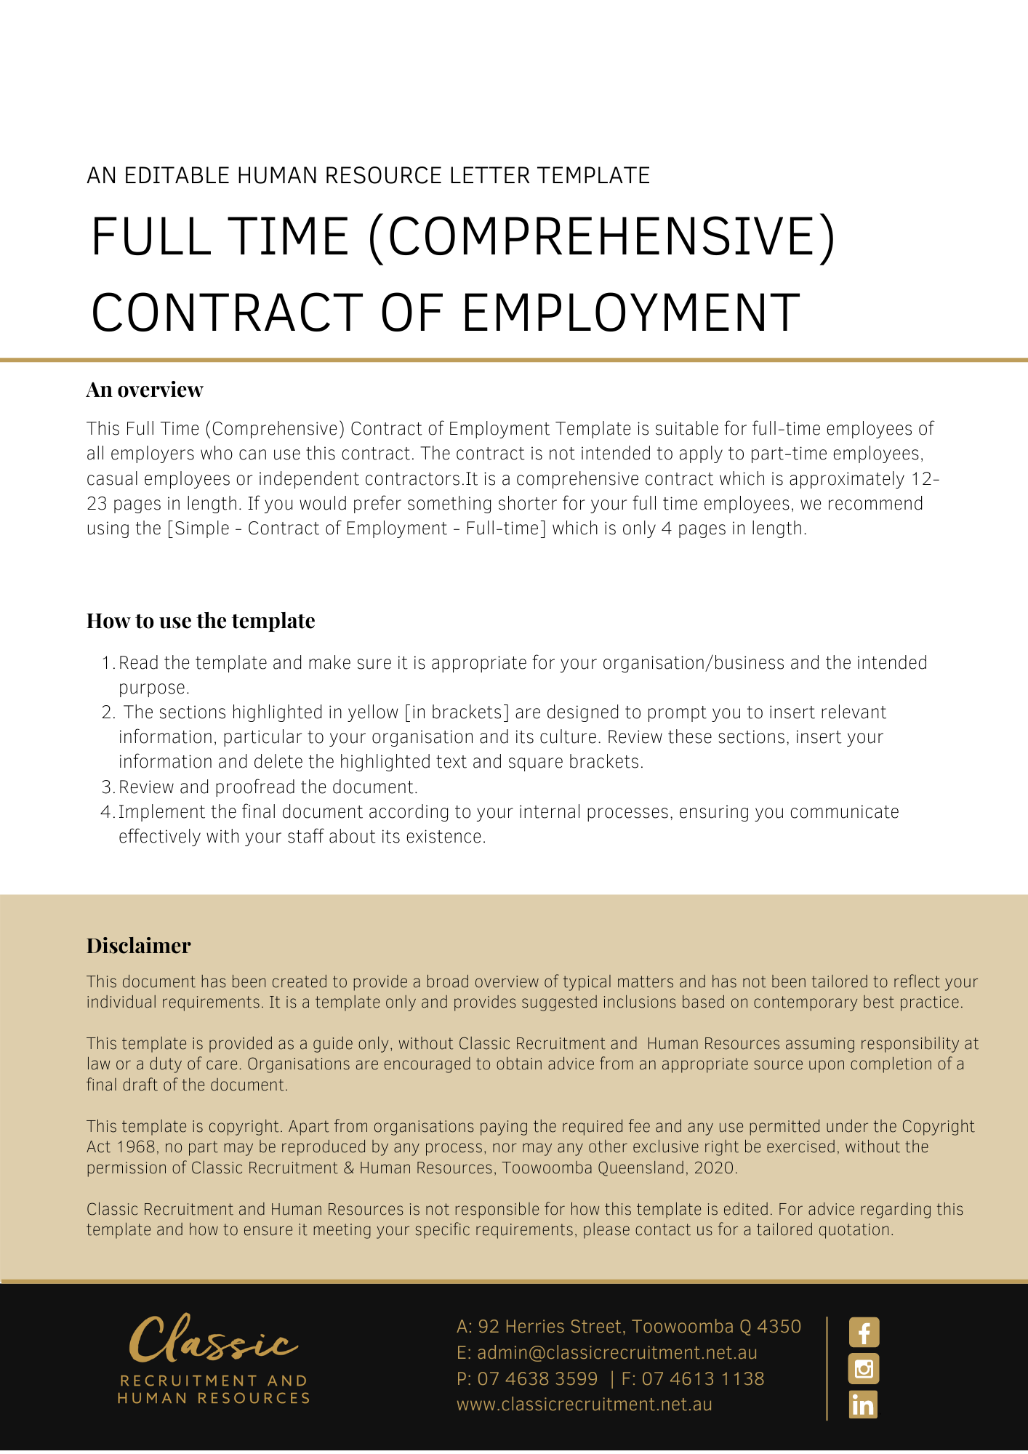
Contract of Employment Full Time (Comprehensive)

[Date]
PRIVATE & CONFIDENTIAL
[Employee First Name] [Employee Surname]
[Employee Address]
Dear [Employee First Name],

Position: [Employee Position Title]

On behalf of [Company Name] trading as [Insert Trading Name] (‘the Employer’), I am pleased to confirm the offer of employment on the terms and conditions in the Contract of Employment (‘the Contract’) set out below.
For your information, as of 1 January 2010, all employees who commence their employment with a National System Employer must receive a copy of the Fair Work Information Statement provided by Fair Work Australia the relevant regulatory body. The Fair Work Information Statement may be viewed via this link https://www.fairwork.gov.au/sites/default/files/migration/724/Fair-Work-Information-Statement.pdf.

Summary Table

The items in the following Summary Table are subject to any additional detail, requirement or obligation set out otherwise in this Contract, including in any attached schedules:
Item | Term | Details
 | Employer | [Company Name] trading as [Insert Trading Name]
 | Contract Commencement Date | [Date of Commencement]
 | Position | [Employee Position] [Award Title] [Role Classification] or Award Free
 | Location | [Work Location]
 | Employment Status | Full Time
 | Office Hours | [Start Hours] to [Finish Hours]
 | Weekly Ordinary Hours | 38
 | Reports to | [Insert Position (e.g. CEO/Director/Owner)]
 | Remuneration | $[Annual Salary] annual
 | Salary Payment Frequency | [Pay Regularity]
 | Probationary period | 6 months [Delete After Reading: alter as required]
 | Notice Period | As per the National Employment Standards (NES). If you are over 45 years of age and have completed at least two years of continuous service with [Company Name] then you will receive one additional week of notice.
 | Performance and Salary review | Annually [Delete After Reading: alter as required]
 | Driver Licence Requirement | [Insert Requirement]
 | Leave | As per the National Employment Standards https://www.fairwork.gov.au/tools-and-resources/fact-sheets/minimum-workplace-entitlements/introduction-to-the-national-employment-standards

Commencement

Your employment with the Employer commences on the date specified in Item 2 in the Summary Table.

The commencement of the employment is conditional upon you attending at the workplace and commencing the performance of work in accordance with this Contract.

Conditional Offer of Employment

This offer of employment is conditional on:
    - You demonstrating that you are eligible to work in Australia by:
      - providing the Employer with evidence of Australian citizenship;
      - providing the Employer with evidence of Australian permanent residency; or
      - obtaining a valid temporary visa permitting you to work in Australia and:
- providing the Employer with your travel document details (e.g. passport); and
- permitting the Employer to use these details to confirm your eligibility to work through the Department of Home Affairs’ Visa Entitlement Verification Online system.
Copies of these documents will be taken and held by the Employer. If your eligibility to work changes during the course of your employment you must inform the Employer. Should you be ineligible to work in Australia your employment will immediately cease from the date of such ineligibility.
    - There being no restriction upon your ability to commence employment immediately with the Employer under the terms of employment specified in this Contract. In this regard, by signing this Contract, you warrant:
      - that there are no limitations on your ability to fully and safely perform all of your duties and responsibilities for the Employer, including, but not limited to physical or psychological limitations; and
      - that you will not breach continuing obligations arising from any prior employment in the performance of your duties and responsibilities for the Employer, including but not limited to confidentiality obligations.

You warrant that you have provided accurate information to the Employer on your qualifications, professional accreditation, professional training, currency of all relevant licences, and experience required to perform the Position. You agree that the Employer may terminate your employment without notice, should it discover the information you provided is inaccurate.

By signing this Contract you agree that:
    - any breach of these warranties will constitute grounds for immediate termination of your employment or revocation of this Contract, as may be the case; and
    - retains the right to terminate your Contract immediately in the event that you are unable to commence employment with the Employer from the commencement date or continue such employment due to a limitation, restriction or restraint in any contract of employment with a previous employer, or other agreement, whether written or oral, formal or informal, that prevents you from commencing or continuing employment with the Employer under the terms of employment specified in this Contract.

Position

Your position is set out in Item 3 in the Summary Table.

You will be employed on the basis set out in Item 5 in the Summary Table

Your duties and responsibilities are set out in the Position Description in Schedule A, attached to this Contract.

Your duties and responsibilities are set out in the Position Description which has been provided to you.

You are required to carry out other duties reasonably required by the Employer that you are skilled and capable of performing.

You may also be required to perform duties from time to time for the Employer’s Related Entities.

The Employer may alter your position, Position Description and responsibilities in accordance with the needs of the business from time to time. You may also be redeployed to another position having regard to your skills, experience and competency as determined by the Employer. You agree that the terms of this Contract continue to apply to any altered position unless varied in writing in accordance with this Contract.

You must disclose to the Employer prior to the commencement of your employment if you have secondary employment.

You will not engage in secondary employment or work either as an employee, contractor, volunteer or agent (in some capacity) without the express written consent of the Employer subsequent to the commencement of your employment with the Company. The Employer will not unreasonably withhold consent.

The Employer may direct you to work shift work whenever it so requires to meet its operational needs.

Hours of Work

Your normal office hours are set out in Item 6 in the Summary Table to be worked Monday to Friday.

However, due to the nature of the Employer’s business and your position, you agree it is reasonable for you to work any additional hours necessary to achieve the efficient and effective performance of your duties. You will not receive any additional remuneration for any additional hours worked as these additional hours have been taken into account in setting your remuneration.

Performance

In your employment you will perform:
- the duties and responsibilities of the position; and
- any other duties which the Employer may reasonably require from you.

In the course of your employment with the Employer, you are required to:
- carry out all lawful and reasonable instructions and directions given to you in relation to your employment;
- perform your duties and responsibilities in a proper, ethical, diligent, professional and efficient manner; including always acting in good faith and in the best interests of the Employer;
- ensure that you are fit to safely perform the inherent requirements of your position and any duties you may be directed to carry out from time-to-time;
- use your best endeavours to protect, enhance and promote the interests, welfare, profitability, growth and reputation of the Employer’s business;
- not engage in any business or activities which may conflict with or be harmful to the business interests of the Employer, or any of its officers, employees, agents, contractors or consultants;
- perform your duties in a safe manner, respecting all work health and safety laws and policies (despite the fact these do not form part of your Contract);
- during work hours, devote the whole of your time and attention to the Employer’s business;
- perform your duties with due care and skill and in a proper, thorough and co-operative manner;
- perform your duties in accordance with any written direction, procedure, policies or other specifications provided by the Employer to you (relating to the performance of your work or anything connected with it);
- perform your duties in accordance with the Employer’s values;
- perform your duties without jeopardising or damaging the Employer's business;
- perform your duties in compliance with all relevant laws; and
- attend supervisory meetings or training meetings outside work hours as reasonably required by the Employer.

You must not:
- use information or resources provided by the Employer for your personal gain or for the benefit of any other person or business;
- do anything that is reasonably likely to harm the Employer or the Employer’s reputation; or
- enter into contracts or agreements on the Employer’s behalf without the Employer’s express permission to do so.

Reporting

Your reporting arrangements are set out in Item 8 in the Summary Table.

However, the Employer may change your reporting arrangements in accordance with the needs of the business.

Location

Your place of work is set out in Item 4 in the Summary Table.

However, you may be asked to travel to and work at different locations to meet business needs from time to time, such as travel interstate or overseas for temporary periods. You agree to work at any of the different locations where the Employer requires you to do so.

You may also be required to relocate to another place of work from time to time without compensation or additional payment in accordance with the needs of the Employer’s business.

Probationary Period

You will initially be employed on a probationary period which is set out in Item 11 in the Summary Table. Your work performance and conduct will be monitored during the period. Prior to the completion of your probationary period, the Employer will decide on your suitability to continue employment.

The ‘minimum employment period’ (as defined in the Fair Work Act 2009 (Cth)) is unaffected by this clause.

Remuneration

Your remuneration is set out in in Item 9 in the Summary Table.

If the Employer pays Fringe Benefits Tax on your behalf, this payment also forms part of your remuneration package.

Your salary (less applicable taxation) will be paid in accordance with Item 10 in the Summary Table into the bank account of your choice.

Your salary and other employment conditions are confidential and must not be discussed with other employees of the Employer or other persons outside the Employer (with the exception of your legal and financial advisers).

Compensation for all Legal Entitlements

Except as specifically provided for under this Contract, the salary and any other benefits are in satisfaction of any legal entitlement arising under an award, NAPSA, collective/enterprise agreement, the National Employment Standards or any other law or legal instrument (collectively ‘the Instruments’), such as, but not limited to, any periodic rate of pay, overtime payments, weekend and holiday penalties, shift allowance, vehicle allowance, travelling expense, penalty payments and annual leave loading.

You expressly agree that any remuneration you receive that is greater than the entitlement you would receive under the Instruments satisfies any other legal entitlements where you receive under the minimum amount under the instruments.

The remuneration paid to you in excess of your entitlements or benefits under an applicable award or industrial instrument in any week or month, may be offset against any underpayment of award or industrial instrument entitlements in any other week or month.

Superannuation

The Employer will, where required, make compulsory superannuation guarantee contributions on your behalf in accordance with the relevant legislation and/or industrial instrument in force from time to time.

As part of your Salary Package, you may elect to sacrifice part of your salary as voluntary superannuation contributions into the superannuation fund of your choice. If you want to salary sacrifice to superannuation you must provide the Employer with a written election stating the amount of salary that you elect to salary sacrifice to superannuation.

Performance and Salary Reviews

Reviews are based on your position within the Employer, your performance and contribution to the effective functioning of the Employer’s business, the Employer’s financial performance and the market generally. Remuneration increases are not automatic, and any increase is within the Employer’s absolute discretion.

Skills and Qualifications

It is a requirement of your position that you maintain the skills and qualifications necessary to perform your duties.

Employment Policies and Procedures

You are directed to read and comply with the obligations described within the Employer’s policies and procedures as they relate to your employment. These policies and procedures may be varied from time to time at the Employer’s discretion, and you are directed to comply with such variations. Such policies and procedures do not form part of your Employment Contract.

A breach of your obligations under the Employer’s policies and procedures may result in disciplinary action, up to and including the immediate termination of your employment.

Annual Leave

You are entitled to annual leave in accordance with the provisions of relevant legislation as per Item 15 in the Summary Table.

Annual leave may be taken at such time as may be agreed between you and the Employer and in accordance with the relevant legislation.

Personal/Carer’s Leave

You are entitled to personal/carer’s leave in accordance with the terms of relevant legislation.

Other Leave

You are also entitled to compassionate leave, long service leave and parental leave in accordance with relevant legislation.

Resignation and Termination

During the probationary period, either party may terminate your employment with one week’s notice in writing, except in cases of summary dismissal. The Employer may elect to pay you in lieu of part or all of your notice period or provide you with altered duties during the notice period.

Except where your employment is terminated for reasons of serious misconduct, either the Employer or you may terminate your employment by giving the period of notice set out in Item 12 in the Summary Table.

The Employer may elect to pay you in lieu of part or all of your notice period.

Alternatively, the Employer may require you not to report for work, or provide you with altered duties, during part or all of your notice period.

The Employer may terminate your employment at any time without notice or payment in lieu of notice in the case of serious misconduct. Serious misconduct will include, but is not limited to:
- ongoing breach of your obligations as set out in this Contract without rectifying such breach within 7 days of receiving notice of the breach;
- breach of the warranties provided under the Condition of Employment clause of this Contract;
- performing your work in a manner reasonably considered by the Employer to be unprofessional;
- gross negligence;
- disobeying or refusing to follow a lawful and reasonable direction of the Employer or the Employer’s Related Entities;
- engaging in conduct which the Employer reasonably considers is likely to damage the Employer’s reputation; or
- committing any act of dishonesty including acts of embezzlement, theft or fraud involving the Employer’s assets or property; or
- being found guilty of a criminal offence which, in the reasonable opinion of the Employer, prevents or impedes the further performance of your duties or is otherwise incompatible with your position as an employee of the Employer; or
- any conduct that would justify summary dismissal at common law.

On termination of your employment by any means, the Employer will pay to you:
    - your salary — payable to you up to and including the date of termination;
    - payment in lieu of any accrued untaken annual leave to which you are entitled up to and including the date of the termination; and
    - any other benefits due to you under this Contract or relevant legislation.

If your employment is terminated summarily without notice or payment in lieu of notice, you will only be paid up to the date of termination.

If your employment is terminated for any reason, you agree to resign all directorships, offices and positions that you may hold in relation to the Employer, its Related Entities or any other entity in which you hold office in connection with your employment. You agree to do all things and execute all documents necessary to give effect to these resignations.

The Employer may direct you to not attend work and not to undertake any of your work duties at any time (e.g. a period of suspension), provided that the Employer provides you with payment of your entitlements under your remuneration package during the period you are not required to work or whilst otherwise suspended.

Redundancy

You are entitled to redundancy pay in accordance with the provisions of relevant legislation.

Termination by Agreement

Your employment and this Contract may at any time be terminated in writing by the mutual agreement of the parties or upon whatever notice or terms they may agree.

Deduction of Monies Owed to the Company

You agree that, on termination of employment, the Employer is authorised to deduct any monies owing to it by you (including, but not necessarily limited to, leave entitlements) and you acknowledge that the deduction is for the primary benefit of you.

Return of Property

On request by the Employer or on resignation or termination of your employment for any reason, you must:
- return to the Employer all property belonging to the Employer in your possession, custody or control, including but not limited to Confidential Information, Intellectual Property, records pertaining to Clients or Suppliers, mobile telephones, computers, keys, data storage devices, cards, documents, diaries, records and papers, reports, working papers, training manuals, equipment, computer information and programs and all copies of such items.
- cause to be deleted all records in your possession, custody or control, including but not limited to Confidential Information, Intellectual Property, and information pertaining to Clients or Suppliers, including digital records and information contained on professional or social media platforms such as LinkedIn, Facebook, Twitter, etc.

You may be required to declare that you have complied with the conditions above.

Confidential Information

You must maintain the confidentiality of information and documents to which you have access in the course of or arising from your employment with the Employer or any of its Related Entities. This extends to an obligation to treat the Employer’s owner/s personal information with discretion and in confidence.

You must not, during your employment or after the termination of your employment, directly or indirectly use or disclose (or attempt to use or disclose) any Confidential Information for any purpose, including to obtain any benefit for you or any other Person.

You must ensure secure custody of Confidential Information in your control or possession and use your best endeavours to prevent the use or disclosure of Confidential Information by any Person.

These restrictions do not apply to:
- information that is used or disclosed in the proper course of performing your duties for the Employer;
- information that is used or disclosed with the Employer’s prior consent
- information that is required by law to be disclosed; or
- information that is in the public domain, other than through your breach of this Contract.

Any Confidential Information which is disclosed by you in accordance with the Confidential Information clause a), must only be done to the extent necessary, and only to Persons who:
- have been approved by the Manager, to receive such information;
- are aware and agree that the Confidential Information must be kept confidential; and
- sign and agree to be bound by the terms of any confidentiality agreement, as may be required by the Employer to be signed, from time to time.

If you are uncertain about whether information is Confidential Information, you must immediately ask your Insert Supervisor/Manager Title. Until you receive an answer, you must treat that information as Confidential Information.

You acknowledge and agree that:
- damages may be inadequate compensation for breach of your obligations contained in this ‘Confidential Information’ clause and subject to the court’s discretion, the Employer may seek specific performance or may seek to restrain, by an injunction or similar remedy, any conduct or threatened conduct which is or will be in breach of this clause, in addition to any other remedy the Employer may wish to pursue; and
- you will fully indemnify the Employer in respect of any and all loss, damage, claims, liability, cost and expenses, of any kind, suffered or incurred by the Employer as a result of your breach of this ‘Confidential Information’ clause, in any way, including, but not limited to, any disclosure by you of any Confidential Information to any Person(s), other than is authorised under this Contract.

The obligations set out in this Confidential Information clause are:
- in addition to any legal obligations imposed on you at common law or in statute in relation to confidential information; and
- survive the termination of your employment with the Company.

Definitions and General Provisions

In this Contract:

‘Moral Rights’ has the meaning given to it in the Copyright Amendment (Moral Rights) Act 2000 (Cth) and includes rights of integrity of authorship, rights of attribution of authorship and similar rights that exist or may come to exist anywhere in the world.

‘Person’ includes any natural person, Company, partnership, association, trust, business, or other organisation or entity of any description and a Person’s legal personal representative(s), successors, assigns or substitutes.

‘Products’ means any products produced, manufactured, sold or distributed (and prospective products to be produced, manufactured, sold or distributed) by the Employer.

Entire Agreement

This Contract sets out all of the terms of your employment contract with the Employer. This Contract supersedes and replaces all prior representations, contracts and agreements (whether oral or in writing) concerning your employment with the Employer.

If there are any other matters that you have relied on in our discussions or other communications to date or there are any other matters you wish to discuss, please let the Employer know before you sign the Contract. The Employer’s representative may then consider them and discuss them with you. If agreed, the terms set out in this Contract will be amended, to ensure that it contains all the agreed terms.

Once you sign this Contract, you are confirming it is complete and no agreed terms are missing.

Employer’s Discretion

Where any provision of this contract entitles or engages discretion for the purposes of the Employer exercising its discretion the Employer may act arbitrarily, with any payment being entirely gratuitous and voluntary.

Please sign the attached copy of this Contract to acknowledge that you accept the Employer’s offer of employment on the terms and conditions set out in this Contract.

Yours sincerely,
[Salutations for goodbye],
[Company Name]
[Letter Signatory Name]
[Letter Signatory Position]

Acceptance
I, [Employee Name], have read and understood this Contract and I accept the offer of employment with [Company Name] on the terms contained in it.

Signed: …………………………………………………
Date: ………………………….

Schedule A: Position Description

Position Title: [Employee Position Title]
Award: [Award Title] or Award Free
Classification: [Role Classification]
Reports to: [Insert Position (e.g. CEO/Director/Owner)]

Position Summary:
- [Position Summary]

Key responsibilities:
- [Key Responsibilities]

Competencies and Experience required:
- [Competencies And Experience Required]

Qualifications Required:
- [Qualifications Required]

