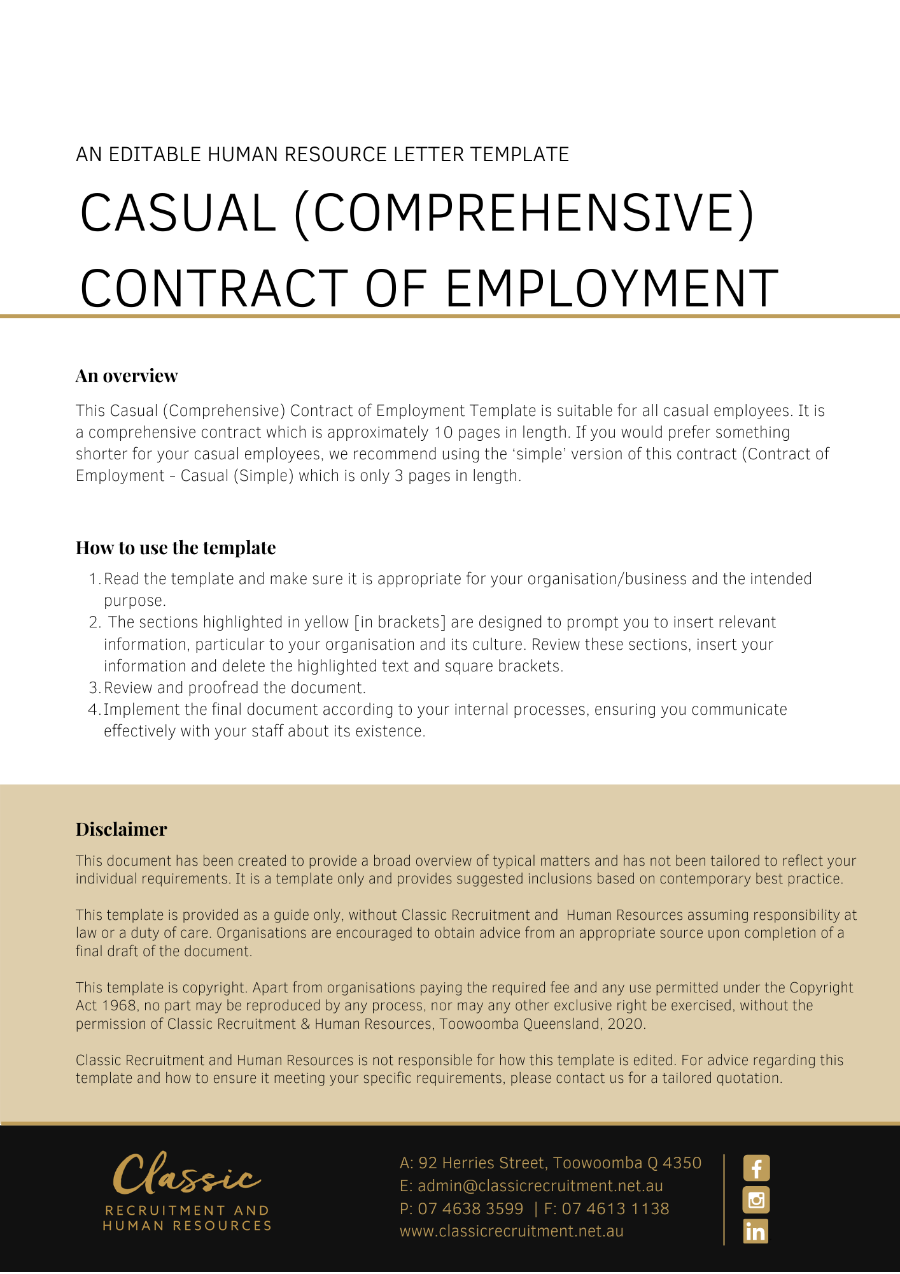
Contract of Employment Casual (Comprehensive)

[Date]
[Employee First Name] [Employee Surname]
[Employee Address]
Dear [Employee First Name],

Employment Contract

On behalf of [Company Name], I am pleased to offer you casual engagements with on the terms and conditions in the Contract of Employment (‘the Contract’) set out below.
This Contract will govern each casual engagement with [Company Name].
As a casual employee, you are employed by the hour and there is no advance commitment to continuing and indefinite work with the Company. This means your engagement terminates at the end of each work period and begins again at the beginning of the next work period. For each engagement, this Contract sets out the terms and conditions of your employment.

Summary Table

The items in the following summary table are subject to any additional detail, requirement or obligation set out otherwise in this agreement, including in the attached schedules:
Item | Term | Details
 | Employer | [Company Name]
 | Date of Commencement | [Date of Commencement]
 | Position | [Employee Position]
 | Location | [Work Location]
 | Reports to | [Enter Manager Name & Insert Position (e.g. CEO/Director/Owner)]
 | Hourly Wage  Casual Loading Percentage  Total Hourly Rate | $[Insert $00.00] per hour (excluding casual loading)  25%  $[Insert $00.00] per hour
 | Wages Instalments | [Pay Regularity ie. weekly]
 | Duties, tasks or responsibilities | [Enter details of role here or include a Position Description as Schedule A]

Commencement

Your casual engagement/s with [Company Name] commence on the date specified in Item 2 at the Summary Table clause. The commencement of the employment is conditional upon you attending at the workplace and commencing the performance of work in accordance with this Contract.

Conditional offer of employment

This offer of employment is conditional on:
    - you demonstrating as required by [Company Name], that you are eligible to work in Australia by the production of one of the following documents:
      - evidence of Australian citizenship;
      - evidence of Australian permanent residency; or
      - a valid temporary visa permitting you to work in Australia.
Copies of these documents will be taken and held by [Company Name]. If your eligibility to work changes during the course of your employment you must inform [Company Name]. Should you be ineligible to work in Australia your employment will immediately cease from the date of such ineligibility.
    - there being no restriction upon your ability to commence employment immediately with under the terms of employment specified in this Contract. In this regard, by signing this Contract, you warrant:
      - that there are no limitations on your ability to fully perform all of your duties and responsibilities for [Company Name], including, but not limited to physical or psychological limitations; and
      - that you will not breach continuing obligations arising from any prior employment in the performance of your duties and responsibilities for [Company Name], including confidentiality obligations.
    - you warrant that you have provided accurate information to [Company Name] on your qualifications, professional accreditation, professional training and currency of all relevant licences, required to perform the Position. You agree that may terminate your employment immediately, should it discover the information you provided is inaccurate.

By signing this Contract you agree that:
    - any breach of these warranties will constitute grounds for immediate termination of your employment or revocation of this Contract, as may be the case; and
    - retains the right to terminate your Contract immediately in the event that you are unable to commence employment with [Company Name] from the commencement date or continue such employment due to a limitation, restriction or restraint in any contract of employment with a previous employer, or other agreement, whether written or oral, formal or informal, that prevents you from commencing or continuing employment with [Company Name] under the terms of employment specified in this Contract.

Modern Award

In addition to this Contract, your employment will be regulated by the [Insert Award] (‘Award’), however, the Award is not incorporated into, and does not form part of, this Contract.

Position

Your position at the commencement of your employment is set out in Item 3 at the Summary Table clause. You will be employed on a casual basis.

Your duties and responsibilities are set out in either Item 8 at the Summary Table or in the Position Description in Schedule A, attached to this Contract. This position description does not form part of your Contract.

You are required to carry out other duties reasonably required by [Company Name] that you are skilled and capable of performing.

You may also be required to perform duties from time to time for ’s Related Entities.

[Company Name] may alter your position, Position Description and responsibilities in accordance with the needs of the business from time to time. You may also be redeployed to another position having regard to your skills, experience and competency. You agree that the terms of this Contract continue to apply to any altered position unless varied in writing in accordance with this Contract.

[Company Name] may direct you to work shift work whenever it so requires to meet its operational needs.

Hours

As a casual employee you have no guaranteed or fixed hours of work. [Company Name] may offer you work as required according to its operational requirements.

Any offer of work will be made to you as soon as reasonably practicable and usually by the preceding day. [Company Name] does not make or give any advanced commitment as to continuing and indefinite work, nor to any agreed pattern of work.

As a casual employee, you will be engaged on an hourly basis and can be requested to perform work any day, [Insert Details], between the hours of [Insert Details]. Where you are offered a period of work, the minimum number of hours you will be offered is [Insert Details].

The Business is under no obligation to offer work to you. The business may elect to offer work and you have the ability to accept or reject hours offered.

Performance

In the course of your employment with [Company Name], you are required to:
- carry out all lawful and reasonable instructions and directions given to you in relation to your employment;
- perform your duties and responsibilities in a proper, ethical, diligent, professional and efficient manner; including always acting in good faith and in the best interests of [Company Name];
- use your best endeavours to protect, enhance and promote the interests, welfare, profitability, growth and reputation of [Company Name]’s business;
- not engage in any business or activities which may conflict with or be harmful to the business interests of [Company Name], or any of its officers, employees, agents, contractors or consultants;
- perform your duties in a safe manner, respecting all work health and safety laws and policies (despite the fact these do not form part of your Contract);
- during work hours, devote the whole of your time and attention to [Company Name]’s business;
- perform your duties with due care and skill and in a proper, thorough and co-operative manner;
- perform your duties in accordance with any written direction, procedure or other specifications provided by [Company Name] to you (relating to the performance of your work or anything connected with it);
- perform your duties in accordance with [Company Name]’s values;
- perform your duties without jeopardising or damaging [Company Name]’s business;
- perform your duties in compliance with all relevant laws; and
- attend workplace training and meetings.

You must not:
- use information or resources provided by [Company Name] for your personal gain or for the benefit of any other person or business;
- do anything that is reasonably likely to harm [Company Name] or [Company Name]’s reputation; or
- enter into contracts or agreements on [Company Name]’s behalf without [Company Name]’s express permission to do so.

Reporting

Your reporting arrangements are set out in Item 5 at the Summary Table clause. However, [Company Name] may change your reporting arrangements in accordance with the needs of the business.

Location

Your place of work is set out in Item 4 at the Summary Table clause.

However, you may be asked to travel to and work at different locations to meet business needs from time to time. You agree to work at any of the different locations where [Company Name] requires you to do so.

You may also be required to relocate to another place of work from time to time without compensation or additional payment in accordance with the needs of [Company Name]’s business.

Wages

Your total hourly rate is set out in Item 6 at the Summary Table clause.

This amount also includes the Casual loading set at the Casual Loading Percentage set out in Item 6 at the Summary Table clause.

Your receipt of the Casual Loading Percentage is conditional on, and based on our understanding that, you are a casual employee at law. The Casual Loading Percentage is only payable for as long as you are a casual employee at law.

The Casual Loading Percentage is paid to you in compensation for: paid annual leave, paid personal/carer’s leave, paid compassionate leave, notice in lieu of termination, redundancy benefits and other entitlements to which casual employees are not entitled under the Fair Work Act 2009 (Cth).
Other Payment matters

You will be paid by electronic funds transfer into your nominated bank account. The frequency of your wage instalments in outlined in Item 7 at at the Summary Table clause.

Your wages and other employment conditions are confidential and must not be discussed with other employees of [Company Name] or other persons outside [Company Name] (with the exception of your legal and financial advisers).

Compensation for all Legal Entitlements

Where, at any time a law and/or industrial instrument (including a modern award or enterprise agreement) applies to your employment, your wages and any other benefits provided to you in this contract are in satisfaction of any entitlements or benefits you may have or that may arise pursuant to the award or industrial instrument as well as entitlements arising under the National Employment Standards or other laws. This includes but is not limited to entitlements to overtime payments, weekend and holiday penalties, allowances, travelling expenses, penalty payments and any other entitlement or benefit.

You expressly agree that any remuneration you receive that is greater than the entitlement you would receive under a law or industrial instrument satisfies any other legal entitlements where you receive less than the minimum amount under the Instruments.
The remuneration paid to you in excess of your entitlements or benefits under an applicable award or industrial instrument in any month, may be offset against any underpayment of award or industrial instrument entitlements in any other week or month.

Superannuation

[Company Name] will, when required, make superannuation contributions on your behalf in accordance with the relevant legislation and/or industrial instrument in force from time to time. These contributions will be deposited into a complying fund nominated by yourself or, if you do not nominate a fund, into [Company Name]’s default fund.

Drugs & Alcohol
Your ability to safely perform your duties at [Company Name] could be affected by your consumption of alcohol and/or other drugs.
The effects of alcohol and/or other drugs are different from person to person. The taking of alcohol or other drugs before commencing work, including the night and/or day prior to commencing work increases the chances that you could be affected by alcohol or any other drug you have consumed or have otherwise taken.
You must not attend work, commence work, continue to work or return to work having consumed alcohol and/or drugs unless those drugs are properly prescribed by a medical practitioner with respect to a medical condition.
You must not possess, distribute, sell, use or consume illegal drugs in the workplace.
You must inform [Company Name] if you are taking any prescribed medicines which may affect or impair your ability to work safely. In particular, you will inform [Company Name] of any potential impairment to your ability to safely operate machinery or other such equipment.
[Enter Company Name] may require you to undergo testing for the presence of drugs and/or alcohol, with or without prior notice. You must submit to such testing and understand that it may be random, incident related or planned testing at any time as directed by [Company Name].
You will take whatever action is necessary or required of you to ensure that the medical practitioner or testing facility’s report can be provided to [Company Name]. In that respect, you will sign any authority that the medical practitioner or testing facility may require before releasing the information to [Company Name].
Failure to comply with this clause of the Contract, including failing to agree to submit to any drug or alcohol testing, may result in disciplinary action being taken, up to and including the termination of your employment.

Employment Policies and Procedures

You are directed to read and comply with the obligations imposed upon you within [Company Name]’s policies and procedures as they relate to your employment. These policies and procedures may be varied from time to time at [Company Name]’s discretion, and you are directed to comply with such variations. Such policies and procedures do not form part of your Contract.

A breach of your obligations under [Company Name]’s policies and procedures may result in disciplinary action, up to and including the immediate termination of your employment.

Leave

As a casual employee, you are not entitled to paid annual leave or personal/carer’s leave.

You are entitled to unpaid leave in accordance with relevant legislation.

You may be entitled to long service leave in accordance with relevant legislation.

Termination

[Company Name] may terminate your employment on one hour’s notice at any time.

Return of Property
On request by [Enter Company Name] or on termination of your employment, you must:
- return to [Enter Company Name] all property belonging to [Enter Company Name] in your possession, custody or control, including but not limited to Confidential Information, Intellectual Property, mobile telephones, computers, keys, data storage devices, cards, documents, diaries, records and papers, reports, working papers, training manuals, equipment, computer information and programs and all copies of such items;
- any [Enter Company Name] property, which is also a storage medium, e.g. USB, laptop, mobile phone etc must be returned with all [Company Name] information on it intact and unaltered; and
- cause to be deleted all records pertaining to Clients, including digital records and information contained on professional or social media platforms such as LinkedIn, Facebook, Twitter, etc.
You may be required to declare that you have complied with the conditions above.

Confidential Information

You must maintain the confidentiality of information and documents to which you have access in the course of or arising from your employment with [Company Name] or any of its Related Entities.

You must not, during your employment or after the termination of your employment, directly or indirectly use or disclose (or attempt to use or disclose) any Confidential Information for any purpose, including to obtain any benefit for you or any other Person.

You must ensure secure custody of Confidential Information in your control or possession and use your best endeavours to prevent the use or disclosure of Confidential Information by any Person.

These restrictions do not apply to:
    - information that is used or disclosed in the proper course of performing your duties for;
    - information that is used or disclosed with [Company Name]’s prior consent;
    - information that is required by law to be disclosed; or
    - information that is in the public domain, other than through your breach of this Contract.

Any Confidential Information which is disclosed by you in accordance with clause [Insert Clause], must only be done to the extent necessary, and only to Persons who:
    - have been approved by the Manager, to receive such information;
    - are aware and agree that the Confidential Information must be kept confidential; and
    - sign and agree to be bound by the terms of any confidentiality agreement, as may be required by to be signed, from time to time.

If you are uncertain about whether information is Confidential Information, you must immediately ask your Manager. Until you receive an answer, you must treat that information as Confidential Information.

You acknowledge and agree that:
    - damages may be inadequate compensation for breach of your obligations contained in this ‘Confidential Information’ clause and subject to the court’s discretion, may seek specific performance or may seek to restrain, by an injunction or similar remedy, any conduct or threatened conduct which is or will be in breach of this clause, in addition to any other remedy [Company Name] may wish to pursue; and
    - you will fully indemnify [Company Name] in respect of any and all loss, damage, claims, liability, cost and expenses, of any kind, suffered or incurred by [Company Name] as a result of your breach of this ‘Confidential Information’ clause, in any way, including, but not limited to, any disclosure by you of any Confidential Information to any Person(s), other than is authorised under this Contract.

Definitions and General Provisions

In this Contract:

‘Client of’ [Company Name] includes any Person who, at the Termination Date:
    - is or was a Person to whom [Company Name] provides and/or provided products or services at any time during the 12 months prior to the Termination Date; or
    - has entered into discussions or negotiations with [Company Name] at either the Person’s own initiative or at the initiative of [Company Name] at any time during the 12 months prior to the Termination Date with a view to receiving products or services provided by [Company Name] and who had not notified [Company Name] at least 3 months prior to the Termination Date that they did not wish to receive such products or services (other than any act you have performed, indirectly or directly, in breach of the terms of this Contract, to induce a Person to not receive such products or services).

‘Confidential Information’ means all information obtained in the course of your employment with , that is by its nature confidential and includes (but is not limited to) the following, [Company Name]’s and its Related Entities’: trade secrets; Intellectual Property; confidential know-how; policies, systems and protocols; information about the business and its affairs such as pricing and fee information, marketing or strategic plans, commercial and business plans, financial information and data, and operational information and methods; methodologies and supporting documentation; software products, manuals and associated tools; commercial information in relation to current and prospective operations; information about suppliers, dealers, clients or customers such as their specific requirements, arrangements and past dealings; client lists, customer lists, supplier lists, dealer lists; customer, client and supplier lists; business cards and diaries, calendars or schedulers; reports; working papers; training manuals; equipment; computer information and programs; personal and financial information of which you become aware.

‘Intellectual Property’ means all forms of intellectual property rights throughout the world including copyright, registered patent, design, trademark and Confidential Information, including know-how and trade secrets.

‘Moral Rights’ has the meaning given to it in the Copyright Amendment (Moral Rights) Act 2000 (Cth) and includes rights of integrity of authorship, rights of attribution of authorship and similar rights that exist or may come to exist anywhere in the world.

‘Person’ includes any natural person, company, partnership, association, trust, business, or other organisation or entity of any description and a Person’s legal personal representative(s), successors, assigns or substitutes.

‘Products’ means any products produced, manufactured, sold or distributed (and prospective products to be produced, manufactured, sold or distributed) by [Company Name].

‘Related Entities’ means any entity connected with [Company Name] by an interest in a common economic enterprise, including a Related Body Corporate (as that term is used in the Corporations Act 2001 (Cth)).

‘Services’ means any services offered or provided by [Company Name].

‘Supplier’ means any Person:
    - who supplied any products or services to and with whom you or a Person reporting to you had contact or dealings with; or
    - who has entered into discussions or negotiations with you or a Person reporting to you on behalf of , at either your own initiative, or at the initiative of a Person reporting to you, or at the initiative of , at any time during the twelve (12) months prior to the Termination Date, with a view to supplying products or services to [Company Name] and who had not notified prior to the Termination Date that they did not wish to supply such products or services.

‘Termination Date’ means your last day of employment with [Company Name] however occurring.

‘Work(s)’ means all inventions, designs, drawings, plans, software, hardware, reports, documents, systems, improvements and other materials, and includes all literary, dramatic, musical and artistic works and cinematographic films in which copyright subsists.

General Matters

This Contract sets out all of the terms that will apply to your engagements with [Company Name]. This Contract supersedes and replaces all prior representations, contracts and agreements (whether oral or in writing) concerning your engagements with [Company Name].

Any amendment or addition to this Contract must be in writing, and signed by both parties.

Each provision of this Contract is severable from the others and the severance of a provision does not affect the remainder of the Contract.

This contract is governed by the laws of Queensland, Australia.

Where any provision of this contract entitles or engages discretion for the purposes of [Company Name] exercising its discretion [Company Name] may act arbitrarily, with any payment being entirely gratuitous and voluntary.
Please sign the attached copy of this Contract to acknowledge that you accept [Company Name]’s offer of casual engagements on the terms and conditions set out in this Contract.

Yours sincerely,
[Salutations for goodbye],
[Company Name]
[Letter Signatory Name]
[Letter Signatory Position]

Acceptance
I [Enter First Name] [Enter Last Name] have read and understood this Contract and I accept that all casual engagements I perform will be subject to these terms.

Signed: …………………………………………………
Date: ………………………….
Schedule A: Position Description

Position Title: [Employee Position Title]
Grade: [Employee Grade]
Reports to: [Insert Position (e.g. CEO/Director/Owner)]

Position Summary:
- [Position Summary]

Key responsibilities:
- [Key Responsibilities]

Competencies and Experience required:
- [Competencies And Experience Required]

Qualifications Required:
- [Qualifications Required]

