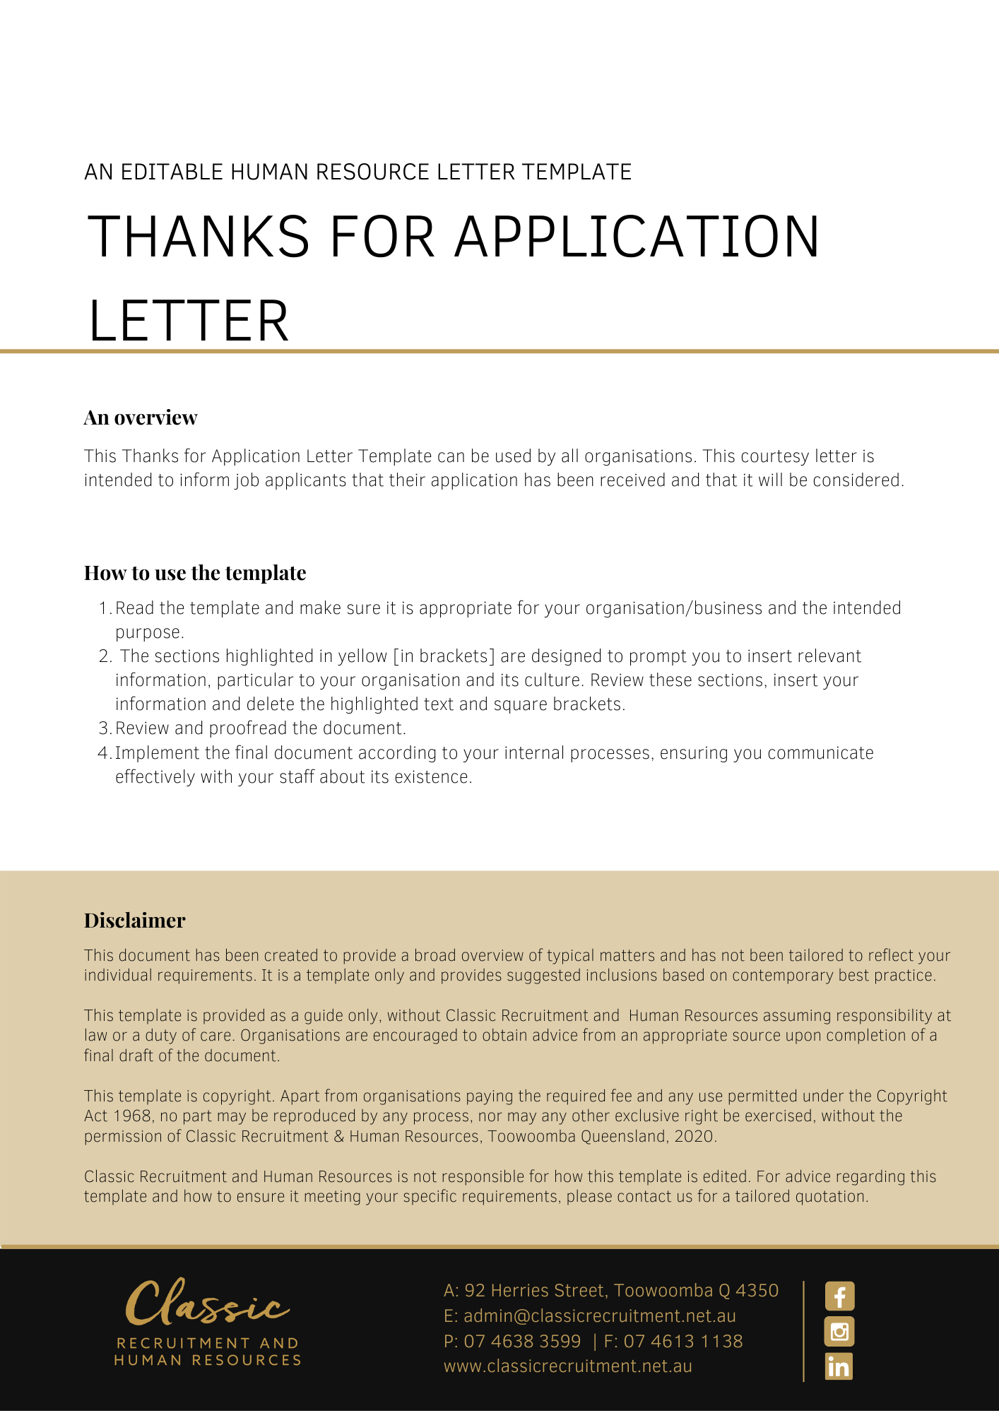
[Date]
[Candidate First Name] [Candidate Surname]
[Candidate Address]

Thank You for Your Application

Dear [Candidate First Name],

Thank you for your application for the advertised position of [Position] with [Company Name].

We are currently assessing your application and will contact you to inform you whether we wish to proceed to interview you for this position.

We appreciate the time you have taken to submit your application and thank you for your interest in joining our organisation.

[Salutations for goodbye],
[Company Name]
[Letter Signatory Name]
[Letter Signatory Position]

