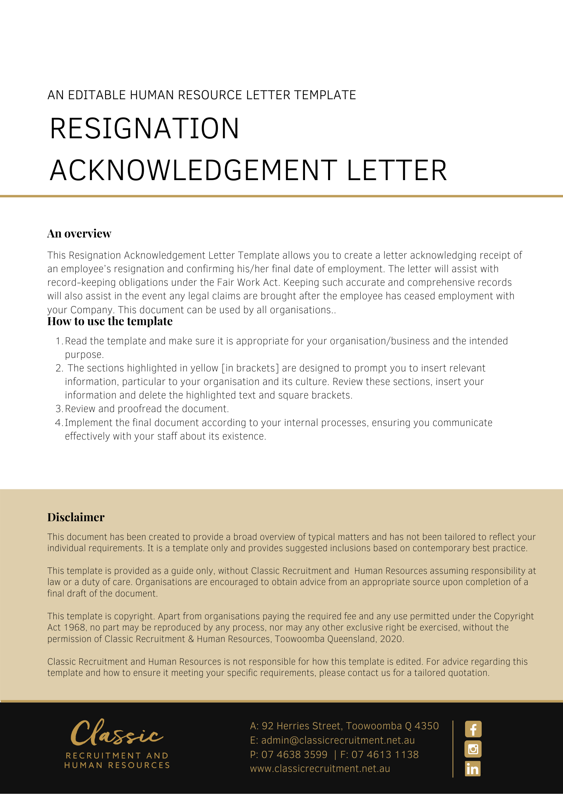
[Date]
[Employee First Name] [Employee Surname]
[Employee Address]

Your Resignation
Dear [Employee First Name],

We refer to your resignation from your employment with [Company Name] given on [Resignation Given Date]. The purpose of this letter is to confirm receipt of your resignation and confirm that your last day of employment will be [Final Date].
We advise that payment of your outstanding wages and accrued entitlements will be paid into your usual bank account.
You are also reminded that following your last day of employment with [Company Name] that you remain subject to the restraints contained at clause [Clause Number] of your Contract of Employment and the requirement to keep confidential information of [Company Name] confidential.
We thank you for your service with [Company Name] and ask you to ensure that you return all [Company Name] property in your possession or control to the office by close of business on [Company Name].
We wish you all the best in your future.

[Salutations for goodbye],
[Company Name]
[Letter Signatory Name]
[Letter Signatory Position]

