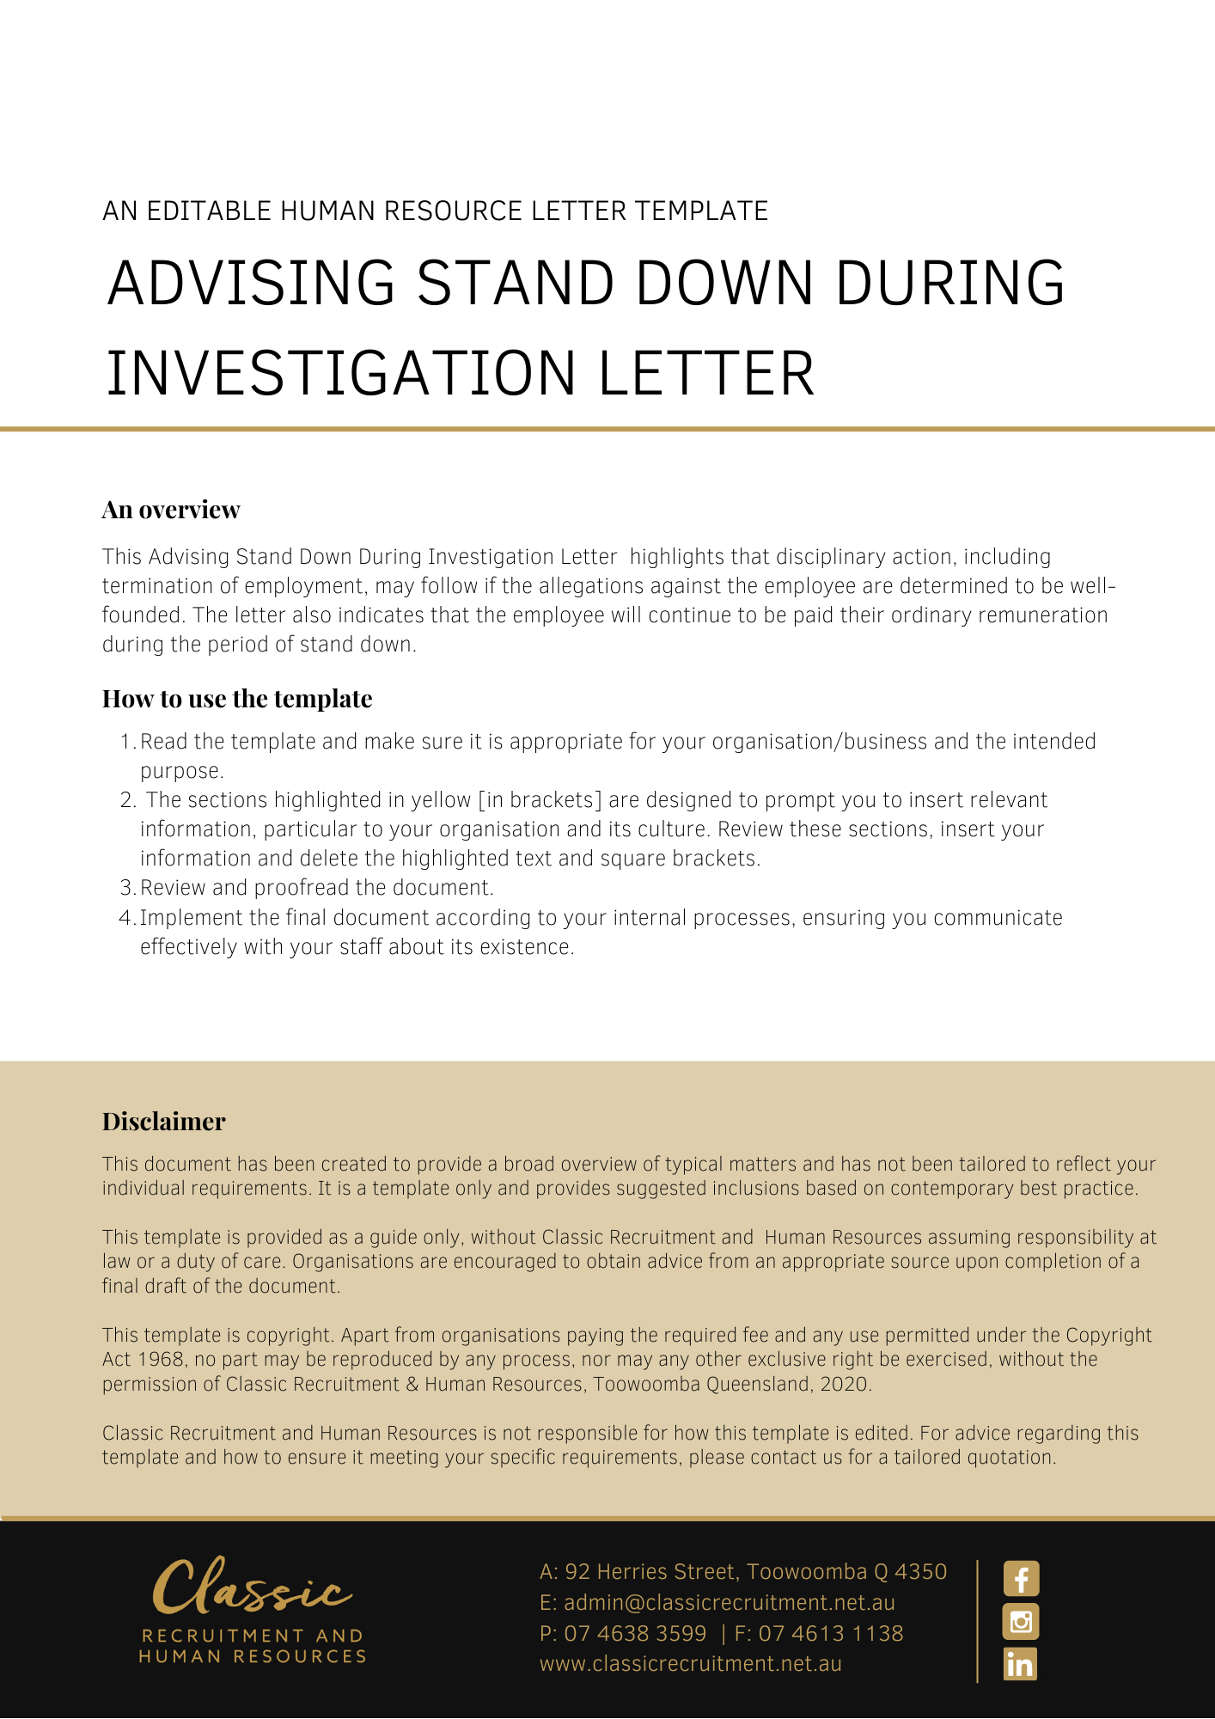
[Date]
[Employee First Name] [Employee Surname]
[Employee Address]

Stand down of your employment with [Company Name]
Dear [Employee First Name],

[Company Name] has been made aware of allegations against you. Specifically, it is alleged that you have:
- [Allegation Details]
[Company Name] has not made any assumptions about the accuracy of the allegations.
This letter is to inform you that you have been directed not to attend work pending an investigation into the allegations. You will be paid your usual remuneration during this period and are required to remain away from work until further notice.
You are required to cooperate with those conducting the investigation, including attendance at any investigation meetings, and to provide any information that may assist with the investigation.
You must keep the investigation, and any information provided by you during the course of the investigation, confidential. Failure to comply with this direction may result in disciplinary action against you.
At the completion of the investigation you will be informed of the findings and be given an opportunity to respond to those findings.
If the allegations are founded, [Company Name] may take disciplinary action against you. Such disciplinary action may include the termination of your employment.

Please contact [Insert Position (e.g. CEO/Director/Owner)] if you wish to discuss any detail relating the contents of this letter.

[Salutations for goodbye],
[Company Name]
[Letter Signatory Name]
[Letter Signatory Position]

