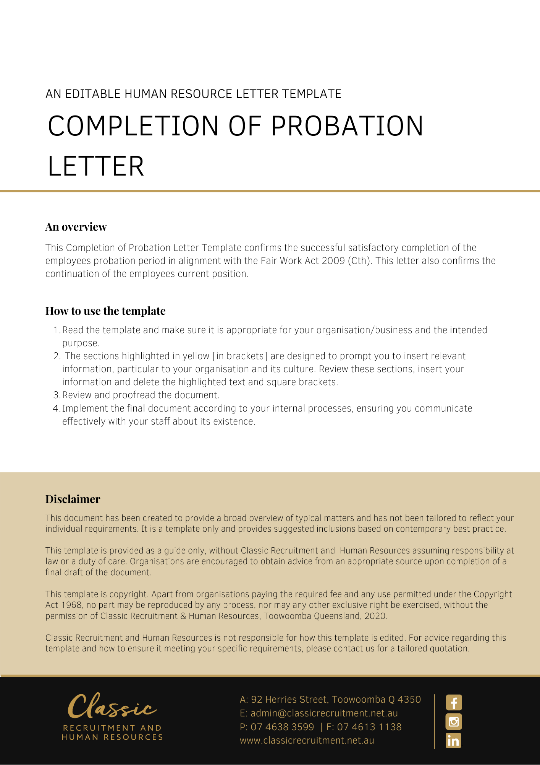
[Date]
[Employee First Name] [Employee Surname]
[Employee Address]

Completion of Probation Letter

Dear [Employee First Name],

Your employment with [Company Name] was subject to a probationary period of [Probation Length], due to be completed on [Probation End Date].
We are pleased to confirm that you have successfully completed your probationary period with [Company Name]. The terms and conditions of employment set out in your written contract of employment dated [Contract Date] will continue to apply to your ongoing position.

Your employment record will be updated to reflect that you have satisfactorily completed your probationary period.

Thank you for the effort you have applied to your new position to date. We hope to have a continuing successful and enjoyable working relationship with you.

[Salutations for goodbye],
[Company Name]
[Letter Signatory Name]
[Letter Signatory Position]

