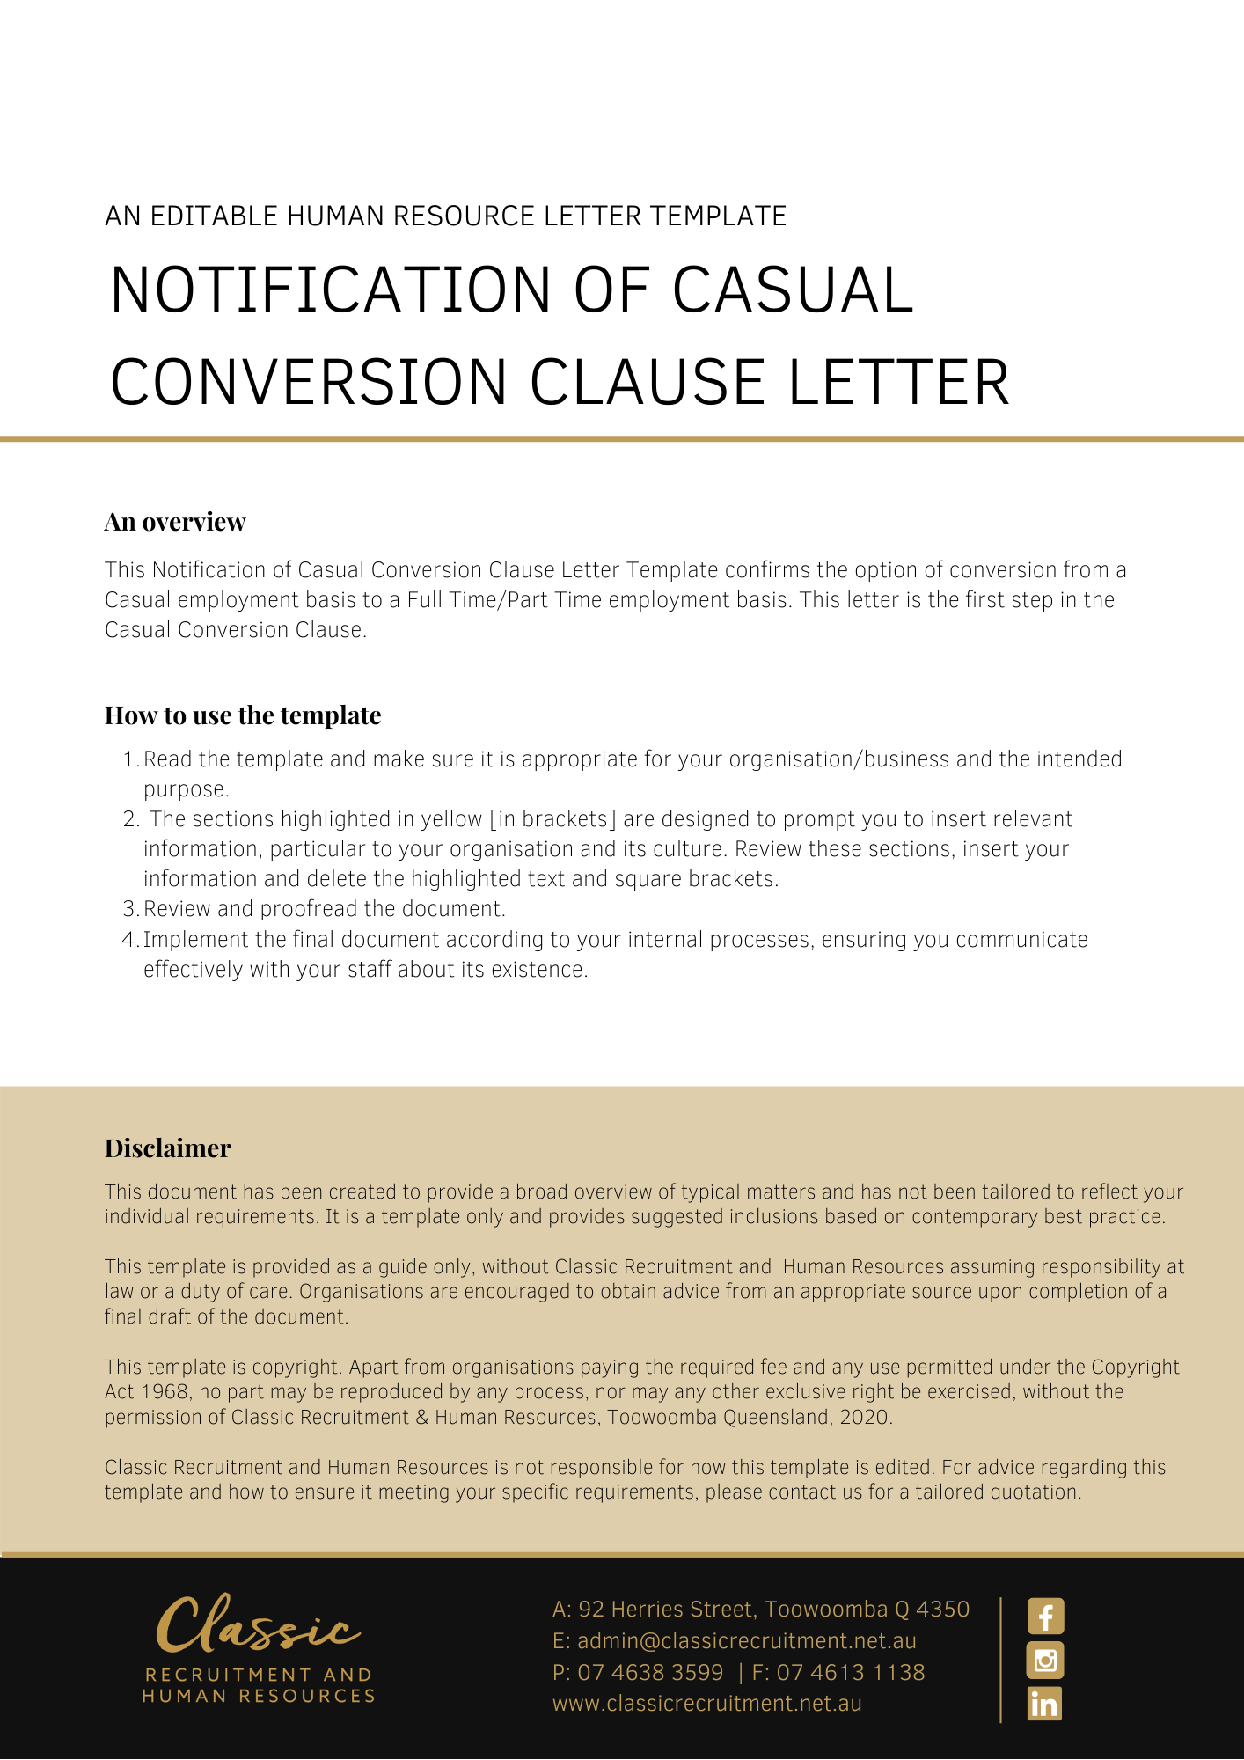
[Date]
[Employee First Name] [Employee Surname]
[Employee Address]

Notification of Casual Conversion Clause

Dear [Employee First Name],

Converting from casual employment to full-time or part-time employment will mean that the 25% casual loading will no longer apply to the hourly rate of pay. However, as a full-time or part-time employee, you would be entitled to the benefits associated with this type of employment, including paid annual leave and personal leave in accordance with the Award and relevant legislation.

If you are a regular casual employee and are interested in exploring this option with [Company Name] now that the Award has been amended, please contact [Insert Position (e.g. CEO/Director/Owner)] on [Delete after reading: insert most appropriate phone or mobile number as well as email address] to discuss this opportunity further.

[Salutations for goodbye],
[Company Name]
[Letter Signatory Name]
[Letter Signatory Position]

