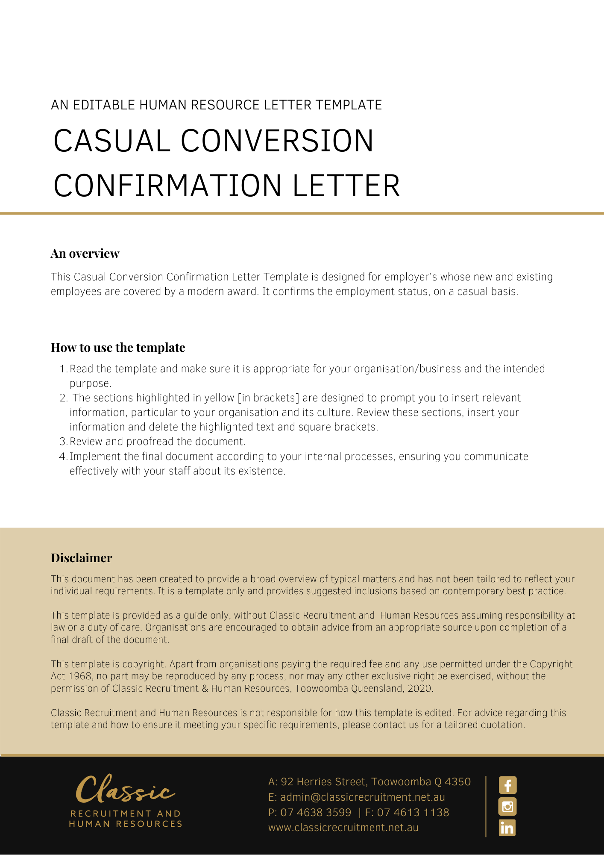
[Date]
[Employee First Name] [Employee Surname]
[Employee Address]

Confirmation of Employment Status
Dear [Employee First Name],

We are writing this letter to confirm your employment status as a casual employee at [Company Name] effective [Employment Start Date].

As you have requested, your employment will continue on a casual basis. This also means there is no firm advance commitment from the organisation in relation to your employment.

Please contact [Insert Position (e.g. CEO/Director/Owner)] if you if you have any questions.

[Salutations for goodbye],
[Company Name]
[Letter Signatory Name]
[Letter Signatory Position]

