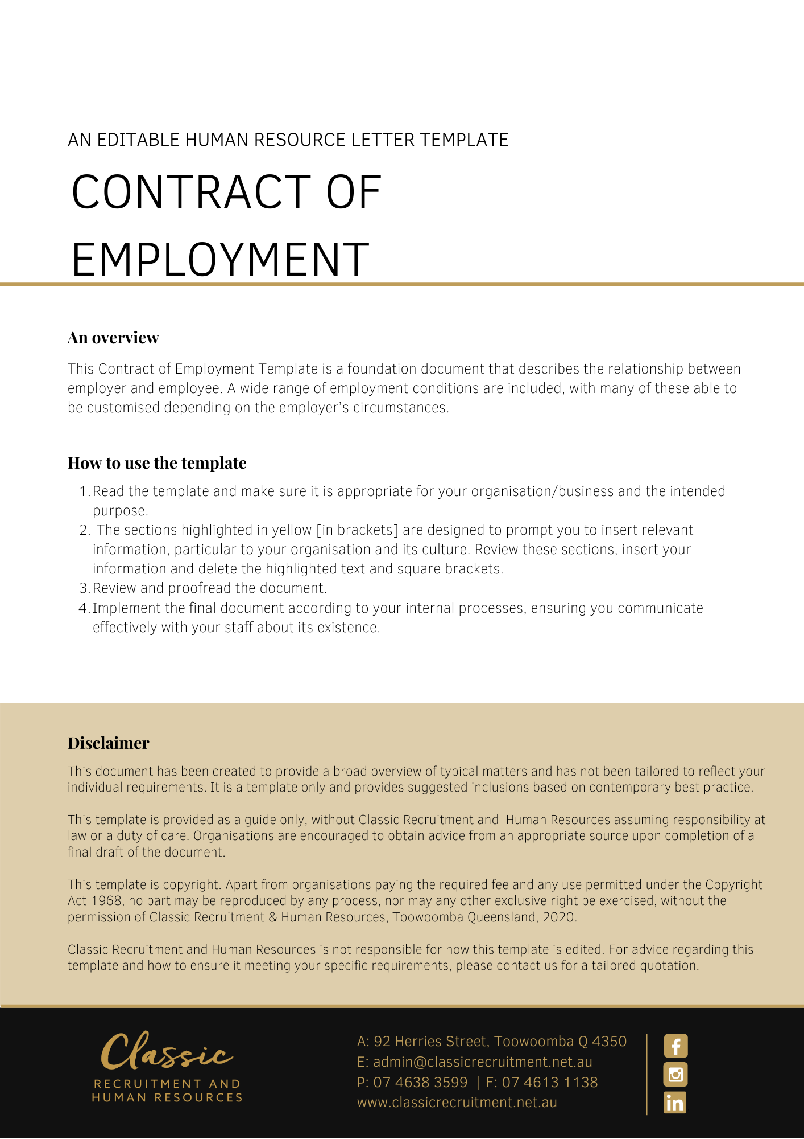
Contract of Employment

[Date]
[Employee First Name] [Employee Surname]
[Employee Address]
Dear [Employee First Name],

Position: [Employee Position Title]

On behalf of [Company Name], I am pleased to confirm the offer of employment with [Company Name] on the terms and conditions in the Contract of Employment (‘the Contract’) set out below.

Summary Table

The items in the following Summary Table are subject to any additional detail, requirement or obligation set out otherwise in this Contract, including in any attached schedules:
Item | Term | Details
 | Employer | [Company Name]
 | Date of Commencement | [Date of Commencement]
 | Position | [Employee Position] [Award Title] [Role Classification] or Award Free
 | Location | [Work Location]
 | Office Hours | [Work Start Hours] to [Work Finish Hours]
 | Weekly Ordinary Hours | 38 [Delete After Reading: adjust as required]
 | Reports to | [Insert Position (e.g. CEO/Director/Owner)]
 | Remuneration | $[Annual Salary] annual
 | Salary Payment Frequency | [Pay Regularity]
 | Probationary period | 6 months [Delete After Reading: alter as required]
 | Notice Period | [Insert Notice Period Information]
 | Performance and Salary review | Annually [Delete After Reading: alter as required]

Commencement

Your employment with [Company Name] commences on the date specified in Item 2 in the Summary Table.

The commencement of the employment is conditional upon you attending at the workplace and commencing the performance of work in accordance with this Contract.

Conditional Offer of Employment

This offer of employment is conditional on:
    - You demonstrating as required by [Company Name], that you are eligible to work in Australia by producing one of the following documents:
      - evidence of Australian citizenship;
      - evidence of Australian permanent residency; or
      - a valid temporary visa permitting you to work in Australia.
Copies of these documents will be taken and held by [Company Name]. If your eligibility to work changes during the course of your employment you must inform [Company Name]. Should you be ineligible to work in Australia your employment will immediately cease from the date of such ineligibility.
    - There being no restriction upon your ability to commence employment immediately with [Company Name] under the terms of employment specified in this Contract. In this regard, by signing this Contract, you warrant:
      - that there are no limitations on your ability to fully and safely perform all of your duties and responsibilities for [Company Name], including, but not limited to physical or psychological limitations; and
      - that you will not breach continuing obligations arising from any prior employment in the performance of your duties and responsibilities for [Company Name], including but not limited to confidentiality obligations.
    - You warrant that you have provided accurate information to [Company Name] on your qualifications, professional accreditation, professional training, currency of all relevant licences, and experience required to perform the Position. You agree that [Company Name] may terminate your employment without notice, should it discover the information you provided is inaccurate.

By signing this Contract you agree that:
- any breach of these warranties will constitute grounds for immediate termination of your employment or revocation of this Contract, as may be the case; and
- [Company Name] retains the right to terminate your Contract [Company Name] immediately in the event that you are unable to commence employment with [Company Name] from the commencement date or continue such employment due to a limitation, restriction or restraint in any contract of employment with a previous employer, or other agreement, whether written or oral, formal or informal, that prevents you from commencing or continuing employment with [Company Name] under the terms of employment specified in this Contract.

Position

Your position at the commencement of your employment is set out in Item 3 in the Summary Table. You will be employed on a full-time basis.

You are required to carry out other duties reasonably required by [Company Name] that you are skilled and capable of performing.

You may also be required to perform duties from time to time for ’s Related Entities.

[Company Name] may alter your position, Position Description and responsibilities in accordance with the needs of the business from time to time. You may also be redeployed to another position having regard to your skills, experience and competency as determined by [Company Name]. You agree that the terms of this Contract continue to apply to any altered position unless varied in writing in accordance with this Contract.

[Company Name] may direct you to work shift work whenever it so requires to meet its operational needs.

Hours of Work

Your normal office hours are set out in Item 5 in the Summary Table to be worked Monday to Friday.

You agree that your weekly ordinary hours of work are set out in Item 6 at clause 1.1, averaged over a period of up to 26 weeks.

However, due to the nature of [Company Name]’s business and your position, you agree it is reasonable for you to work any additional hours necessary to achieve the efficient and effective performance of your duties. You will not receive any additional remuneration for any additional hours worked as these additional hours have been taken into account in setting your remuneration.

Performance

In your employment you will perform:
- the duties and responsibilities of the position; and
- any other duties which [Company Name] may reasonably require from you.

In the course of your employment with [Company Name], you are required to:
- carry out all lawful and reasonable instructions and directions given to you in relation to your employment;
- perform your duties and responsibilities in a proper, ethical, diligent, professional and efficient manner; including always acting in good faith and in the best interests of [Company Name];
- ensure that you are fit to safely perform the inherent requirements of your position and any duties you may be directed to carry out from time-to-time;
- use your best endeavours to protect, enhance and promote the interests, welfare, profitability, growth and reputation of ’s business;
- not engage in any business or activities which may conflict with or be harmful to the business interests of [Company Name], or any of its officers, employees, agents, contractors or consultants;
- perform your duties in a safe manner, respecting all work health and safety laws and policies (despite the fact these do not form part of your Contract);
- during work hours, devote the whole of your time and attention to ’s business;
- perform your duties with due care and skill and in a proper, thorough and co-operative manner;
- perform your duties in accordance with any written direction, procedure, policies or other specifications provided by [Company Name] to you (relating to the performance of your work or anything connected with it);
- perform your duties in accordance with ’s values;
- perform your duties without jeopardising or damaging 's business;
- perform your duties in compliance with all relevant laws; and
- attend supervisory meetings or training meetings outside work hours as reasonably required by [Company Name].

You must not:
- use information or resources provided by [Company Name] for your personal gain or for the benefit of any other person or business;
- do anything that is reasonably likely to harm [Company Name] or [Company Name]’s reputation; or
- enter into contracts or agreements on [Company Name]’s behalf without [Company Name]’s express permission to do so.

Reporting

Your reporting arrangements are set out in Item 7 in the Summary Table.

However, [Company Name] may change your reporting arrangements in accordance with the needs of the business.

Location

Your place of work is set out in Item 4 in the Summary Table.

However, you may be asked to travel to and work at different locations to meet business needs from time to time, such as travel interstate or overseas for temporary periods. You agree to work at any of the different locations where [Company Name] requires you to do so.

You may also be required to relocate to another place of work from time to time without compensation or additional payment in accordance with the needs of [Company Name]’s business.

Probationary Period

You will initially be employed on a probationary period which is set out in Item 10 in the Summary Table. Your work performance and conduct will be monitored during the period. Prior to the completion of your probationary period, [Company Name] will decide on your suitability to continue employment.

The ‘minimum employment period’ (as defined in the Fair Work Act 2009 (Cth)) is unaffected by this clause.

Remuneration

Your remuneration is set out in in Item 8 in the Summary Table.

Annual Salary

Your annual salary is set out in Item 8 in the Summary Table. If [Company Name] pays Fringe Benefits Tax on your behalf, this payment also forms part of your remuneration package.

Your salary (less applicable taxation) will be paid in accordance with Item 9 in the Summary Table into the bank account of your choice.

Your salary and other employment conditions are confidential and must not be discussed with other employees of [Company Name] or other persons outside [Company Name] (with the exception of your legal and financial advisers).

Superannuation

[Company Name] will, where required, make compulsory superannuation guarantee contributions on your behalf in accordance with the relevant legislation and/or industrial instrument in force from time to time.

Performance and Salary Reviews

Your performance and salary may be reviewed in accordance with Item 12 In the Summary Table.

Reviews are based on your position within [Company Name], your performance and contribution to the effective functioning of ’s business, ’s financial performance and the market generally. Remuneration increases are not automatic, and any increase is within [Company Name]’s absolute discretion.

Employment Policies and Procedures

You are directed to read and comply with the obligations imposed upon you within [Company Name]’s policies and procedures as they relate to your employment. These policies and procedures may be varied from time to time at the [Company Name]’s discretion, and you are directed to comply with such variations. Such policies and procedures do not form part of your Contract.

A breach of your obligations under [Company Name]’s policies and procedures may result in disciplinary action, up to and including the immediate termination of your employment.

Annual Leave

You are entitled to annual leave in accordance with the provisions of relevant legislation. For example, a full-time employee who works an average of 38 hours per week would be entitled to accrue 4 weeks’ annual leave per year.

Annual leave may be taken at such time as may be agreed between you and [Company Name] from time to time and in accordance with the relevant legislation.

Personal/Carer’s Leave

You are entitled to personal/carer’s leave in accordance with the terms of relevant legislation.

For the purposes of this clause and the relevant legislation, personal/carer’s leave is:
- leave that you take because of your personal illness or injury (i.e. sick leave); or
- leave that you take to provide care or support to a member of your immediate family, or a member of your household, who requires care or support (i.e carer’s leave) because of:
      - a personal illness, or injury, affecting the member; or
      - an unexpected emergency affecting the member.

Applications for personal/carer’s leave must be made in accordance with relevant legislation and ’s policies as varied from time to time. If you are absent on personal/carer’s leave, [Company Name] may:
- require you to provide to [Company Name] evidence to ’s satisfaction, confirming the illness or injury (such as a statutory declaration or a medical certificate to ’s satisfaction); and/or
- require you to be examined by a medical practitioner nominated by [Company Name], to provide a report to [Company Name], on your current and/or future capacity to perform the duties of your role.

You are required to inform [Company Name] as soon as practicable of any personal and carer’s leave, and the reason for and expected duration of such an absence.

Other Leave

You are also entitled to long service leave, parental leave and compassionate leave in accordance with relevant legislation.

Resignation and Termination

During the probationary period, either party may terminate your employment with one week’s notice in writing, except in cases of summary dismissal. [Company Name] may elect to pay you in lieu of part or all of your notice period or provide you with altered duties during the notice period.

Except where your employment is terminated for reasons of serious misconduct, either [Company Name] or you may terminate your employment by giving the period of notice set out in Item 11 in the Summary Table.

[Company Name] may elect to pay you in lieu of part or all of your notice period.

Alternatively, [Company Name] may require you not to report for work, or provide you with altered duties, during part or all of your notice period.

The notice of termination required to be given by you is the same as that required of [Company Name], except that there is no requirement to give additional notice based on your age.

[Company Name] may terminate your employment at any time without notice or payment in lieu of notice in the case of serious misconduct. Serious misconduct will include, but is not limited to:
- ongoing breach of your obligations as set out in this Contract without rectifying such breach within 7 days of receiving notice of the breach;
- breach of the warranties provided under clause 3.1 of this Contract;
- performing your work in a manner reasonably considered by [Company Name] to be unprofessional;
- gross negligence;
- disobeying or refusing to follow a lawful and reasonable direction of [Company Name] or ’s Related Entities;
- engaging in conduct which [Company Name] reasonably considers is likely to damage ’s reputation; or
- committing any act of dishonesty including acts of embezzlement, theft or fraud involving ’s assets or property; or
- being found guilty of a criminal offence which, in the reasonable opinion of [Company Name], prevents or impedes the further performance of your duties or is otherwise incompatible with your position as an employee of [Company Name]; or
- any conduct that would justify summary dismissal at common law.

On termination of your employment by any means, [Company Name] will pay to you:
- your salary — payable to you up to and including the date of termination;
- payment in lieu of any accrued untaken annual leave to which you are entitled up to and including the date of the termination; and
- any other benefits due to you under this Contract or relevant legislation.

If your employment is terminated summarily without notice or payment in lieu of notice, you will only be paid up to the date of termination.

If your employment is terminated for any reason, you agree to resign all directorships, offices and positions that you may hold in relation to [Company Name], its Related Entities or any other entity in which you hold office in connection with your employment. You agree to do all things and execute all documents necessary to give effect to these resignations.

[Company Name] may direct you to not attend work and not to undertake any of your work duties at any time, provided that [Company Name] provides you with payment of your entitlements under your remuneration package during the period of suspension.

Return of Property

On request by [Company Name] or on resignation or termination of your employment for any reason, you must:
- return to [Company Name] all property belonging to [Company Name] in your possession, custody or control, including but not limited to Confidential Information, Intellectual Property, records pertaining to Clients or Suppliers, mobile telephones, computers, keys, data storage devices, cards, documents, diaries, records and papers, reports, working papers, training manuals, equipment, computer information and programs and all copies of such items.
- cause to be deleted all records in your possession, custody or control, including but not limited to Confidential Information, Intellectual Property, and information pertaining to Clients or Suppliers, including digital records and information contained on professional or social media platforms such as LinkedIn, Facebook, Twitter, etc.

You may be required to declare that you have complied with the conditions above.

Definitions and General Provisions

In this Contract:

‘Moral Rights’ has the meaning given to it in the Copyright Amendment (Moral Rights) Act 2000 (Cth) and includes rights of integrity of authorship, rights of attribution of authorship and similar rights that exist or may come to exist anywhere in the world.

‘Person’ includes any natural person, Company, partnership, association, trust, business, or other organisation or entity of any description and a Person’s legal personal representative(s), successors, assigns or substitutes.

‘Products’ means any products produced, manufactured, sold or distributed (and prospective products to be produced, manufactured, sold or distributed) by [Company Name].

This Contract supersedes and replaces all prior representations and agreements concerning your employment with [Company Name].

Any amendment or addition to this Contract must be in writing, and signed by both parties.

Each provision of this Contract is severable from the others and the severance of a provision does not affect the remainder of the Contract.

This contract is governed by the laws of Australia - QLD.

You acknowledge and agree that the terms and conditions of your employment, as outlined in This Contract, are confidential and will not be disclosed by you to any Person(s) other than [Company Name]’s, or your own legal or financial advisers.

This contract will remain open for acceptance for a period of five working days from its date.

Entire Agreement

This Contract sets out all of the terms of your employment contract with [Company Name]. This Contract supersedes and replaces all prior representations, contracts and agreements (whether oral or in writing) concerning your employment with [Company Name].

If there are any other matters that you have relied on in our discussions or other communications to date or there are any other matters you wish to discuss, please let [Company Name] know before you sign the Contract. ’s representative may then consider them and discuss them with you. If agreed, the terms set out in this Contract will be amended, to ensure that it contains all the agreed terms.

Once you sign this Contract, you are confirming it is complete and no agreed terms are missing.

Employer’s Discretion

Where any provision of this contract entitles or engages discretion for the purposes of [Company Name] exercising its discretion [Company Name] may act arbitrarily, with any payment being entirely gratuitous and voluntary.

Please sign the attached copy of this Contract to acknowledge that you accept [Company Name]’s offer of casual engagements on the terms and conditions set out in this Contract.

Yours sincerely,
[Salutations for goodbye],
[Company Name]
[Letter Signatory Name]
[Letter Signatory Position]

Acceptance
I have read and understood this Contract and I accept the offer of employment with [Company Name] on the terms contained in it.

Signed: …………………………………………………
Date: ………………………….

