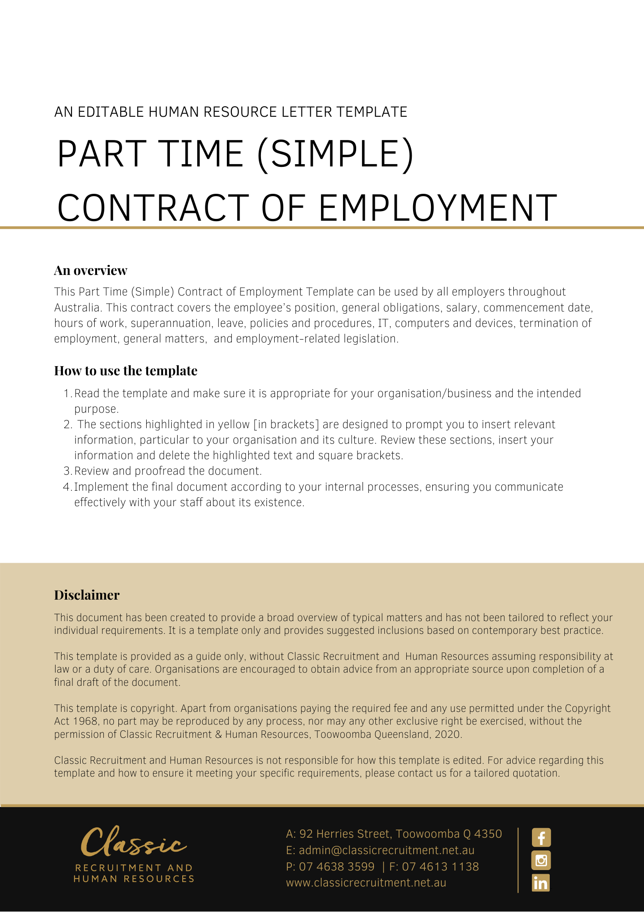
Contract of Employment Part Time (Simple)

[Date]
[Employee First Name] [Employee Surname]
[Employee Address]

PRIVATE AND CONFIDENTIAL
Dear [Employee First Name],

Re: Offer of Employment with [Company Name]

I am pleased to confirm our offer of employment as set out in the attached employment agreement. I look forward to you joining the team and wish you every success in your new role.

[Salutations for goodbye],
[Company Name]
[Letter Signatory Name]
[Letter Signatory Position]

ACCEPTANCE OF THIS OFFER OF EMPLOYMENT
I accept this offer of employment and agree to be bound by the terms and conditions set out in the attached Employment Agreement.

SIGNATURE |  | DATE

EMPLOYMENT AGREEMENT

Key Details
The Key Details are set out in the table below:

Employee | [Employee First Name] [Employee Surname]

The Business | [Company Name]

The Position | Employee Position] [Award Title] [Role Classification] or Award Free

Position Status | Part Time

Wages | $[Hourly Rate]

Start Date | [Start Date]

Location | [Work Location]

Wages Instalments | [Pay Basis]

Specific hours of work on particular days | Day Start Finish  Monday [Insert Start Time] [Insert Finish Time]  Tuesday [Insert Start Time] [Insert Finish Time]  Wednesday [Insert Start Time] [Insert Finish Time]  Thursday [Insert Start Time] [Insert Finish Time]  Friday [Insert Start Time] [Insert Finish Time]  Saturday [Insert Start Time] [Insert Finish Time]  Sunday [Insert Start Time] [Insert Finish Time]

Position, Probation and Employment-Related Legislation

You will be employed in the Position set out in the Key Details.

This Position’s Status is set out in the Key Details.

The first six months of your employment will constitute a probationary period. Your continued employment with the Business is dependent on you completing the probationary period to the Business’ satisfaction.

Your employment may also be governed by the provisions of an applicable industrial instrument such as an award or enterprise agreement or other employment related legislation. Any such industrial instrument or employment related legislation does not form part of and is not incorporated into this Employment Agreement for any purposes.

General Obligations

During your employment, you must perform your work and anything connected with it:

a) with due care and skill and in a proper, thorough and co-operative manner;

b) safely, and in accordance with the Business safety requirements (including attending for work free from the risks associated with taking alcohol and/or other drugs at, or prior to attending, work);

c) in accordance with any day-to-day directions given by the Business;

d) in accordance with any written direction, procedure or other specifications provided by the Business to you (relating to the performance of your work or anything connected with it);

e) by avoiding conflicts of interest, without acting (directly or indirectly) in competition with or against the Business without prior written consent from the Business;

f) in accordance with the Business values;

g) using best efforts to promote the Business;

h) without jeopardising or damaging the Business;

i) by maintaining confidentiality; and

j) in compliance with all relevant laws.

Remuneration

You will initially be paid the Wages set out in the Key Details.

Your Wages will be paid into an account of a recognised financial institution of your choice which will be paid to you in the Wages Instalments set out in the Key Details.

Commencement

You will commence your employment with the Business on the Start Date and the Location set out in the Key Details.

Hours of Work

If we have fixed specific hours of work on particular days of the week, these will be set out in the Key Details.

You may be required to work reasonable additional hours Monday to Sunday to meet operational needs.

Superannuation

The Business will, when required, make superannuation contributions on your behalf in accordance with the relevant legislation and/or industrial instrument in force from time to time.

Leave

Any entitlement you have to leave, including annual leave, personal/carer’s leave, compassionate leave and long service leave is regulated by applicable employment related legislation.

Policies and Procedures

As an employee of the Business, you are required to comply with the Business policies and procedures as they relate to your employment as varied from time to time at the Business’ discretion. Such policies and procedures are not incorporated into, and do not form part of, this Employment Agreement.

IT, Computers and Devices

The Business may engage in:

a) computer surveillance of all its information technology systems, including email usage, internet usage and any other usage of information technology supplied by the Business. This surveillance may be carried out on a continuous and ongoing basis and may be ongoing from the commencement of your employment;

b) camera surveillance by way of closed circuit television cameras. The surveillance may be continuous and ongoing. For the purposes of your employment with the Business and exposure to the surveillance, it may effectively start upon your commencement. Access to the recorded material will be strictly limited to authorised personnel; and

c) tracking surveillance by means of an electronic device the primary purpose of which is to monitor or record geographical location or movement (such as a Global Positioning System tracking device). The surveillance may be continuous and ongoing. For the purposes of your employment with the Business and exposure to the surveillance, it may effectively starts upon your commencement. Access to the recorded material will be strictly limited to authorised personnel.

You consent to this surveillance.

Termination

You or the Business may terminate your employment by providing notice in accordance with the National Employment Standards.

This means that either party may terminate the employment by providing notice according to the following scale:

Length of service Period of Notice

Not more than 1 year 1 week

More than 1 year but not more than 3 years 2 weeks

More than 3 years but not more than 5 years 3 weeks

More than 5 years 4 weeks

If you are 45 years of age or older, the period of notice to be provided by the Business will be increased by 1 week, if you have at least 2 years’ service.

The Business may, at its discretion, make payment in lieu of part or all of the notice period.

The Business may otherwise terminate your employment immediately and without notice in the event you are found to have engaged in serious misconduct.

General Matters

This Employment Agreement constitutes the entire agreement between you and the Business in relation to your employment.

Each provision of this Employment Agreement is severable from the others and the severance of a provision does not affect the remainder of this Employment Agreement.

Where, at any time a law and/or industrial instrument (including a modern award or enterprise agreement) applies to your employment, while any instrument is not incorporated into, and does not form part of, this Employment Agreement, your salary covers all monetary amounts that the Business might otherwise have to pay arising under a law and/or industrial instrument (including wages, overtime, allowances, penalties and loadings) and compensates you for all hours worked.

The Business may alter your Position, work location, reporting arrangements, position description and responsibilities in accordance with the needs of the Business. You agree that irrespective of any such changes, the terms and conditions of this Employment Agreement continue to apply unless mutually agreed and varied in writing.

