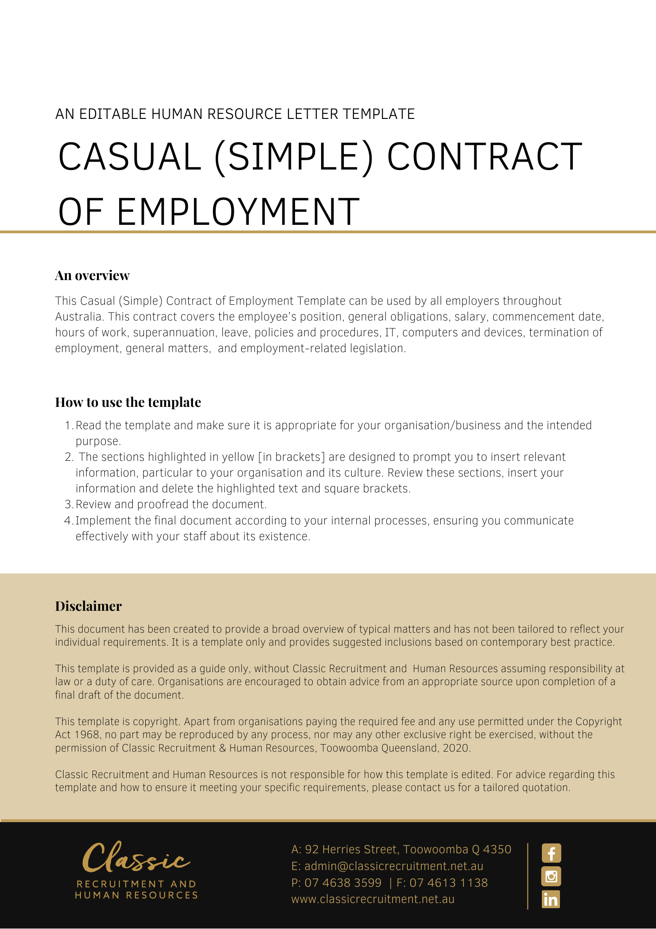
Contract of Employment Casual (Simple)

[Date]
[Employee First Name] [Employee Surname]
[Employee Address]

PRIVATE AND CONFIDENTIAL
Dear [Employee First Name],

Re: Offer of Employment with [Company Name]

I am pleased to confirm our offer of employment as set out in the attached employment agreement. I look forward to you joining the team and wish you every success in your new role.

[Salutations for goodbye],
[Company Name]
[Letter Signatory Name]
[Letter Signatory Position]

ACCEPTANCE OF THIS OFFER OF EMPLOYMENT
I accept this offer of employment and agree to be bound by the terms and conditions set out in the attached Employment Agreement.

SIGNATURE |  | DATE

EMPLOYMENT AGREEMENT

Key Details
The Key Details are set out in the table below:

Employee | [Employee First Name] [Employee Surname]

The Business | [Company Name]

Position Title | [Insert Position]

Position Status | Casual

Wages | $[Hourly Rate] per hour (including casual loading)

Start Date | [Start Date]

Location | [Work Location]

Wages Instalments | [Pay Basis]

Award | [Insert Award Title]

Classification | [Insert Classification Level]

Casual Loading Percentage | 25%

Position and Employment-Related Legislation

You will be employed in the Position set out in Key Details.

This Position’s Status is set out in the Key Details.

Your employment may also be governed by the provisions of an applicable industrial instrument such as an award or enterprise agreement or other employment related legislation. Any such industrial instrument or employment related legislation does not form part of and is not incorporated into this Employment Agreement for any purposes.

General Obligations

During your employment, you must perform your work and anything connected with it:

a) with due care and skill and in a proper, thorough and co-operative manner;

b) safely, and in accordance with the Business safety requirements (including attending for work free from the risks associated with taking alcohol and/or other drugs at, or prior to attending, work);

c) in accordance with any day-to-day directions given by the Business;

d) in accordance with any written direction, procedure or other specifications provided by the Business to you (relating to the performance of your work or anything connected with it);

e) by avoiding conflicts of interest, without acting (directly or indirectly) in competition with or against the Business without prior written consent from the Business;

f) in accordance with the Business Values;

g) using best efforts to promote the Business;

h) without jeopardising or damaging the Business;

i) by maintaining confidentiality; and

j) in compliance with all relevant laws.

Remuneration

You will initially be paid the Wages set out in the Key Details.

This amount also includes the casual loading set at the Casual Loading Percentage set out in the Key Details.

Your receipt of the Casual Loading Percentage is conditional on, and based on our understanding that, you are a casual employee at law. The Casual Loading Percentage is only payable for as long as you are a casual employee at law.

The Casual Loading Percentage is paid instead of annual leave, paid personal/carer’s leave, notice of termination, redundancy benefits and other entitlements to which casual employees are not entitled under the Fair Work Act 2009 (Cth).

Your Wages will be paid into an account of a recognised financial institution of your choice which will be paid to you in the Wages Instalments set out in the Key Details.

Commencement

You will commence your employment with the Business on the Start Date and the Location set out in the Key Details.

Hours of work

As a casual employee you have no guaranteed or fixed hours of work. The Business may offer you work based on its operational requirements.

Any offer of work will be made to you as soon as reasonably practicable and usually by the preceding day. The Business does not make or give any advanced commitment as to ongoing or regular hours of work being available to you.

You are under no obligation to accept any work that is offered to you. You are required to work any hours of work that you do actually accept unless:

a) the Business agrees that you are not required to work the hours;

b) you are entitled to take leave in accordance with a law and/or industrial instrument; or

c) you are unable to work due to other exceptional circumstances.

The Business may require you to provide evidence that would satisfy a reasonable person that your absence is for one of these reasons.

Superannuation

The Business will, when required, make superannuation contributions on your behalf in accordance with the relevant legislation and/or industrial instrument in force from time to time.

Leave

Any entitlement you have to leave, including annual leave, personal/carer’s leave, compassionate leave and long service leave is regulated by applicable employment related legislation.

Policies and Procedures

As an employee of the Business, you are required to comply with the Business policies and procedures as they relate to your employment as varied from time to time at the Business’ discretion. Such policies and procedures are not incorporated into, and do not form part of, this Employment Agreement.

IT, Computers and Devices

The Business may engage in:

a) computer surveillance of all its information technology systems, including email usage, internet usage and any other usage of information technology supplied by the Business. This surveillance may be carried out on a continuous and ongoing basis and may be ongoing from the commencement of your employment;

b) camera surveillance by way of closed circuit television cameras. The surveillance may be continuous and ongoing. For the purposes of your employment with the Business and exposure to the surveillance, it may effectively start upon your commencement. Access to the recorded material will be strictly limited to authorised personnel; and

c) tracking surveillance by means of an electronic device the primary purpose of which is to monitor or record geographical location or movement (such as a Global Positioning System tracking device). The surveillance may be continuous and ongoing. For the purposes of your employment with the Business and exposure to the surveillance, it may effectively starts upon your commencement. Access to the recorded material will be strictly limited to authorised personnel.

You consent to this surveillance.

Termination

The Business may terminate your employment by providing you written notice at any time.

General Matters

This Employment Agreement constitutes the entire agreement between you and the Business in relation to your employment.

Each provision of this Employment Agreement is severable from the others and the severance of a provision does not affect the remainder of this Employment Agreement.

Where, at any time a law and/or industrial instrument (including a modern award or enterprise agreement) applies to your employment, your wages and any other benefits provided to you in this contract are in satisfaction of any entitlements or benefits you may have or that may arise pursuant to the award or industrial instrument as well as entitlements arising under the National Employment Standards or other laws. This includes but is not limited to entitlements to overtime payments, weekend and holiday penalties, allowances, travelling expenses, penalty payments and any other entitlement or benefit.

The Business may alter your Position, reporting arrangements, position description and responsibilities in accordance with the needs of the Business. You agree that irrespective of any such changes, the terms and conditions of this Employment Agreement continue to apply unless varied and mutually agreed in writing.

