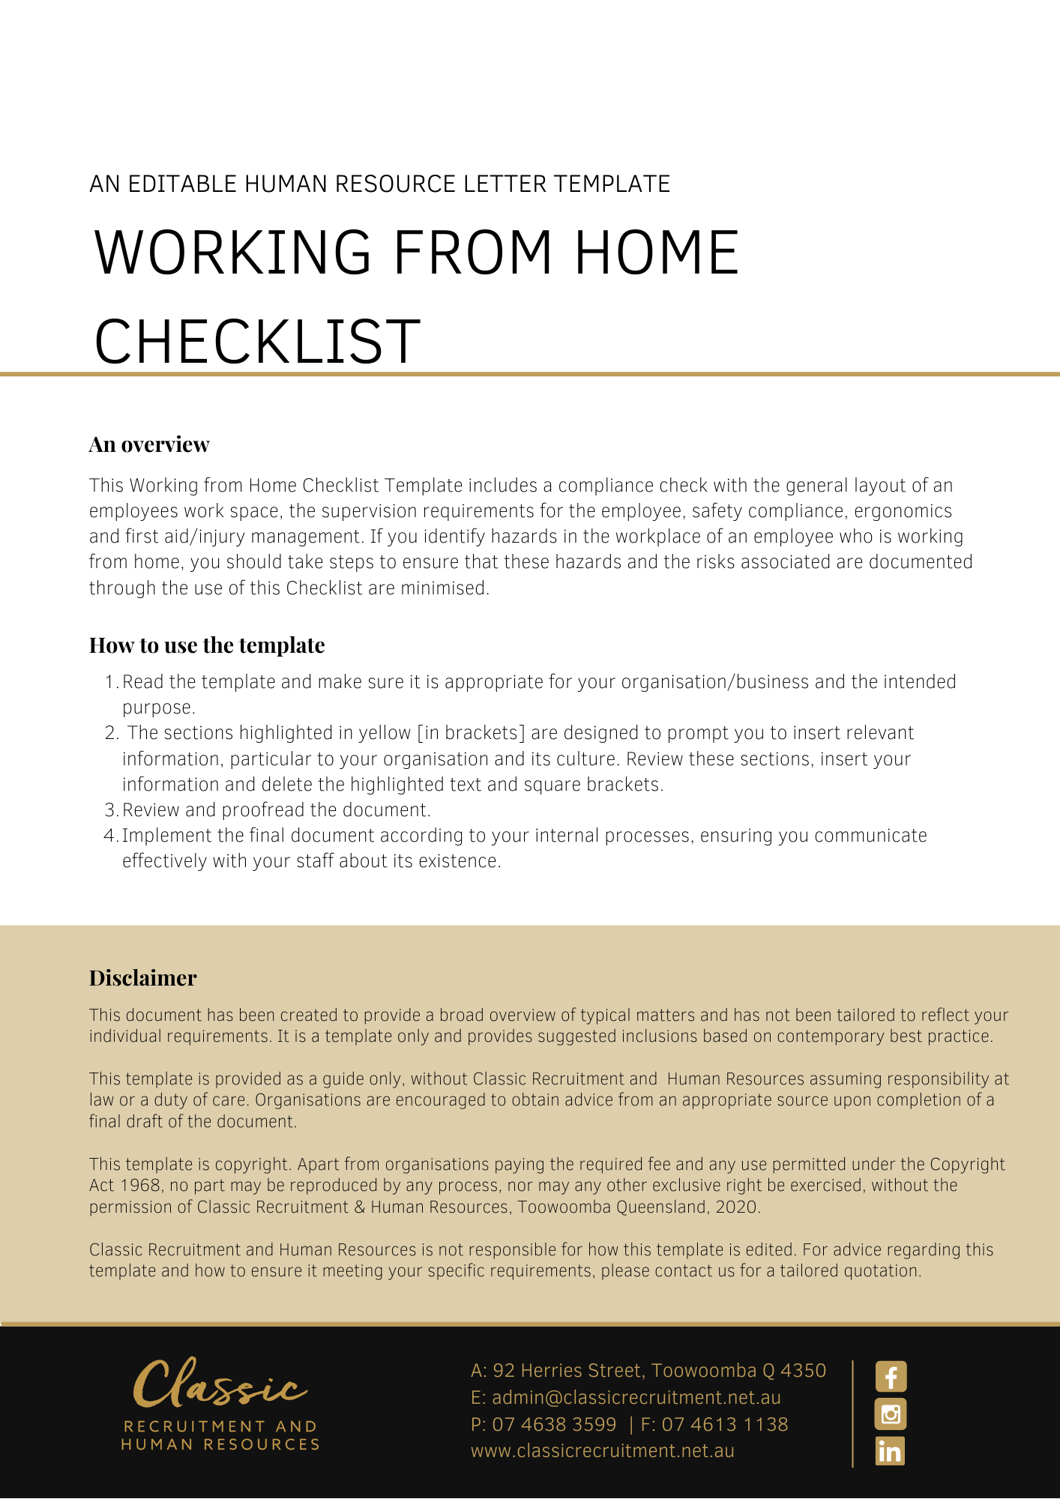
WORKING FROM HOME CHECKLIST
WORKER’S NAME: ____________________________________________________________________

ADDRESS:____________________________________________________ _______________________

DESIGNATED WORK AREA:______________________________________ PHONE:_________________

CHECKLIST COMPLETED BY:___________________________ DATE: ____________________________

GENERAL LAYOUT  - Is there a separate office/area available to work in? Where is it located in the home?  _____________________________________________________________________________  - Is the lighting in the room adequate for the tasks being performed?  - Are floor surfaces even? (e.g. no loose tiles or carpet that is torn or has ridges or holes)?  _____________________________________________________________________________  - Are there any sources of excessive or disruptive noise?  - Does the layout of the workplace allow easy access to equipment?  - Are floors clear of trip hazards on a daily basis?  - What type of work at home is proposed and is it suitable to be conducted in the home environment?  _____________________________________________________________________________  _____________________________________________________________________________  _____________________________________________________________________________ | YES | NO
SUPERVSION
- Outline the supervision arrangements for this work

_____________________________________________________________________________
_____________________________________________________________________________
_____________________________________________________________________________

- Has the Worker received the necessary information and training to do the work safely?
- Has there been an agreement made in writing concerning work hours, work breaks etc

ELECTRICAL SERVICES

- Are safety switches or earth leakage circuit breaker installed?
- Are power boards used to prevent overloading of power points and use of double adaptors?
- Are electrical leads or extension cords exposed or damaged?

WORKING FROM HOME CHECKLIST
ERGONOMICS/MANUAL HANDLING  - Is there ergonomic furniture available? Does it meet Australian Standards?  - Chair  - Desk  - Is a document holder required?  - Is a footrest required?  - Are laptop stands used for laptops  - Is the furniture ergonomically adjusted?  - Is the computer screen located at an appropriate height for the individual to avoid extremes of head and neck flexion?  - Are laptops connected to a docking station?  - What manual handling tasks are performed? List the control measures in place.  __________________________________________________________________________________  _________________________________________________________________________________ | YES | NO
FIRST AID/INJURY MANAGEMENT

- Is there adequate first aid available based on the nature of the hazards?
- Is the worker aware of the company’s incident reporting procedure, who to report incidents to and has access to incident reporting forms?
- Is the worker aware of the company’s rehabilitation or injury management policy and procedures?
CHEMICAL SAFETY
- Are chemicals required to be regularly handled during work hours?
If so list the chemicals used:
________________________________________________________________________________
________________________________________________________________________________

- Are Material Safety Data Sheets (Safety data Sheets) available for any chemicals in the workplace/home?

PHOTOGRAPHS
- Are there any photos of the work area and workstation?
If so attach to document. If not, provide reasons:

______________________________________________________________________________

ADDITIONAL COMMENTS AND ACTION TAKEN FOR THE ABOVE POINTS
__________________________________________________________________________________
___________________________________________________________________________________
___________________________________________________________________________________

