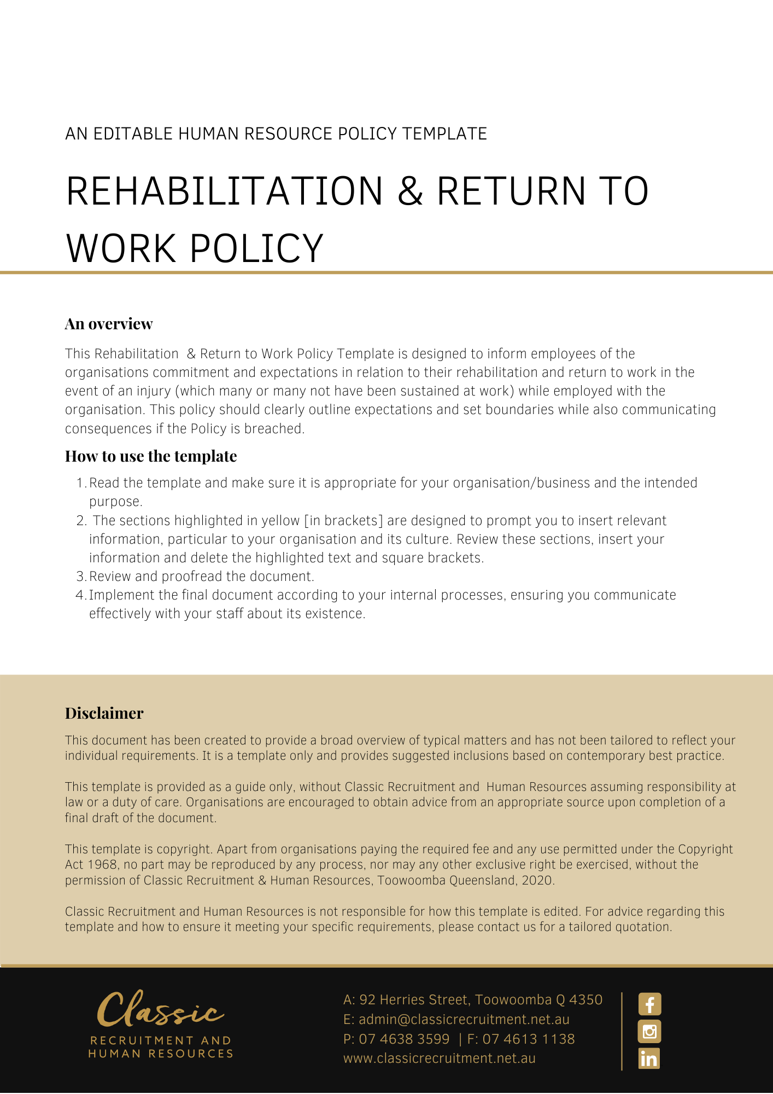

Rehabilitation & Return to Work Policy

Overview
[Company Name] has implemented a Rehabilitation & Return to Work Policy. The policy takes effect immediately and has been developed to inform employees of our commitment and expectations in relation to their rehabilitation and return to work in the event of an injury (which may or may not have been sustained at work) while employed by [Company Name].

The aim of this policy is to confirm our commitment to ensure we have procedures in place to safely manage an employee’s Rehabilitation & Return to Work from illness or injury.

Here at [Company Name] we are committed to:

- providing a safe and healthy work environment
- encouraging the prompt & early reporting of injuries
- making suitable duties available to injured workers as soon as possible after an injury occurs, as appropriate
- consulting with injured workers to develop their suitable duties program
- respecting the confidentiality of our worker’s medical and rehabilitation information
- reviewing our workplace rehabilitation policy and procedures at least every three years.

Injuries sustained outside of the workplace are the responsibility of the employee. If an employee is unfit for work, they will be required to access Personal Leave or Leave Without Pay (LWOP). If suitable duties are unavailable, or working from home is not appropriate, leave will need to be taken. Of course, [Company Name] will try to assist however, this may not always be possible or practical. Employees will not be able to return to the workplace until their medical certificate has been completed. If an employee recovers sooner than anticipated, it is the employee’s responsibility to obtain a revised Medical Certificate from their medical practitioner. Costs for medical assessments etc will of course be for the employee’s personal account.

Application
This policy applies to all employees of [Company Name] regardless of whether they are permanent full-time, permanent part-time or casual employees. This policy applies to all employees while they are in our workplace under the management and control of [Company Name] and/ or using [Company Name] vehicles, machinery, plant or substances and/or performing work in the conduct of [Company Name] (including at a client site away from their usual workplace).

Definitions
Injury Management (IM) Program: This is a coordinated and managed program that integrates all aspects of injury management including treatment, rehabilitation, retraining, claims management and employment practices.

Injury Management (IM) Plan: An IM Plan is a plan for coordinating and managing those aspects of injury management that concern the treatment, rehabilitation and retraining of an injured worker, for the purpose of achieving a timely, safe and durable return to work for a particular worker. The IM Plan is developed by the insurer.

Return to Work (RTW) Program: An employer must establish a RTW Program with respect to policies and procedures for the rehabilitation (and, if necessary, vocational re-education) of any injured workers of the employer. An employer’s Return to Work Program must not be inconsistent with the Injury Management Program of the employer’s insurer and is of no effect to the extent of any such inconsistency.

Return to Work (RTW) Plan: When an injured employee returns to work on suitable duties with restrictions, the supervisor/Return to Work Coordinator or Rehabilitation Provider must write a RTW Plan. This plan must be regularly monitored and reviewed by all parties. Physical restrictions, suitable duties, hours worked, supervision arrangements, and treatment times and dates must be clearly outlined in the RTW Plan.

Procedure
If an employee is injured at work, they should follow this procedure:

- seek first aid or medical treatment
- notify the [Insert Position (e.g. CEO/Director/Owner)] that an injury has been sustained and complete an incident report form as soon as possible
- If attendance at a Medical Practitioner is required, make sure they understand the injury was sustained at work and that they issue a workers’ compensation medical certificate - this is required to make a claim
- The claim form, Medical Capacity Certificate and Incident Report Form must be returned to your [Insert Position (e.g. CEO/Director/Owner)] as soon as possible
- Any medical expenses that relate to a WorkCover claim should also be provided to your [Insert Position (e.g. CEO/Director/Owner)]
- Employees requiring time off work must provide a medical certificate. Wages will be paid for lost time as soon as the [Insert Position (e.g. CEO/Director/Owner)] has received approval of the workers compensation claim from WorkCover
- Once the claim has been accepted, relevant payments and reimbursements (including of medical expenses) will be made. It is therefore extremely important that all paperwork is completed immediately to ensure that employees are paid promptly.

Employee Responsibilities
Employees are responsible for:

- attending medical appointments that are organised by WorkCover
- participating in the development of a suitable duties program
- providing the [Insert Position (e.g. CEO/Director/Owner)] with a copies of medical certificates and other receipts and correspondence
- keeping the [Insert Position (e.g. CEO/Director/Owner)] informed of progress

Return to work (RTW) planning
The priority of all RTW planning is to facilitate an early, safe return to suitable duties following a work-related injury or illness. [Company Name], in consultation with the injured employee, nominated treating doctor, and WorkCover will work on an individually tailored return to work strategy and plan. The objective is always for the injured employee to return to work as soon as possible.

We support our injured workers by providing suitable duties where possible/appropriate for them while they are recovering. We expect that all injured workers will return to work on suitable duties as soon as it is medically safe to do so.

Management Responsibilities:

- Make suitable duties available to injured workers who are certified fit for suitable duties and where it is reasonably practical to do so
- Refer an injured employee to a rehabilitation provider if required
- Notify WorkCover QLD if unable to provide suitable duties
- Cooperate with WorkCover QLD in providing retraining to an injured worker who is unable to return to their pre-injury job.

Return to work not to disadvantage injured employee
WorkCover QLD sets guidelines for how an injured employee must not be disadvantaged while participating in a return to work process following a work related injury.

This includes but is not limited to, injured employees having access to their sick leave as per their contractual entitlements (if a valid medical certificate is provided). If the medical condition is subsequently accepted as a compensable workplace injury, the sick leave will be reinstated in accordance with applicable legislation.

All monies that the injured employee is entitled to under the workers compensation legislation will be passed on to that employee as soon as practicable after notification from the insurer.

Confidentiality
A confidential return to work file for each injured employee will be established, maintained, and stored securely. Access will be restricted to those who have direct responsibility in the rehabilitation process. At the beginning of the return to work process the “Consent to disclose medical information” form shall be completed and signed by all involved with the rehabilitation process.

What do I need to do?
You need to read through the Rehabilitation & Return to Work Policy to make yourself familiar with the contents of the policy and procedures. You are expected to comply with this policy as amended and implemented from time to time.

What happens if I do not comply with the Rehabilitation & Return to Work Policy?
The consequences of a breach of this policy will vary depending on the type and seriousness of the breach and will be at the discretion of [Company Name].

Depending on the circumstances, [Company Name] may take disciplinary action up to and including termination of employment.

Policy and further information
To the extent that the contents of this Policy refers to obligations on [Company Name], they are guidelines for management or summaries of applicable legislative requirements only and are not contractual terms, conditions or representations on which a staff member may rely. Management is available to assist with any queries you have relating to the Policy which is detailed above.

[Insert Position (e.g. CEO/Director/Owner)] is available to assist with any queries you have relating to the policy which is detailed above. Further information may be found in:

- Leave Policy

- Working from Home Policy

- Workplace Health & Safety Policy

WorkCover Queensland https://www.worksafe.qld.gov.au/

Document Control
This Policy will be reviewed on a regular basis and approved by the [Insert Position (e.g. CEO/Director/Owner)].

Implementation date | Author | Approved by | Date of next review
[Date] | [Name] | [Position] | [Month, Year]

