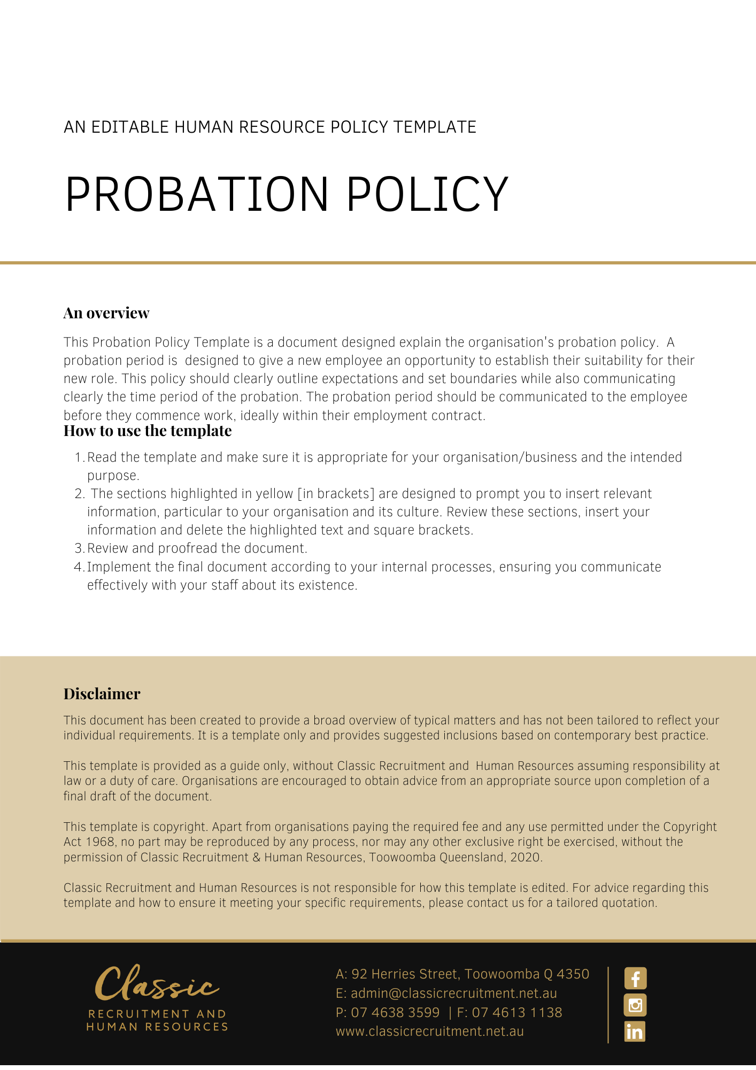

Probation Policy

Overview
[Company Name] requires all new employees to complete a period of Probation when they commence their employment (the ‘Probation period’). The purpose of this Probation Policy (‘Policy’) is to explain [Company Name]’s approach to the Probation period, i.e. to assess the suitability of new employees before ongoing employment is confirmed.

Application
This Policy applies to all new employees of [Company Name], including employees whose employment has transferred to [Company Name] as part of a transfer of business arrangement (a ‘transferring employee’).

This Policy does not form part of any employee’s contract of employment. If a term of this Policy is inconsistent with an employee’s contract of employment or any relevant industrial instrument, the contract or industrial instrument will prevail over this Policy to the extent of any inconsistency.

This Policy does not affect the minimum employment period under the Fair Work Act 2009 (Cth).

Probation Period
New employees of [Company Name] will be employed for a Probation period of 6 months [Delete after reading: Amend this if it is incorrect]. The purpose of the Probation period is for [Company Name] to provide advice and guidance for new employees to assist them to become familiar and competent in performing the work they have been appointed to do.

[Company Name] will assess an employee’s performance and conduct throughout the Probation period and provide feedback about their suitability for their new role. The continuing employment of the employee is dependent upon their successful completion of the Probation period.

New employees acknowledge and understand that their employment may be terminated if the employee’s performance and/or conduct does not meet the standard required for the job, [Company Name] may elect to terminate the employee’s employment with the requisite period of notice or upon payment in lieu of notice.

Variations
[Company Name] reserves the right to vary, replace or terminate this Policy from time to time.

Policy and further information
To the extent that the contents of this Policy refers to obligations on [Company Name], they are guidelines for management or summaries of applicable legislative requirements only and are not contractual terms, conditions or representations on which a staff member may rely. Management is available to assist with any queries you have relating to the Policy which is detailed above.

Document Control
This Policy will be reviewed on a regular basis and approved by the [Insert Position (e.g. CEO/Director/Owner)].

Implementation date | Author | Approved by | Date of next review
[Date] | [Name] | [Position] | [Month, Year]

