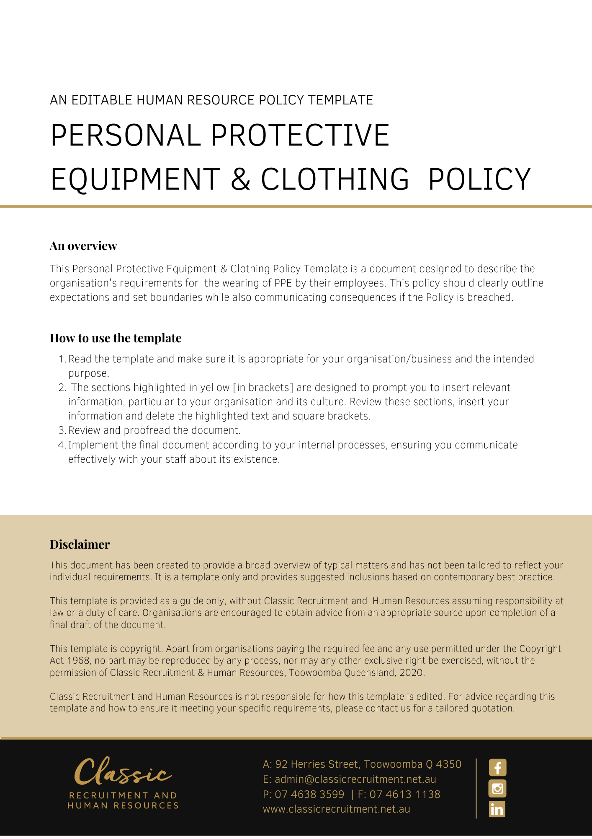

Personal Protective & Clothing Policy

Overview
[Company Name] is committed to providing and maintaining Personal Protective Equipment (PPE) to protect the health and safety of all employees so far as is reasonably practicable. The need for PPE will be determined through the risk management process.

Appropriate PPE will be provided to control the risk for workers. Instruction and training for the correct use, maintenance and storage will also be provided.

Application
This Policy applies to employees, agents and contractors (including temporary contractors) of [Company Name], collectively referred to in this Policy as ‘workers’ and other persons to the extent that they will be required to attend at the workplace in circumstances ordinarily requiring the wearing of PPE.

This Policy does not form part of any employee's contract of employment. Nor does it form any part of any other worker’s contract for service.

Aims of the Policy
[Company Name] aims to ensure:

    - PPE is issued to workplace participants in accordance with the requirements of their job.
    - PPE is appropriate for the person and controls the risk for that person.
    - instruction, training, and information is provided to workers required to wear PPE in its fit, use and maintenance.
    - PPE purchased is in compliance with all appropriate Australian Standards (where applicable).
    - areas of known hazard that require PPE use, are appropriately sign posted to warn all personnel; and
    - PPE provided is in a clean and hygienic condition.

Managers’/Supervisors’ Responsibilities
Complete the PPE Checklist to determine whether PPE is required to be worn and what type. Specific jobs may require more personal protective equipment or clothing. For example:

    - hand, face, and eye protection (when welding, angle grinding etc).
    - respirators for workers who may be exposed to atmospheric contaminants (e.g. hazardous fumes, gases, or dust).
    - fall arrest systems and devices when working at heights (e.g. harnesses).
    - hearing protection in noisy areas (e.g. earmuffs or plugs).
    - protective clothing in hot and cold environments; and/or
    - broad brim hat, sunscreen, and eye protection for outside workers.

Ensure PPE is worn by workers during all job tasks which require such protection.

Ensure PPE chosen meets the relevant Australian Standard (where applicable) and has been certified accordingly.

Provide appropriate instruction and training to workers required to use PPE.

Record the PPE provided in the PPE register.

Where other forms of hazard control cannot be applied, PPE will be supplied and worn as appropriate by workers exposed to the relevant hazard(s). As such equipment is personal, all dealings with PPE will take into account each individual likely to require such protection where reasonably practicable. This will include, but not limited to considering such issues as body size (e.g. where protective clothing is needed); sight imperfections (e.g. when considering safety-glasses); and facial hair (e.g. when considering the correct seal around a breathing apparatus).

Workplace Participant’s Responsibilities
    - Wear PPE provided as part of their cooperation with legal requirements for health and safety at work.
    - Participate in training provided.
    - Report any damaged PPE to the Manager or Supervisor of the relevant department.
    - Do not use the PPE unless you have had appropriate training and instruction in its use.
    - Observe any signage for the area that you are working in to see if there is any particular PPE that is required for known hazards.
    - Ensure the PPE is worn at all times when performing the work task.
    - All PPE is to be returned in a clean condition and stored in the appropriate facility.
    - Request PPE where you believe it is required for the job and has not been provided.
    - Take good care of PPE and any special clothing used as part of the job.
    - Follow manufacturer’s instructions for care and maintenance of PPE.

Policy and further information

[Company Name] reserves the right to vary, replace or terminate this Policy from time to time.

Policy and further information
To the extent that the contents of this Policy refers to obligations on [Company Name], they are guidelines for management or summaries of applicable legislative requirements only and are not contractual terms, conditions or representations on which a staff member may rely. Management is available to assist with any queries you have relating to the policy which is detailed above.

Document Control
This Policy will be reviewed on a regular basis and approved by the [Insert Position (e.g. CEO/Director/Owner)].

Implementation date | Author | Approved by | Date of next review
[Date] | [Name] | [Position] | [Month, Year]

