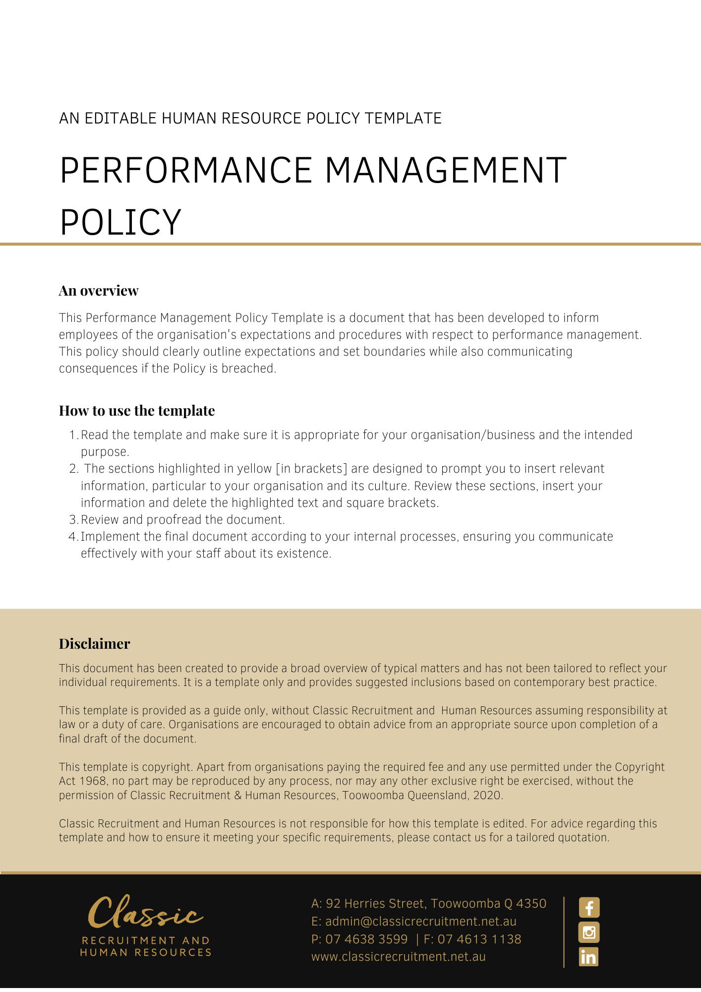

Performance Management Policy

Overview
[Company Name] has implemented a Performance Management Policy. The policy takes effect immediately and has been developed to inform employees of our expectations while employed by [Company Name].

The aim of this policy is to confirm our commitment to positively managing the performance of employees by providing information about the aims, policies, expected outcomes and procedural steps. It explains our objectives and the responsibilities of both management and employees.

Performance management is the process of achieving high levels of organisational performance through the effective management of both individuals and teams. Effective performance management includes ensuring the communication of expectations of both employees and managers by setting and agreeing on targets and to measure and review performance.

Application
This policy applies to all employees of [Company Name] regardless of whether they are permanent full-time, permanent part-time or casual employees. This policy applies to all employees while they are in our workplace under the management and control of [Company Name] and/ or using [Company Name] vehicles, machinery, plant or substances and/or performing work in the conduct of [Company Name] (including at a client site away from their usual workplace).

Performance Management Framework
[Company Name] believes that performance management and review is an important component of supporting employees in their work, ensuring accountability for work performed and identifying the professional development needs of employee.

[Company Name] is committed to ensuring that all employees:

- have a clear understanding of the work they are required to complete
- are clear about the organisation’s expectations and requirements of their work performance
- are provided with adequate direction and support in their work
- perform their role to the best of their abilities, and
- are accountable for the quality and outcomes of their work.

Guidelines
To meet these aims, all [Company Name] employees, regardless of seniority, will take part in regular supervision and in an annual formal structured review process.

The purpose of the regular supervision process is to provide accountability and direction for work completed within a period and:

- ensure that each employee member is completing agreed tasks, activities and or responsibilities to the required quality and timeliness standards;
- identify any impediments to the satisfactory completion of tasks;
- identify any assistance, resources or professional development required; and
- reach agreements about work goals and performance for the coming period

Performance review
The purpose of the employee performance review process is to provide a formal assessment of work performance over a longer period and:

- develop agreed realistic expectations in relation to the employee’s position description and work plan, against which assessment of performance can be made
- provide a formal means by which achievements can be assessed and recognised
- discuss and document how the employee is performing from their point of view and from their [Insert Position (e.g. CEO/Director/Owner)] point of view
- seek a common ground for ways to improve employee performance where needed
- identify strengths in skills and knowledge and consider if these can be better utilised
- identify any weaknesses or problems in performance from the point of view of the employee and their supervisor
- identify training needs and discuss other forms of support or on-the-job development required; and
- reach agreement on any specific goals to be pursued in the period following the assessment.

Procedure
Employees will meet with their manager for a formal supervision session. The employee may request informal consultation or direction from [Insert Position (e.g. CEO/Director/Owner)] at other times, and their [Insert Position (e.g. CEO/Director/Owner)] will attempt to meet these requests within a mutually agreed time frame.

Formal supervision sessions will be held in a meeting room that provides privacy.

Supervision sessions will be structured so as to enable the employee member and manager to:

- identify and agree on KPIs/work plans or tasks;
- discuss any issues of concern or impediments experienced in performing duties;
- discuss strategies or actions for achieving desired outcomes;
- set priorities for the coming period; and
- identify any professional development or training needs.

The performance review is to be conducted by the employees’ immediate Supervisor. It is their responsibility to schedule the review at a mutually convenient time.

The first performance review will occur three months after appointment, then annually thereafter. More frequent reviews e.g. quarterly or 6-month, may be held as agreed between the employee, [Insert Position (e.g. CEO/Director/Owner)] and Human Resource Department.

Performance Review process:

- The employee completes a self-appraisal
- The completed self-appraisal is made available to the reviewer ([Insert Position (e.g. CEO/Director/Owner)]) at least 3 days prior to the review meeting
- Managers prepare their own assessment comments for the review meeting
- The employee, and [Insert Position (e.g. CEO/Director/Owner)] meet to discuss findings, performance, future goals, and development needs. The discussion includes opportunities for both parties to clarify and explain their comments
- The outcome is documented and agreed actions included into relevant work plans

Review discussion
The [Insert Position (e.g. CEO/Director/Owner)] will address the following in discussion with the employee:

1. Review work goals:
- Review the statement of duties and any other documentation about the role, ensuring that the position description reflects the current duties of the role
- Review work goals established at the last review
2. Review performance
- Review progress against documented work goals
- Review assessment information provided by employee, reviewer, and any others, identifying areas of strength and achievement and areas for improvement
- Review impediments to work performance and factors impacting on the person’s job performance and satisfaction
3. Identify action
- Identify any training and development needs, focussing on areas that could be improved or where outstanding performance could enable the employee to play a mentoring and support role with other employee
- Identify any resourcing or support required.
- Identify any other action.
4. Agree goals for next twelve months (a shorter timeframe can be arranged if necessary).
- Review the organisation’s strategic plans and the team’s objectives or service plan.
- Establish work goals which are closely related to the job role and the outcomes required in the objectives.
- Agree how the goals will be measured and reported.
- Identify any training and development needs necessary for the employee person to achieve the goals.
- Where performance is satisfactory or above satisfactory, identify any incentives, rewards, or recognition appropriate to acknowledge the achievement of goals.

Documentation
A record of the main discussion points and agreed actions is written at the meeting or immediately afterwards by the [Insert Position (e.g. CEO/Director/Owner)]. The record of discussion is reviewed by [Insert Position (e.g. CEO/Director/Owner)] and employee, corrections or changes made, and a final version signed by both parties.

Documentation of the review should be completed within 2 weeks of the review meeting. The record is kept on a confidential personnel file. The record is used as reference for the implementation of the agreed actions and for consideration of progress at the next review.

Managing Performance Issues/Opportunities for Improvement
If, as the result of a performance review, performance issues are identified, the [Insert Position (e.g. CEO/Director/Owner)] and HR representative will implement the following steps:

- Formal counselling - a meeting will be scheduled, and the employee informed of the need for performance improvement. The manager will:

  - Ensure the employee understands the objectives and serious nature of the counselling
  - Give the employee the opportunity to have a support person present if they wish to have one
  - Identify and agree on reasons for non-achievement of goals
  - Clarify for the employee member why their performance is unsatisfactory and the possible ramifications
  - Discuss a plan of action to address the issues, this is referred to as a Performance Improvement Plan (PIP)
  - Provide the employee with an opportunity to explain what might be impacting upon their performance, discuss any training requirements and collaboratively agree on a plan going forward
  - Set a timeframe by which the performance issues will be addressed. Typically, 6-8 weeks is recommended
  - Identify any further training and development needs necessary for the employee to achieve the goals.
If the performance issues have not been addressed within the agree time frame, the [Insert Position (e.g. CEO/Director/Owner)] will schedule another review meeting at which the issues will be reviewed, and a revised timeline agreed for the performance issues to be addressed.

If the employee’s performance does not improve then the [Insert Position (e.g. CEO/Director/Owner)] will schedule a further meeting. The purpose of this meeting is to clarify for the employee that they are required to address the issues immediately and advise them of the options if they do not achieve the agreed goals. The [Insert Position (e.g. CEO/Director/Owner)] will attend this meeting.

Other options such as the extension of probation may be considered if the required improvement in performance is not achieved.

Finally, termination of the employment contract may be the final step.

Before commencing any dismissal processes, the [Insert Position (e.g. CEO/Director/Owner)] will review all documentation to ensure that the processes have been fair and objective and that the employee has been given both the opportunity and the support to improve their performance.

What do I need to do?
You need to read through the Performance Management Policy to make yourself familiar with the contents of the policy and procedures. You are expected to comply with this policy as amended and implemented from time to time.

What happens if I do not comply with the Performance Management Policy?
The consequences of a breach of this policy will vary depending on the type and seriousness of the breach and will be at the discretion of [Company Name].

Depending on the circumstances, [Company Name] may take disciplinary action up to and including termination of employment.

Policy and further information
To the extent that the contents of this Policy refers to obligations on [Company Name], they are guidelines for management or summaries of applicable legislative requirements only and are not contractual terms, conditions or representations on which a staff member may rely. Management is available to assist with any queries you have relating to the Policy which is detailed above.

Document Control
This Policy will be reviewed on a regular basis and approved by the [Insert Position (e.g. CEO/Director/Owner)].

Implementation date | Author | Approved by | Date of next review
[Date] | [Name] | [Position] | [Month, Year]

