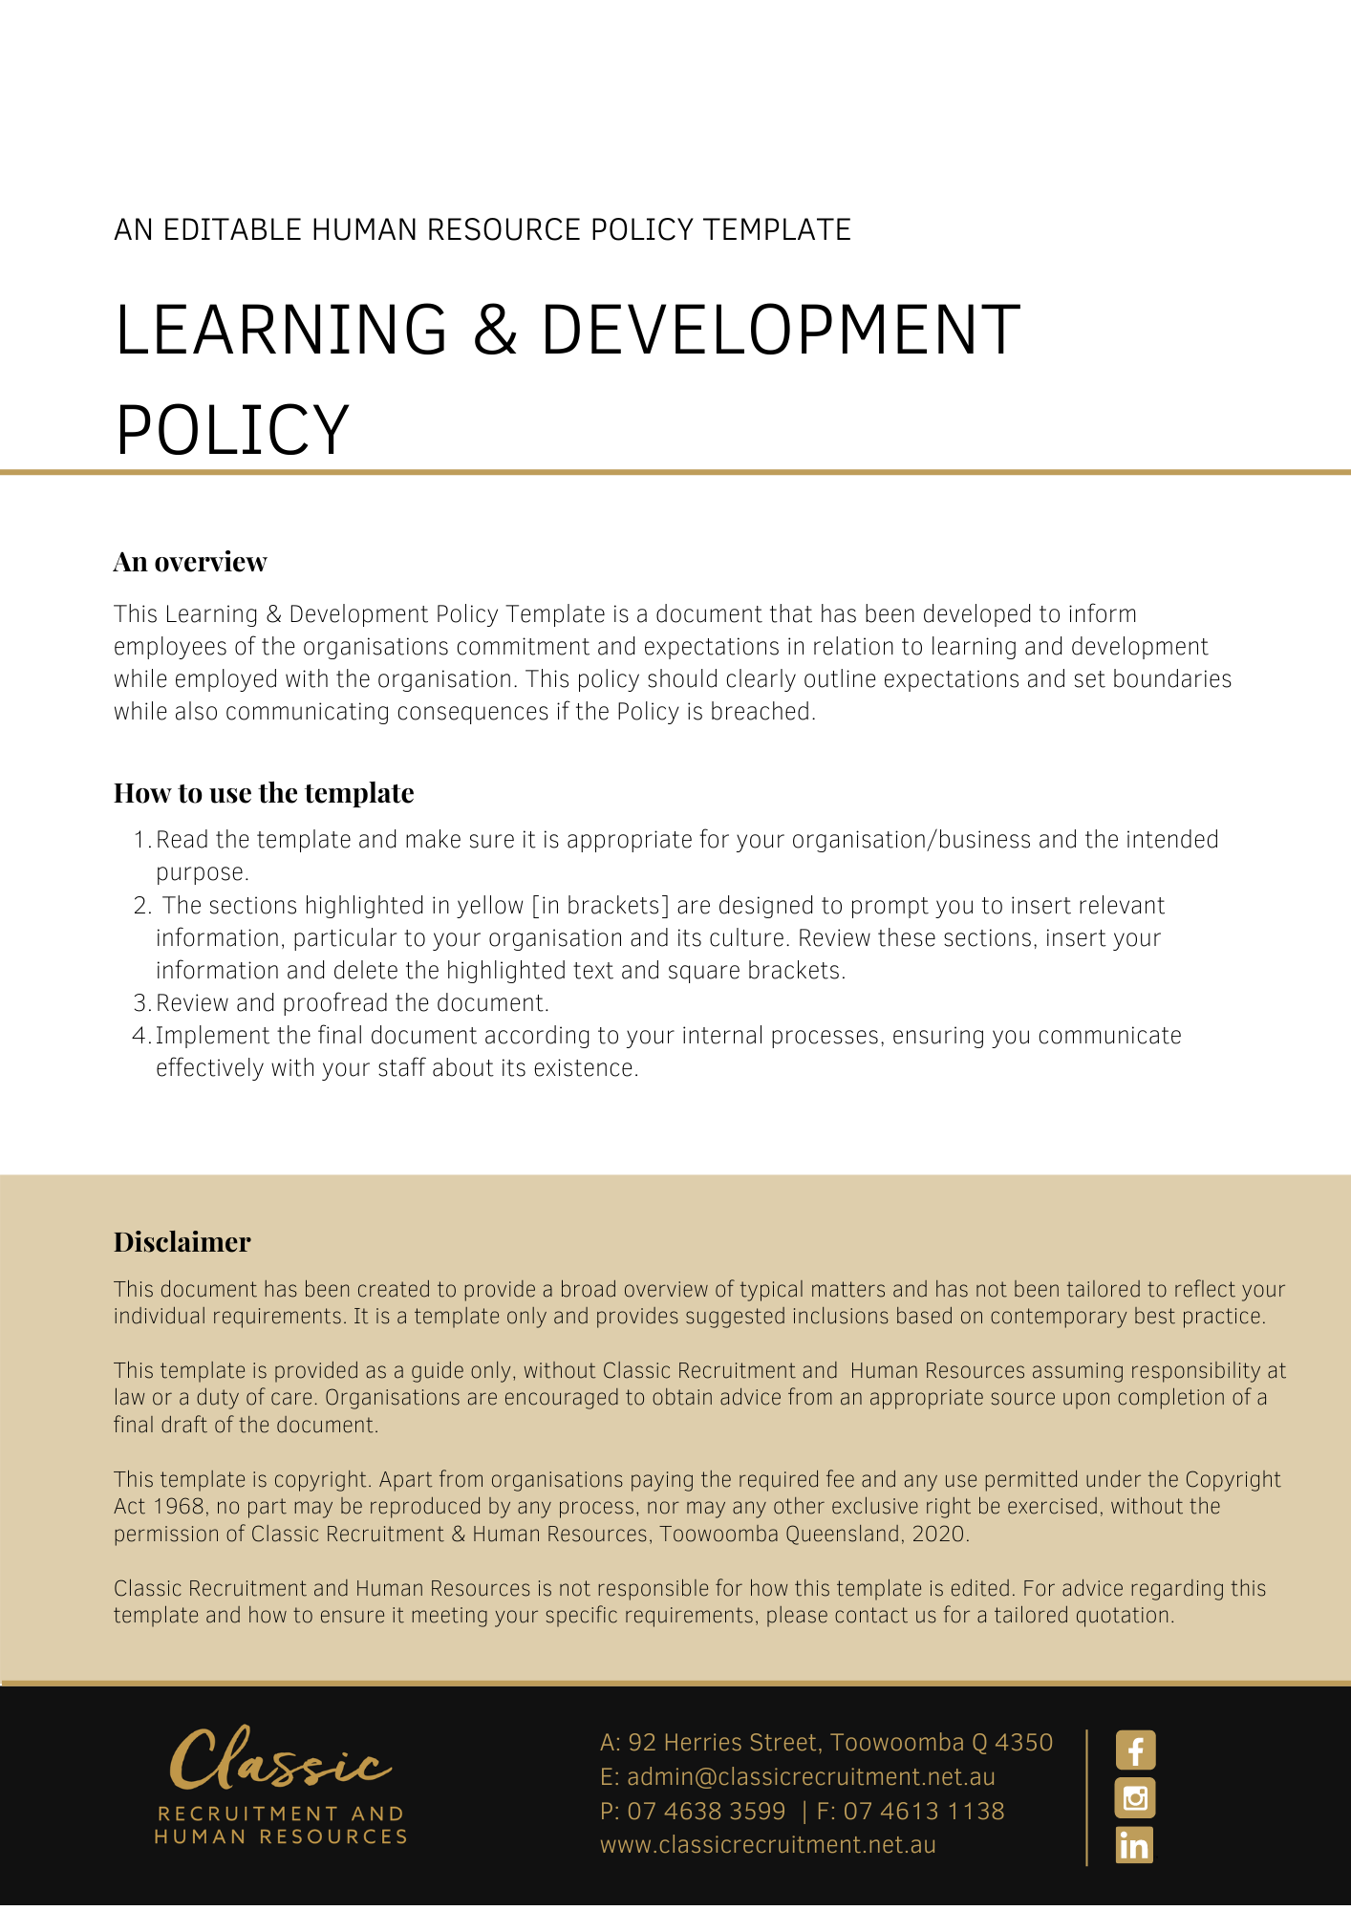

Learning & Development Policy

Overview
[Company Name] has implemented a Learning & Development Policy. The policy takes effect immediately and has been developed to inform employees of our commitment and expectations in relation to learning and development while employed by [Company Name].

The aim of this policy is to confirm our commitment to Learning & Development in that we believe learning is a lifelong event. We are committed to offering all employees, regardless of seniority, opportunities to improve their knowledge base and through this, to continually improve the services we deliver to our clients.

We can always learn better ways to do our current jobs or future roles. Learning & development covers both development and training. Training focuses on skills and knowledge directly connected to a role or occupation, whereas development refers to learning or the acquisition of skills that may or may not be related specifically to your current duties. This policy explains our objectives in relation to both learning and development and the responsibilities of both management and employees.

Application
This policy applies to all employees of [Company Name] regardless of whether they are permanent full-time, permanent part-time or casual employees. This policy applies to all employees while they are in our workplace under the management and control of [Company Name] and/ or using [Company Name] vehicles, machinery, plant or substances and/or performing work in the conduct of [Company Name] (including at a client site away from their usual workplace).

Procedure
A commitment to the professional development of our staff has been an initiative of [Company Name] for many years. We recognise that the continued and increased success of our business is dependent upon the skill and competence of all employees at all levels and in all positions. To these ends, we make available human and financial resources for the provision of effective programs of education and training, such as:

- Employees are required to attend regular training sessions and/or workshops on different topics during their employment
- Training in relation to day to day duties, will be carried out on the job under supervision
- Specific training/education courses will also be conducted as required: e.g. if changes of legislation occur; and
- Training programs will generally be conducted within working hours and it is compulsory for employees to attend as requested
- If training has to be conducted out of hours, employees will be entitled to take time spent off in lieu on a time for time basis

Here at [Company Name] we expect:

- Employee attendance at team meetings as arranged and notified
- Some professional development and competency programs may be held outside working hours
- Employees to meet their training obligations as per the Continuing Professional Development Standard. All Financial Advisers are required to participate in development programs and activities that ensure they maintain and extend their professional capabilities, knowledge and skills including keeping up to date with all regulatory, technical, and other developments relevant to professional financial advice.

- Financial advisers are required to complete 40 hours of CPD each year of which 70% must be approved by their licensee (including a maximum 4 hours of professional reading). The minimum hours for CPD across the mandatory categories are:
  - Technical – 5 hours
  - Client Care and Practice – 5 hours
  - Regulatory Compliance and Consumer Protection – 5 hours and
  - Professionalism and Ethics – 9 hours
  - The balance up to 40 hours must consist of qualifying CPD.

[Company Name] pays for the cost of all training for employees as we acknowledge these activities are an investment for the mutual benefit of both our employees and [Company Name].

Management Responsibilities:
It is the responsibility of [Company Name] to:

- Monitor staff members’ performance to identify areas where training may be required
- Discuss with individual staff members their training and development opportunities
- Discuss training requirements with the appropriate Manager; and
- Provide on-the-job training opportunities.
- After a staff member has completed a training program, their Manager will discuss the results of the program, whether they gained the expected benefit and what opportunities for improvement could potentially be implemented
- After a staff member has completed a training program, their Manager will discuss whether there is an opportunity for the learnings to be passed on to other staff members

Employee Responsibilities
Employees are responsible for:

- Applying for training by submitting an email to their Supervisor which provides details of training course, dates, and costs, and obtaining approval prior to making any commitment to attend the training
- Complete any pre or post course work as required
- Ensuring they attend the training programs
- Fully participate in the training session activities
- Give feedback on the training programs to their Manager, and
- Endeavour to implement new skills and knowledge back on the job.

What do I need to do?
You need to read through the Learning & Development Policy to make yourself familiar with the contents of the policy and procedures. You are expected to comply with this policy as amended and implemented from time to time.

What happens if I do not comply with the Learning & Development Policy?
The consequences of a breach of this policy will vary depending on the type and seriousness of the breach and will be at the discretion of [Company Name].

Depending on the circumstances, [Company Name] may take disciplinary action up to and including termination of employment.

Policy and further information
To the extent that the contents of this Policy refers to obligations on [Company Name], they are guidelines for management or summaries of applicable legislative requirements only and are not contractual terms, conditions, or representations on which a staff member may rely. Management is available to assist with any queries you have relating to the Policy which is detailed above.

Management is available to assist with any queries you have relating to the policy which is detailed above.

Document Control
This Policy will be reviewed on a regular basis and approved by the [Insert Position (e.g. CEO/Director/Owner)].

Implementation date | Author | Approved by | Date of next review
[Date] | [Name] | [Position] | [Month, Year]

