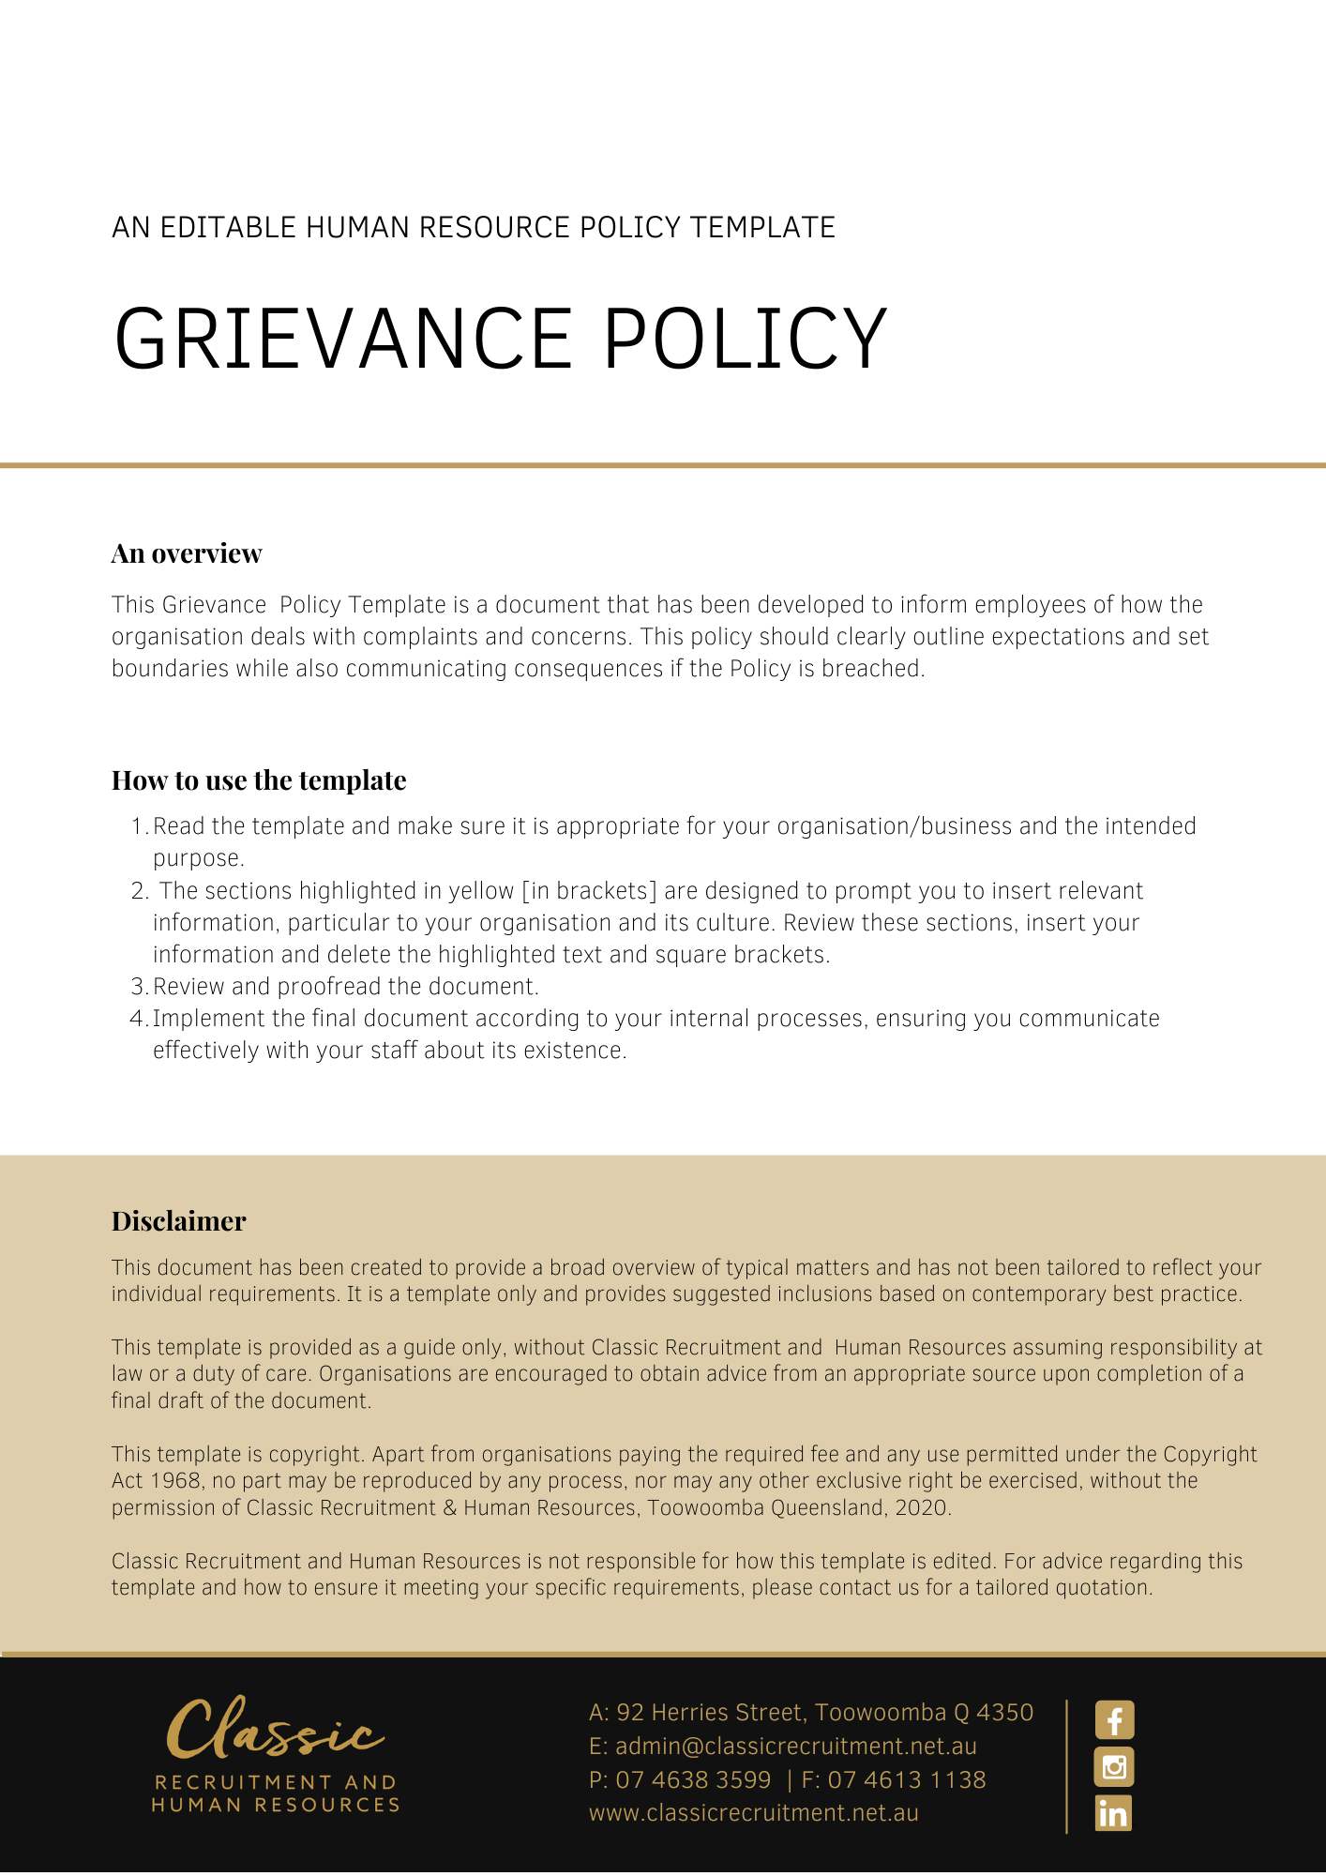

Grievance Policy

Overview
[Company Name] has implemented a Grievance Policy. The policy takes effect immediately. This policy has been developed to inform employees of how we deal with complaints and concerns. Here at [Company Name] we aim to foster good relations amongst employees and between employees and management. We acknowledge that the enjoyment you experience in your role is reflected in how well you work and how well you relate to your colleagues and customers.

We also acknowledge that sometimes problems can arise at work that may cause employees to feel aggrieved. These problems can sometimes arise from the behaviour or decisions of management or other employees. The purpose of this policy is to provide a structure for employees to have such problems, referred to as grievances, addressed internally in a timely and confidential manner.

[Company Name] sets guidelines and policies in the workplace as follows. We believe it is important to clearly communicate our expectations of all employees. It is every employee’s responsibility to act in accordance with this policy.

Application
This policy applies to all employees of [Company Name] regardless of whether they are permanent full-time, permanent part-time or casual employees. The Policy applies to all employees while at any [Company Name] workplace and any other place where the employee performs work for the business.

This policy outlines the procedures you should follow to try to resolve a grievance and also outlines the steps the [Company Name] will take to resolve your grievance if you make a formal complaint.

In so far as this policy imposes any obligations on the [Company Name], those obligations are not contractual and do not give rise to any contractual rights. To the extent that this policy describes benefits and entitlements for employees, they are discretionary in nature and are also not intended to be contractual. The terms and conditions of employment that are intended to be contractual are set out in an employee’s written employment contract.

The [Company Name] may unilaterally introduce, vary, remove, or replace this policy at any time.

Procedure
This policy governs the process for fair complaints handling to ensure that complaints are recorded, acknowledged, and dealt with fairly, efficiently, and effectively.

This Policy has been developed to ensure that [Company Name]:

- provides a robust framework for managing and resolving Discrimination, Bullying and Harassment concerns and complaints, and
- provides appropriate mechanisms for employees to raise a Grievance or Complaint on other employment related matters, in order to foster a safe and inclusive work environment where individuals feel safe and supported and are able to work effectively, without fear of Discrimination, Harassment, Bullying, Vilification, Victimisation and/or reprisal.

This policy relates to responding to complaints about a situation, a process, a person or people, a service provided by or on behalf of the organisation by a third party.

The organisation will attempt in all instances to identify potential causes of complaints and appeals and take appropriate action to eliminate or mitigate the likelihood of reoccurrence.

- All internal complaints and grievances will be dealt with by the designated Manager
- The Manager receiving the complaint owns the complaint. It is their responsibility to deal with the complaint or ensure it is dealt with in the appropriate manner
- All complaints received from clients by telephone or face-to-face will be given full consideration and understanding. A documented account of the complaint will be made
- All complaints will be thoroughly investigated, checked, and reviewed
- Sexual harassment or bullying complaints regarding fellow staff members or a Manager related to must be reported to the [Insert Position (e.g. CEO/Director/Owner)] immediately
- It is our policy that employees with concerns should attempt to put the issue in writing, however verbal complaints may be made where the employee feels unsure of what to do. Verbal complaints will be documented in writing by the designated Manager to whom they are reported to
- It is acknowledged that an employee may prefer to remain anonymous when making a complaint. The likely reasons for this are acknowledged. It is important however we appreciate that it is far easier to deal with a complaint when all the facts are known, and that the person whom the complaint is being made about has the opportunity to defend their actions
- All employees involved will be consulted to ensure the validity of the complaint and the necessary checks will be undertaken and recorded
- Consideration will be given to the complainant’s identity and, if possible, this will be kept confidential. The appropriate resolution will be considered, and the best solution will be adopted. Team members should feel comfortable that there will not be any repercussions or adverse outcomes because they lodge a complaint
- All employees making the complaint (if more than one) will be advised of the outcome
- Assurances that the matter has reached a satisfactory resolution will be undertaken

What are your options if you have a grievance?
In general, there are three options to consider if you have a grievance, being:

- Deal with the matter informally. A grievance can be dealt with informally by approaching the person involved in your grievance if you feel comfortable in doing so. You can tell them that their behaviour, decision, actions, etc. was unfair, offensive, discriminatory etc., and why you believe this to be so. The person may have been totally unaware of the effect of their behaviour or decision on you. By telling them you will give them a chance to redress the situation. It is acknowledged though that this may not be appropriate in some cases, particularly if you do not feel comfortable with speaking to the person.

- Speak to your [Insert Position (e.g. CEO/Director/Owner)]. If you do not want to speak to the person directly, you can tell your [Insert Position (e.g. CEO/Director/Owner)] about your grievance. They should be able to advise you what your options are. They may approach the person complained about and talk to them informally about your grievance. They may decide to take more formal action. Generally, they will seek your approval before doing anything – although sometimes they may decide that taking action will be necessary even if you do not wish them to do so (for example where failure to do so poses a health and safety risk). If your grievance is about your manager, you may wish to speak to another senior person. Alternatively, you may decide to make a formal complaint.

- Make a formal complaint. If you do decide to make a formal complaint, this can be done by putting the complaint in writing and reporting it to your [Insert Position (e.g. CEO/Director/Owner)]. The written complaint should contain a description of the incident(s), decision, behaviour in question, the time and date of the incident(s), the names of any witnesses, your signature and date of the complaint.

How will your grievance be dealt with?
Grievances will be handled as per the following guidelines:

- grievances will be treated with the utmost confidentiality (except where [Company Name] deems it is necessary to disclose the complaint for the purpose of dealing with it effectively; disclosure will be no wider than is strictly necessary). It is important that you also maintain confidentiality and do not discuss your complaint with others, unless [Insert Position (e.g. CEO/Director/Owner)] gives you permission to do so
- any grievance will be taken seriously, handled impartially and any steps taken will be in accordance with the principles of procedural fairness
- employees who raise grievances are protected from victimisation
- grievances will be dealt with promptly, taking into account all of the circumstances; and
- generally, you may have a support person with you at any stage of the process.

Employer responsibilities
Insert Company Name is responsible for:

- Providing timely responses and ensuring actions are proactively taken to investigate and resolve grievances raised by employees
- Implementing appropriate actions and outcomes pending findings of workplace grievance investigations
- Ensuring actions are taken in a procedurally fair manner
- Where possible, ensuring that investigations and findings are dealt with sensitively and as confidentially as possible.

Employee responsibilities
Employees are responsible for their conduct and participation throughout the grievance process and are expected to:
- Ensure that all aspects of the grievance are kept confidential and that any knowledge gained through participation in the grievance and dispute settlement procedure is only discussed with management as part of the investigation process
- Act ethically and honestly if interviewed as part of a workplace investigation
- Provide as much information as possible when making a grievance, for example, dates and times of events, details of who was involved, where it occurred and what happened.
- Implement management decisions as directed
- Not make vexatious or misleading grievance complaints. Grievances that are found to be vexatious or misleading may result in disciplinary action up to and including termination of employment; and
- Not make vexatious or misleading interview statements, including colluding with other parties to distort events or circumstances. Employees that are found to be vexatious, misleading or who collude may have disciplinary action taken against them up to and including termination of their employment.

Investigation Procedure
Where a grievance cannot be resolved informally and [Company Name] deems an investigation is required, the matter will be investigated by such appropriate person as [Company Name] deems appropriate. This may be an external investigator.

How the investigation is to be conducted is at the complete discretion of the Company. The following
are general guidelines only.

During the investigation, you will generally be interviewed first, following which any witnesses, the person against whom the complaint is made, and any other relevant people will be independently interviewed. Both you and the person against whom the complaint is made will generally be allowed to have a support person present when the interview is being conducted.

- If the complaint is substantiated, appropriate action will be taken (see below)
- If the complaint is unsubstantiated, you will generally be given an explanation as to why that finding was made.
- If the complaint is found to have been fabricated or vexatious, appropriate disciplinary action may be taken against you up to and including termination of employment.

If the investigation reveals that your complaint is valid, a number of actions may be taken, depending on the nature of the complaint. The person against whom the complaint is made may be asked to give you a written apology, he/she may be given a written warning, counselling, transfer, demotion, or may be subjected to disciplinary action up to and including termination of employment.

If the investigation is inconclusive, i.e. the complaint cannot be proved due to lack of evidence or the conduct is not sufficiently serious to justify disciplinary action, the Company may nevertheless take a number of actions. These may include training and/or monitoring of relevant staff.

If the complaint is found to have been fabricated or raised vexatiously, appropriate action may be taken against you including counselling, a formal warning, transfer, demotion, or disciplinary action up to and including termination of employment, depending on the seriousness of the circumstances.

If you are not satisfied with the way in which your grievance was handled, you are encouraged to speak to your Human Resources team, your [Insert Position (e.g. CEO/Director/Owner)] or a senior member of the [Insert Position (e.g. CEO/Director/Owner)].

You may also wish to consider making a claim in the Fair Work Commission or the court. In appropriate circumstances you may wish to seek advice from a union or lawyer.

What do I need to do?
You need to review the Grievance Policy and make yourself familiar with the contents of the policy. In the event that you have any questions, make sure you address these to either the [Insert Position (e.g. CEO/Director/Owner)].

What happens if I do not comply with the Grievance Policy?
The consequences of a breach of this policy will vary depending on the type and seriousness of the breach and will be at the discretion of [Company Name]. Depending on the circumstances, [Company Name] may take disciplinary action up to and including termination of employment.

The recommendations described in this policy are not intended to be exhaustive, nor do they anticipate every possible use of Grievance. Employees should contact either the [Insert Position (e.g. CEO/Director/Owner)] with any queries relating to appropriate Grievance use in the first instance.

Policy and further information
To the extent that the contents of the Grievance Policy refers to obligations on [Company Name], they are guidelines for management or summaries of applicable legislative requirements only and are not contractual terms, conditions or representations on which a staff member may rely. Management is available to assist with any queries you have relating to the policy which is detailed above.

Employees are encouraged to read this policy in conjunction with other relevant Company policies such as:

- Bullying & Harassment Policy

- Code of Conduct

- Workplace Health & Safety Policy

Document Control
This Policy will be reviewed on a regular basis and approved by the [Insert Position (e.g. CEO/Director/Owner)].

Implementation date | Author | Approved by | Date of next review
[Date] | [Name] | [Position] | [Month, Year]

