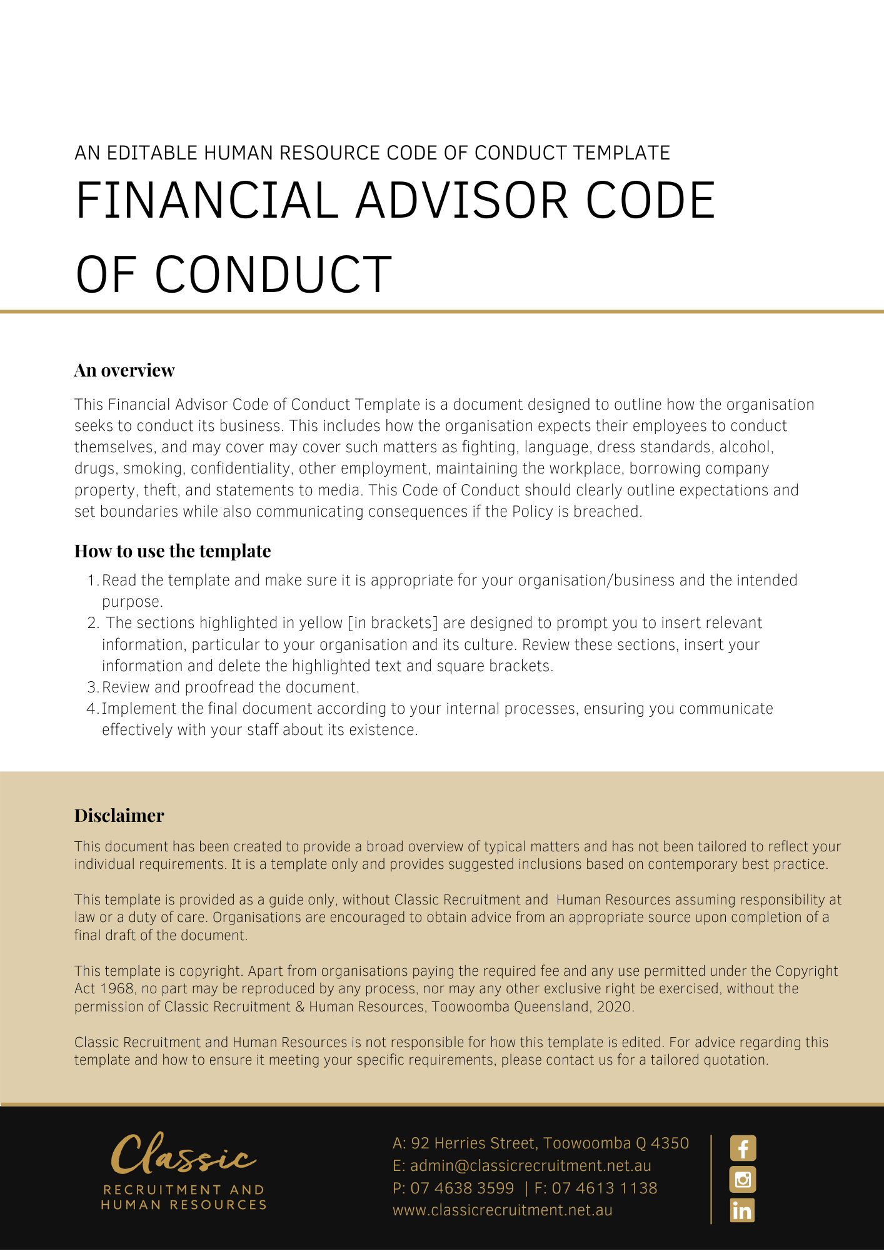
Code of Conduct

This Code of Conduct (the Code) outlines how [Company Name] seeks to conduct its business and how it expects our people, our employees to conduct themselves. In an increasingly complex world, the Code clearly outlines the high standard of conduct we expect of everyone who represents [Company Name], from our [Insert Position (e.g. CEO/Director/Owner)] to our employees, to our contractors, at all times.

The Code outlines [Company Name]’s expectations in relation to minimum standards of behaviour and decision making, including how we treat each other, and our customers, business partners and shareholders. In following this Code, we create an organisation that prioritises making a difference to the lives of our customers and clients. The Code helps to support a workplace that is flexible, supportive, safe, fosters personal and professional development and is dedicated to building meaningful careers by bringing out the best in our people.
Importantly, the Code sets a high benchmark and reflects our aim to deliver the best possible outcomes for our customers, investors, colleagues, and the community. We know that when we are guided by these principles, we make [Company Name] a great place to work, fulfil our purpose of helping guide our client’s stock investment decisions and assist with their financial queries about retirement, superannuation, portfolios, direct shares and ETFs, ensure our legacy will continue for generations to come.

Overview
This Code takes effect immediately applies whenever you represent [Company Name], which includes when you are in the workplace or any time you are, or are perceived to be, representing [Company Name], even if that is outside the workplace or your regular working hours. It includes company functions, conferences, out-of-hours work activities and any social media activity. The Code is a statement of how [Company Name] seeks to conduct its business and how we expect our people to conduct themselves. The Code does not form part of any contract of employment or contract of engagement, nor does it form a legal or contractual term, condition, or representation.

Application
This policy applies to all employees of [Company Name] regardless of whether they are permanent full-time, permanent part-time or casual employees.

Code Principles
The Code of Conduct is based on five principles that define how we seek to conduct ourselves. They are:

- We act professionally with honesty and integrity.
- We respect and value differences and create a safe working environment.
- We identify and manage any conflicts of interest responsibly.
- We respect and maintain privacy and confidentiality.
- We comply with our legal and regulatory obligations, internal standards and policies and deal with breaches promptly and appropriately.

Importantly, we also expect our people to comply with the Code of Ethics issued by the Financial Adviser Standards and Ethics Authority (FASEA) which was established by the Federal government in April 2017 to set the education, training and ethical standards of licensed financial advisers in Australia.

The FASEA Code of Ethics Standard commenced on 1 January 2020 and may be accessed via https://www.fasea.gov.au/code-of-ethics/.

We act professionally with honesty and integrity

Professionalism, honesty, and integrity are core to our business. Everything we do needs to be measured against the highest possible standards. This is more than a legal obligation – it is part of who we are. Our success depends on the trust of customers, which is earned by acting professionally with due care, honesty, and integrity.

Behaving professionally with honesty and integrity means acting and leading respectfully, truthfully, sincerely, and fairly and performing your responsibilities at the highest levels.

You are expected to demonstrate these traits in all you do. You should collaborate freely and strive for the highest standards of service. You must act honestly and be transparent in all your communications with your leaders, colleagues, customers, suppliers, auditors, regulators and other third parties, and comply with the Code and policies.

For example, you must:

- Exercise sound judgment so as not to expose [Company Name] or our customers to undue risk
- When providing advice on products and services to the customer, prioritise their needs by communicating clearly and effectively and make sure that they have the information they need to make an informed decision
- Deal with customers honestly, fairly and in good faith including not making any false, misleading, or deceptive representations to induce a customer to enter or continue with transactions
- Ensure that [Company Name] monies, including corporate credit cards, are used only for proper business purposes, the appropriate approvals for expenses are granted, and proper records of these transactions are maintained
- Only use [Company Name] property, including information technology resources, for proper purposes
- Avoid any behaviour that may be perceived as deceptive, unfair, or unconscionable and ensure your activities (including outside work and on social media), do not negatively affect our brand or reputation
- Exercise caution in the giving and receiving of business-related gifts and entertainment
- Not receive, offer, or give bribes or kickbacks, nor gifts, hospitality, expenses or benefits from/to potential and existing customers, providers and suppliers that may appear to create an obligation, affect impartiality, or inappropriately affect a business decision
- Not conceal or attempt to conceal errors or omissions, or protect colleagues who have breached our legal obligations, the Code, or our policies
- Immediately report to the [Insert Position (e.g. CEO/Director/Owner)] any suspicions of fraud, theft, bribery, money laundering, terrorism financing activities or other dishonest behaviour of customers or colleagues

We respect and value differences and create a safe working environment

[Company Name] encourages a respectful, diverse, and safe workplace which supports the physical and psychological wellbeing of our people. We believe in a workplace that values differences and encourages a flexible and inclusive environment where people feel they can bring their whole self to work.
This is critical to our ability to deliver outstanding results for customers, business partners and shareholders. We do not tolerate bullying, discrimination, harassment, victimisation, unreasonable or unlawful behaviour, or unsafe work practices.

For example, you must:

- Treat all people you deal with through your work with dignity and respect – discrimination, harassment/sexual harassment, bullying or acting unreasonably towards others will not be tolerated
- Take responsibility for your own health and safety and that of your colleagues. This includes identifying and dealing with hazards and safety incidents and ensuring they are resolved appropriately
- Behave appropriately as representatives of [Company Name]. This includes understanding that behaviour which may be acceptable to you, may not be acceptable to others
- Make employment decisions based on merit, and not on attributes irrelevant to employment or work performance
- Never use computers, resources, communication devices or channels or network systems to communicate, view or distribute inappropriate, sexually explicit, or offensive material or to spread derogatory, discriminatory, harassing comments or threatening, abusive language
- Not victimise individual/s who have been involved in, or are proposing to assist with, a complaint about unlawful discrimination, harassment/sexual harassment, bullying or unreasonable behaviour
- Speak up about issues, incidents or concerns that may impact the safety or wellness of our workplace or people

We identify and manage any conflicts of interest responsibly

[Company Name] is committed to effectively managing any conflicts of interest or potential conflict of interest.

We believe focusing on getting the best outcomes for customers also creates the best outcomes for [Company Name].

Acting honestly and with integrity includes identifying and managing conflicts of interest responsibly so that our personal and business interests never interfere with our ability to make sound, objective decisions that are in the best interests of our customers. It also requires avoiding situations that preference, or appear to preference, your personal interests over those of [Company Name] or our customers.

This includes considering whether there are any actual, apparent or potential conflicts in the ongoing management and operation of the business, disclosing these to your leader and managing the conflict appropriately. Conflicts of interest and potential conflicts of interest that are not managed appropriately may put [Company Name]’s reputation and brand at risk. It may also be a breach of our legal obligations, exposing [Company Name] and individuals to regulatory sanctions and penalties.

For example you must:

- Never improperly use your position with [Company Name], or any information you receive through your work at [Company Name] to further your own personal interests or the interests of your friends or family
- Not trade in listed shares or other securities if you have obtained inside information that is not generally available to the marketplace and not pass that inside information to any other person
- Disclose any outside business interest including non- [Company Name] work (paid or unpaid/voluntary), business ventures, directorships, partnerships if these activities may lead to a conflict of interest or a perceived conflict of interest with your work, the interests of [Company Name] or our partners, customers or suppliers
- Disclose any conflicts of personal interest that could have an impact on the independent exercise of your judgment in [Company Name]’s best interest. This includes personal relationships that extend beyond professional relationships in the workplace, for example, spousal, familial or sexual in nature
- Record all conflicts whether real or perceived on the Conflicts of Interest Register on the Intranet
- Avoid making personal representations, including on social media, that could be perceived as the work or opinion of [Company Name] and ensure you act with political neutrality in your job
- Conduct all contract negotiations with suppliers strictly on an arm’s length basis and act in accordance with local and international laws applicable to the transaction or activity

We respect and maintain privacy and confidentiality

In your work at [Company Name] you may have access to private and confidential information relating to [Company Name], colleagues, customers, suppliers or other third parties. Our customers, business partners and shareholders trust [Company Name] with this type of information. To maintain that trust, we uphold the highest security standards for all personal and confidential information. We respect the privacy of our customers, clients, business partners, advisers, suppliers, people, and other business associates and treat all personal information confidentially.

Confidential information must only be used for the purpose for which it is supplied and in accordance with law. Misuse of confidential and private information can have severe regulatory consequences for you and for [Company Name], and serious impacts to the reputation of [Company Name] and our customers’ trust in us.

For example, you must:

- Never confirm if a person is a customer of [Company Name] unless authorised or directed to do so
- Keep information secure and protect the privacy of our customers, clients, business partners, advisers, suppliers, and people and treat all information as confidential
- Never disclose or discuss confidential information (other than in the legitimate course of your duties) unless you have written permission from [Company Name] or if required to do so by law
- Be aware of your obligations under legislation covering the handling of personal information and abide by our privacy obligations and requirements
- Not use our internal systems to access your own personal customer profile or those of your family, friends, colleagues, or public figures
- Follow all protocols and procedures relating to system logons and profiles including those pertaining to passwords. Never give your password or access card to anyone else
- Not misuse or disclose confidential information including for personal benefit or the benefit of others. These obligations continue after you leave the employ of [Company Name]

We comply with legal and regulatory obligations, internal standards and policies and deal with breaches promptly and appropriately

Everyone has a responsibility to understand their obligations and responsibilities at law. Ignorance is no excuse.

Breaches of the law can have serious consequences at an individual and company level, including criminal sanctions, penalties and impacts to our credit and/or financial services licences. Impacts may also extend to our customers. [Company Name]’s internal policies and procedures often exceed standards set by law and govern how we do business. They are in place to protect our customers, those who work for us and the organisation.

At [Company Name] we act promptly to report any errors, work to fix them and learn from our mistakes.

For example, you must:

- Understand and comply with the Code, our policies, your contract of employment and the law and report any conduct that may be in breach of any of these requirements
- Promptly complete all training or education programs assigned to you as these build and maintain awareness and understanding of the obligations and duties under the relevant laws, policies, procedures, and practices
- Complete and close out any breaches and issues by the due date
- Follow reasonable and lawful leader directions issued to you
- Be accountable for your decisions and act within your authorisation level in your operations when making business decisions and when helping our customers
- Immediately report any conduct that may be in breach of [Company Name] policies, the Code and the law to the [Insert Position (e.g. CEO/Director/Owner)] and seek confirmation that the conduct or breach has been or will be investigated
- Take steps to ensure that the concerns you have raised are being addressed. This may involve following up with the person you reported the issue to or escalating further

What do I need to do?
You have a responsibility to raise any issues or actions that seem questionable with your [Insert Position (e.g. CEO/Director/Owner)]. Helpful questions to ask yourself to assist you on whether to speak up:

- What would a [Company Name] customer think of my actions or the actions of others that I have observed?
- What would a [Company Name] customer expect me to do?
- Do the actions and conduct demonstrate professionalism, honesty, and integrity?
- How would my colleagues and the [Insert Position (e.g. CEO/Director/Owner)] think or feel about my actions?
- What impact do the actions have on the image, reputation, brand, and performance of [Company Name]?
- Does this feel like the right thing to do in the circumstances?
- Do the actions demonstrate what is expected at [Company Name]?

What happens if I do not comply with the Code of Conduct?
The consequences of a breach of this policy will vary depending on the type and seriousness of the breach and will be at the discretion of [Company Name].

Depending on the circumstances, [Company Name] may take disciplinary action against you up to and including termination of employment.

Policy and further information
To the extent that the contents of the Code refers to obligations on [Company Name], they are guidelines for management or summaries of applicable legislative requirements only and are not contractual terms, conditions, or representations on which a staff member may rely.

Management is available to assist with any queries you have relating to the Code which is detailed above.

Document Control
This Policy will be reviewed on a regular basis and approved by the [Insert Position (e.g. CEO/Director/Owner)].

Implementation date | Author | Approved by | Date of next review
[Date] | [Name] | [Position] | [Month, Year]

