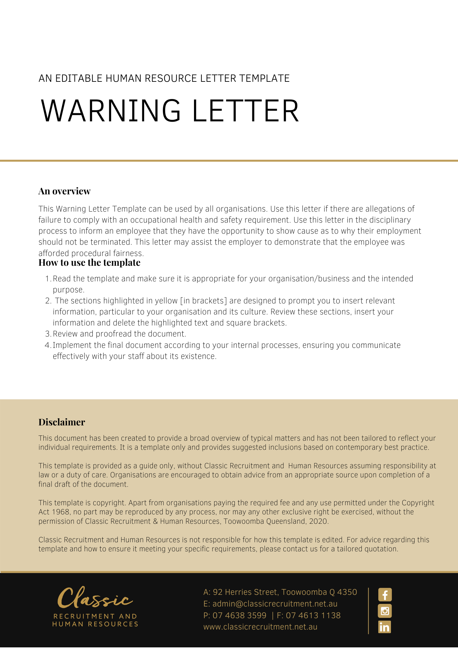
[Date]
[Employee First Name] [Employee Surname]
[Employee Address]

Warning Letter
Dear [Employee First Name],

This is a written warning. This warning relates to your unsatisfactory [Conduct or Performance] on [Date Review].
The following matters relating to your [Conduct or Performance] were raised with you during a meeting on [Meeting Date]:
- [Conduct or Performance Specific Examples]

You were given an opportunity to give your account of the situation. Your response was as follows:
- [Conduct or Performance Response]

Following review of the matters raised and your responses to them, the [Company Name] finds that your [Conduct or Performance] is unsatisfactory. If there is any other unsatisfactory [Conduct or Performance], you may be subject to further disciplinary action up to and including the termination of your employment.
As part of the review process, you have agreed that you need to take the following actions to rectify your [Conduct or Performance] in order to avoid further disciplinary measures by the [Company Name]:
- [Conduct or Performance Actions to Improve]

Your compliance with the agreed actions and your workplace [Conduct or Performance] will be reviewed on [Date Next Review]. A copy of this warning letter will be kept in your personnel file.
Please contact [Insert Position (e.g. CEO/Director/Owner)] if you need to discuss the contents of this warning letter.

[Salutations for goodbye],
[Company Name]
[Letter Signatory Name]
[Letter Signatory Position]

