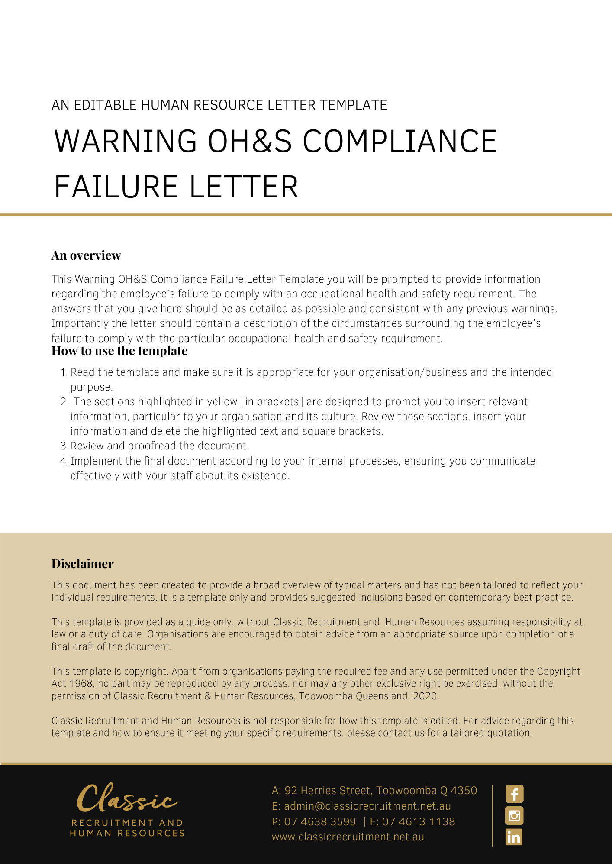
[Date]
[Employee First Name] [Employee Surname]
[Employee Address]

Warning Letter Re: Your Failure to Comply With OHS/WHS Requirements
Dear [Employee First Name],

This written warning arises from your failure to comply with an occupational/workplace health and safety requirement on [Date Review].
Maintaining a safe and healthy work environment is critically important to [Company Name]. It is reasonable for [Company Name] to expect that each employee will co-operate with [Company Name] to achieve safety in the workplace. It is reasonable for [Company Name] to expect that each employee will take reasonable care for the health and safety of themselves and other people in the workplace by complying with requirements which have been initiated in the interests of occupational/workplace health and safety.
The following matters concerning your failure to comply with the requirement were raised with you during a meeting on [Meeting Date]:
- [Conduct or Performance Specific Examples]

You were given an opportunity to give your account of the situation. In summary, your response was as follows:
- [Conduct or Performance Response]
We have concluded that you failed to comply with the occupational/workplace health and safety requirement and there is no reasonable excuse for that failure. This conduct is unsatisfactory. If there is any further unsatisfactory conduct by you, the disciplinary procedure will be invoked again, and you may be asked to show cause as to why your employment should not be terminated.
A copy of this warning letter will be retained on your employment file.
Please contact [Insert Position (e.g. CEO/Director/Owner)] if you need to discuss the contents of this warning letter.

[Salutations for goodbye],
[Company Name]
[Letter Signatory Name]
[Letter Signatory Position]

