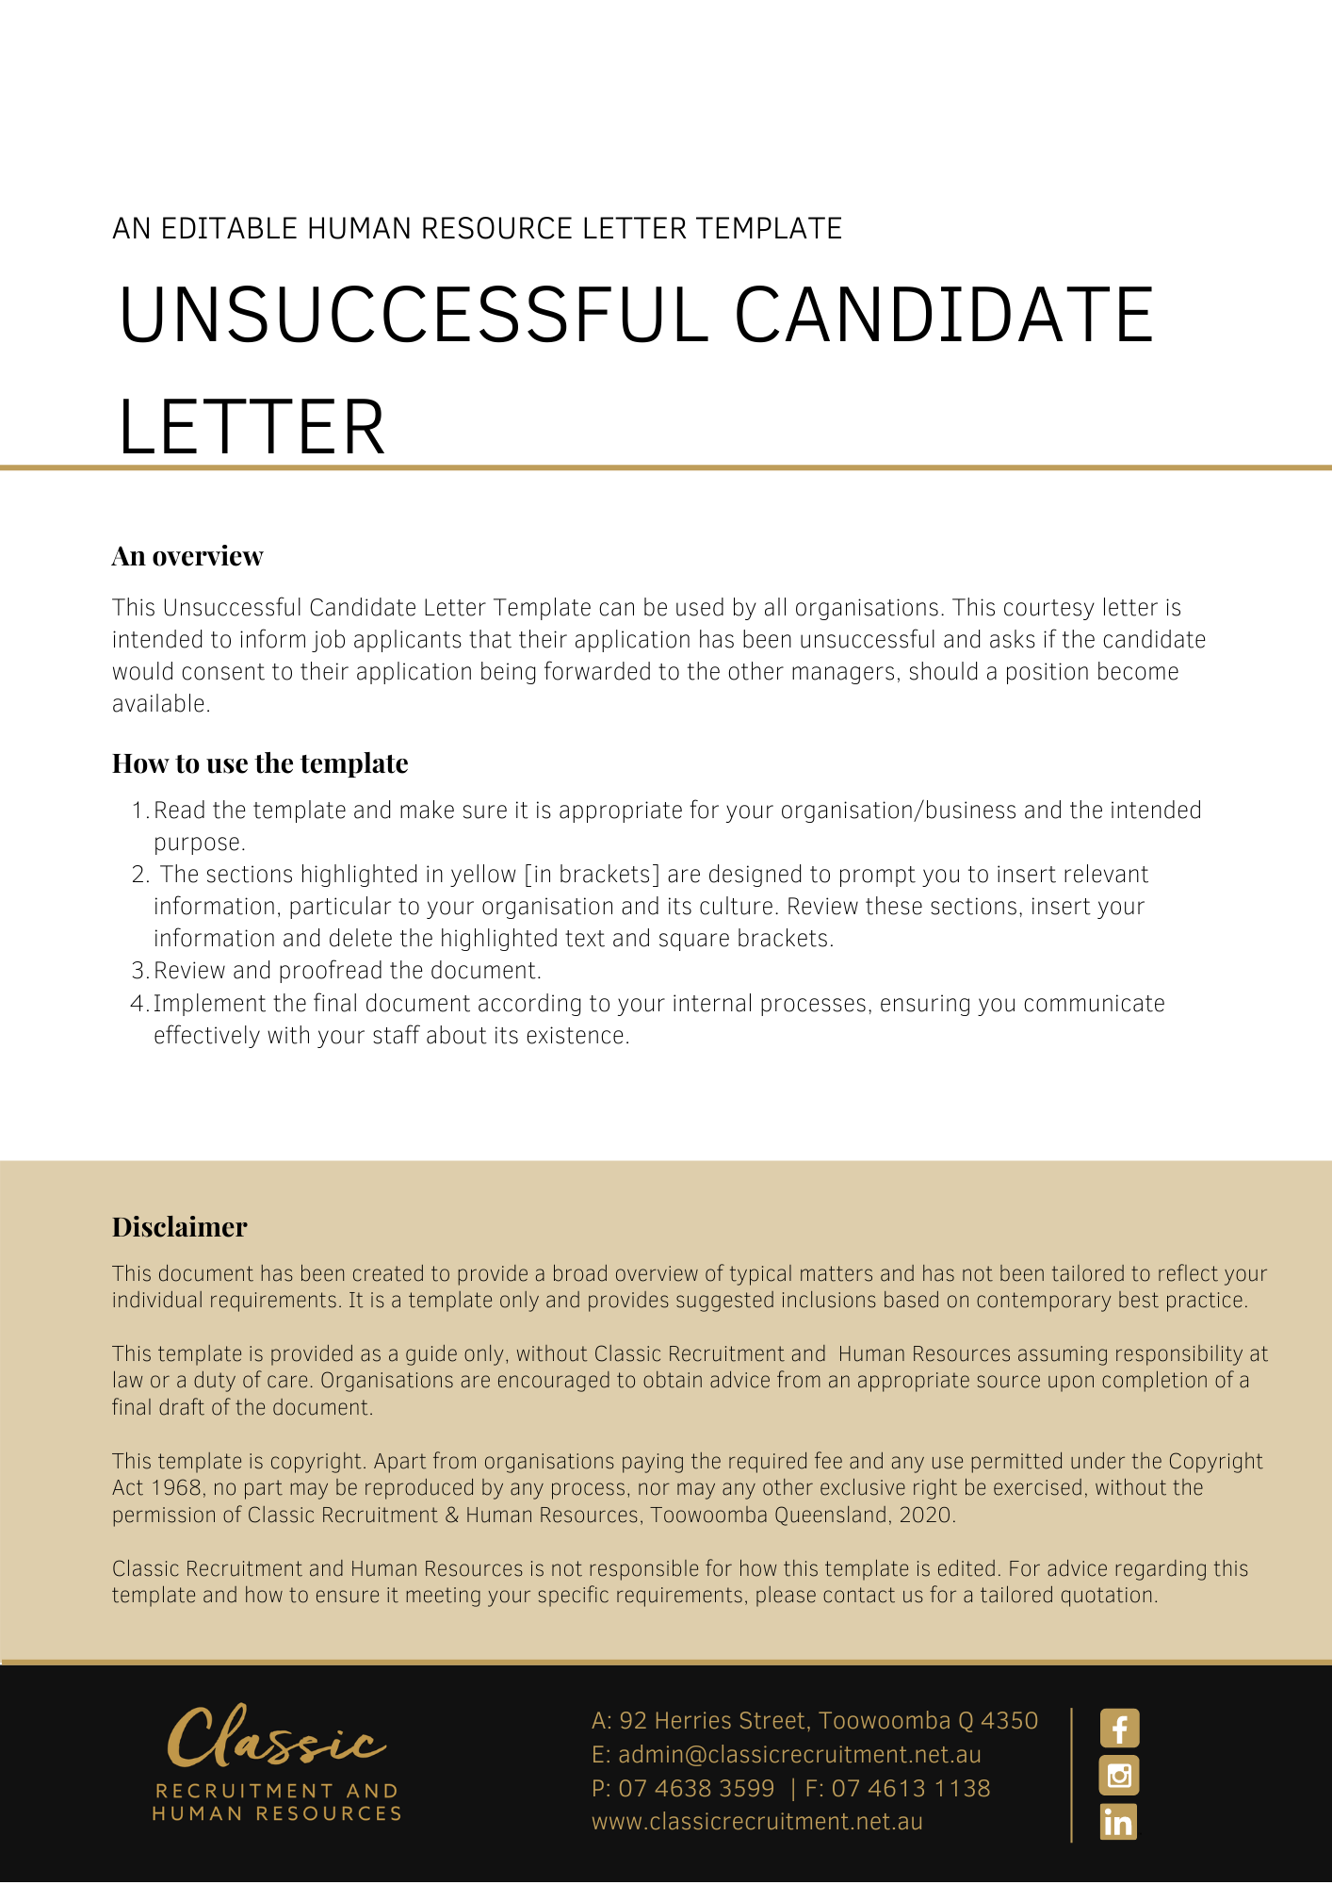
[Date]
[Candidate First Name] [Candidate Surname]
[Employee Address]

Your Application for Employment with [Company Name]
Dear [Employee First Name],

Thank you for your application for the position of [Position] with [Company Name].
Unfortunately, you were unsuccessful at this time. Subject to receiving your written consent, your application will be distributed to other managers within the organisation and should a position become available, we may contact you.
If you would like your applications to be distributed to other manager within the organisation, please read the consent below and if you are agreeable please sign, date and return the duplicate copy of this letter to [Company Name]. This formality is necessary under privacy laws protecting personal information relating to individuals.
If [Company Name] does not receive your signed consent within 28 days of the date of this letter, [Company Name] will arrange for the confidential destruction of your application.
Thank you again for your interest in becoming an employee of [Company Name].
Yours sincerely

[Salutations for goodbye],
[Company Name]
[Letter Signatory Name]
[Letter Signatory Position

Consent

I _____________________________, acknowledge and consent to my personal information being used by [Company Name] to consider my suitability for other positions with [Company Name] and I consent to this information being provided to [Company Name]'s management personnel for this purpose. For this purpose, I acknowledge and consent to my personal information being retained by [Company Name].
I understand that, subject to any agreed or lawful exceptions, I have a right to access my personal information held by [Company Name], by contacting [Company Name] and that I have a right to correct any incorrect information held by [Company Name] about me.
___________________________ | _______________
Signature | Date

