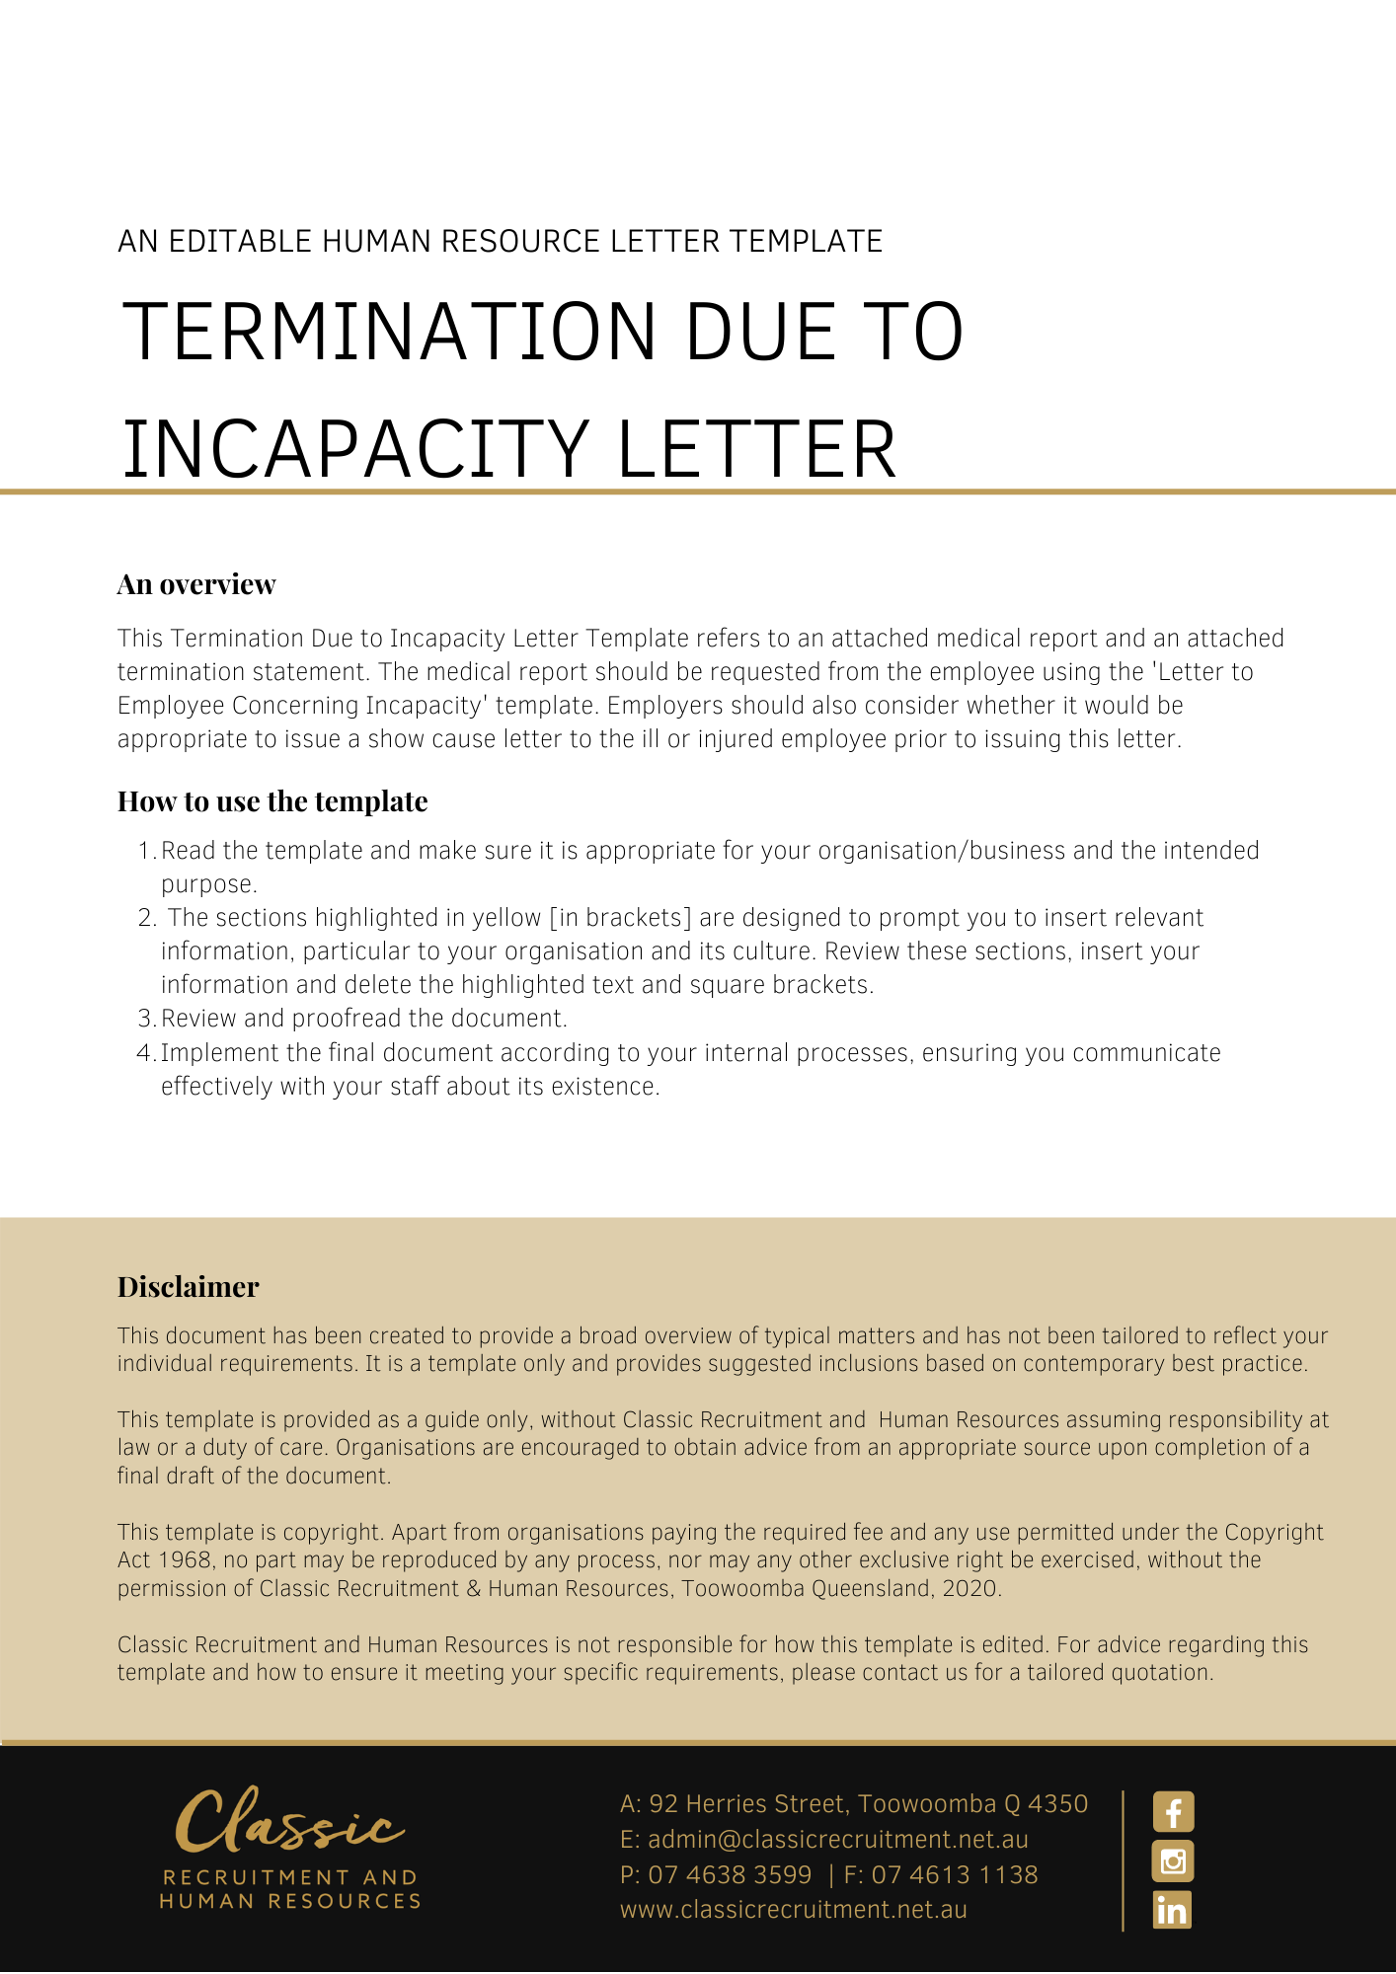
[Date]
[Employee First Name] [Employee Surname]
[Employee Address]

Termination Due to Incapacity
Dear [Employee First Name],

We refer to our letter dated [Date Letter Concerning Incapacity Sent]. In our letter, we requested that you attend a medical examination with Dr [Doctor Name] to determine whether you are fit to return to your position of [Employee Position].
As you know, the medical examination occurred on [Date of Medical Examination]. Thank you for co-operating with that examination. Dr [Doctor Name] was provided with a copy of your job description detailing the duties and responsibilities of the position of [Employee Position]. Following the examination and review of the documentation, Dr [Doctor Name] provided us with a medical report dated [Date of Medica lReport]. A copy of the report is attached for your information.

The Medical Report
We have now reviewed the medical report of Dr [Doctor Name]. Dr [Doctor Name] answered our specific questions in relation to your fitness to return to your position of [Employee Position]. These questions were outlined in our letter to you dated [Date Letter Concerning Incapacity Sent]. Dr [Doctor Name]’s answers to these questions are contained in the report.
In summary, Dr [Doctor Name] report states that:
- [Medical Report Other Details]

Clearly, this is of real concern to [Company Name].

Accommodations to Assist You
Dr [Doctor Name] was asked to consider whether there were any reasonable accommodations [Company Name] could make to assist you to perform the [Employee Position] position safely.

Alternative Positions
Dr [Doctor Name] was also asked to identify the kind of work you are capable of safely performing, so that [Company Name] could consider whether there are alternative positions within [Company Name] that you could perform. In Dr [Doctor Name]’s report, it provides

Your Employment
[Employee First Name], as you know, your continuing has prevented you from performing work since [Date Employee Absent From], and you have been absent from work for [Duration Employee Absent For]. [Company Name] feels it has made a significant effort to accommodate your [Medical Issue]. However, you remain unable to perform your position and there are no accommodations that can be made or alternative positions available.
Unfortunately, [Company Name] considers there is no option other than to terminate your employment.
From the date of this letter, [Company Name] provides you with [Period of Notice] actual notice of termination of your employment. Your termination date will be [Termination Date].
On the termination date you will be paid any accrued but untaken annual leave and long service leave entitlements. Attached to this letter is a Termination Statement which outlines your statutory entitlements on termination of employment, calculated to your termination date.
[Employee First Name], I thank you for your service to [Company Name] and wish you well in your future.

Please contact [Insert Position (e.g. CEO/Director/Owner)] if you if you have any questions.

[Salutations for goodbye],
[Company Name]
[Letter Signatory Name]
[Letter Signatory Position]

