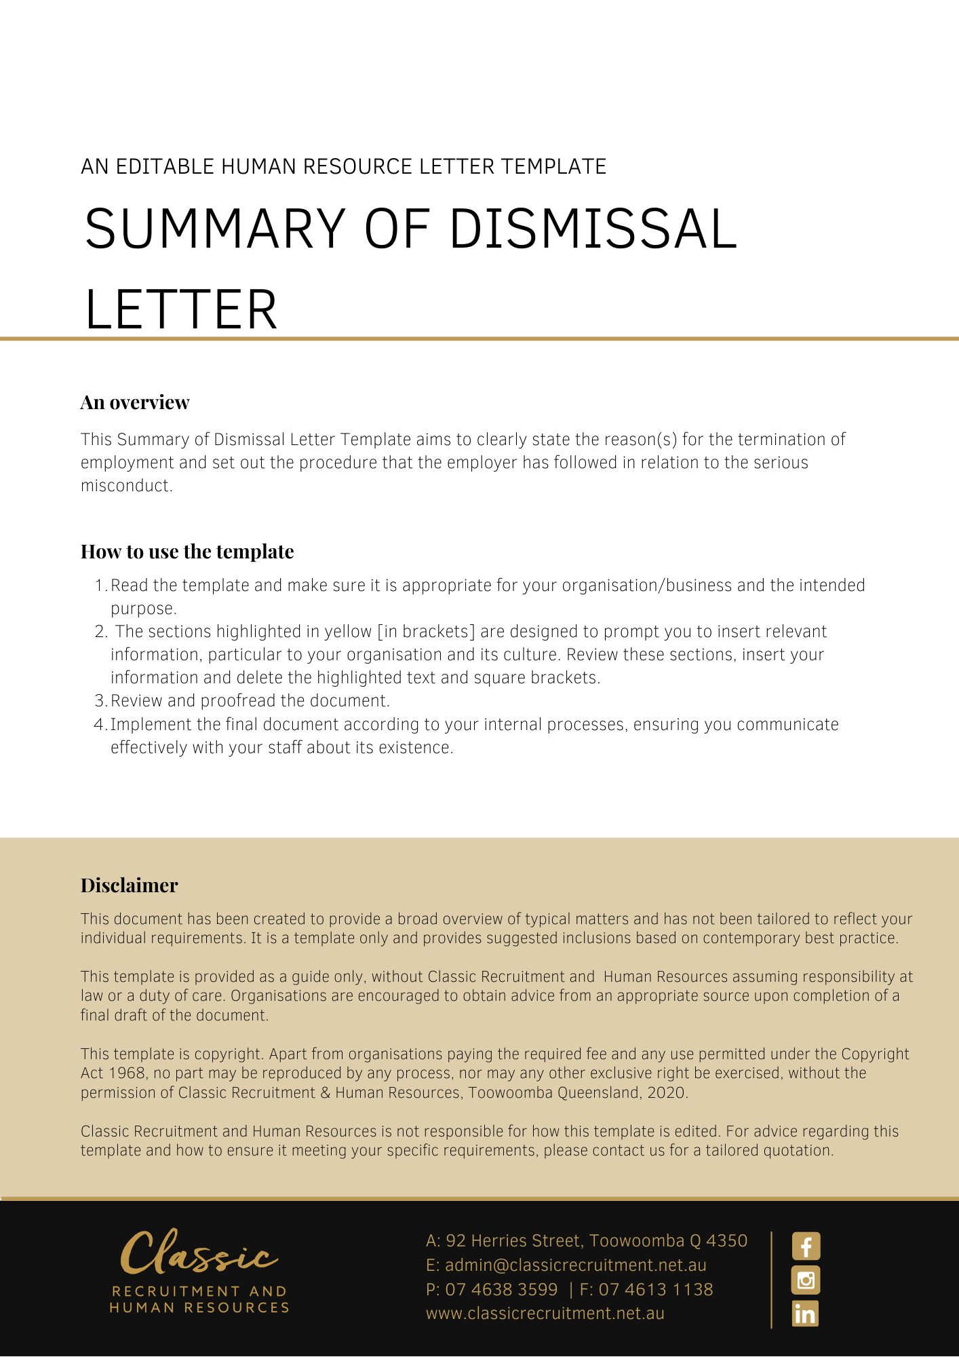
[Date]
[Employee First Name] [Employee Surname]
[Employee Address]

Confirmation of Termination of Your Employment
Dear [Employee First Name],

This letter is to confirm that your employment has been terminated with immediate effect for reason of serious misconduct as discussed in our meeting on [Termination Meeting Date].
As you know, [Company Name] has investigated [Investigation Summary].
You were subsequently provided with details of the allegations and provided with the opportunity to respond to these allegations. The allegations were as follows:
- [Allegations]

[Company Name] has carefully evaluated and considered the material presented during the investigation, and your response, and has come to the conclusion that you did:
- [Conclusion]

We met with you on [Conclusion Meeting Date] to notify you of the outcome of our investigation, and to provide you with an opportunity to put forward any reasons why [Company Name] should not terminate your employment.
[Company Name] does not tolerate [Conduct Not Tolerated Summary]. We have taken into account all of the available information, including your responses. Your conduct constitutes a serious breach of [Terms Breached Details]. Accordingly, [Company Name] considers your actions constitute serious misconduct warranting summary dismissal.
Attached is a statement of your entitlements on termination.
You are required to return all Company property in your possession or control to [Insert Position (e.g. CEO/Director/Owner)] immediately.

[Salutations for goodbye],
[Company Name]
[Letter Signatory Name]
[Letter Signatory Position]

SCHEDULE OF ENTITLEMENTS

Description | Gross Amounts
TOTAL | $ [Insert total sum of entitlements]

