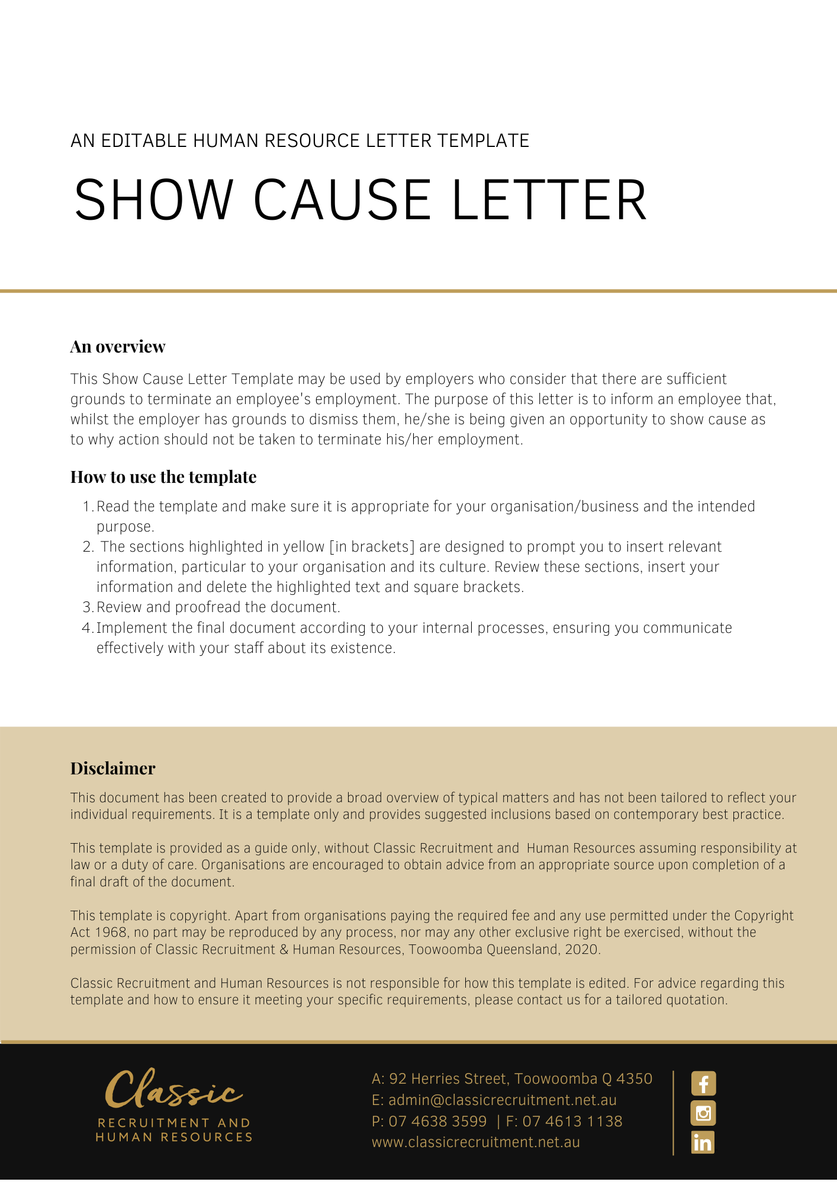
[Date]
[Employee First Name] [Employee Surname]
[Employee Address]

Your Employment
Dear [Employee First Name],

You have been interviewed on [Interview Date] in the presence of [Support Person] and you were provided with an opportunity to give your account. It was explained to you that your [Issue] does not meet [Company Name]’s acceptable standards of [Policy].
In view of this, we have formed a preliminary view and consider that there are sufficient grounds to terminate your employment. However, a final decision has not yet been made.
A meeting has been scheduled for [Scheduled Date] at [Scheduled Time]. You are directed to attend that meeting. At this meeting, you will be given an opportunity to show cause as to why your employment should not be terminated. You may bring a support person to the meeting, if you wish. You may also wish to provide a response in writing prior to this meeting for discussion and consideration at the meeting.
If you fail to either attend the meeting on [Scheduled Date] or provide a written response, [Company Name] will make a final decision regarding your ongoing employment, in your absence. This may include the termination of your employment with [Company Name]. This is an important opportunity to put forward your views.

Please contact [Insert Position (e.g. CEO/Director/Owner)] if you if you have any questions.

[Salutations for goodbye],
[Company Name]
[Letter Signatory Name]
[Letter Signatory Position]

