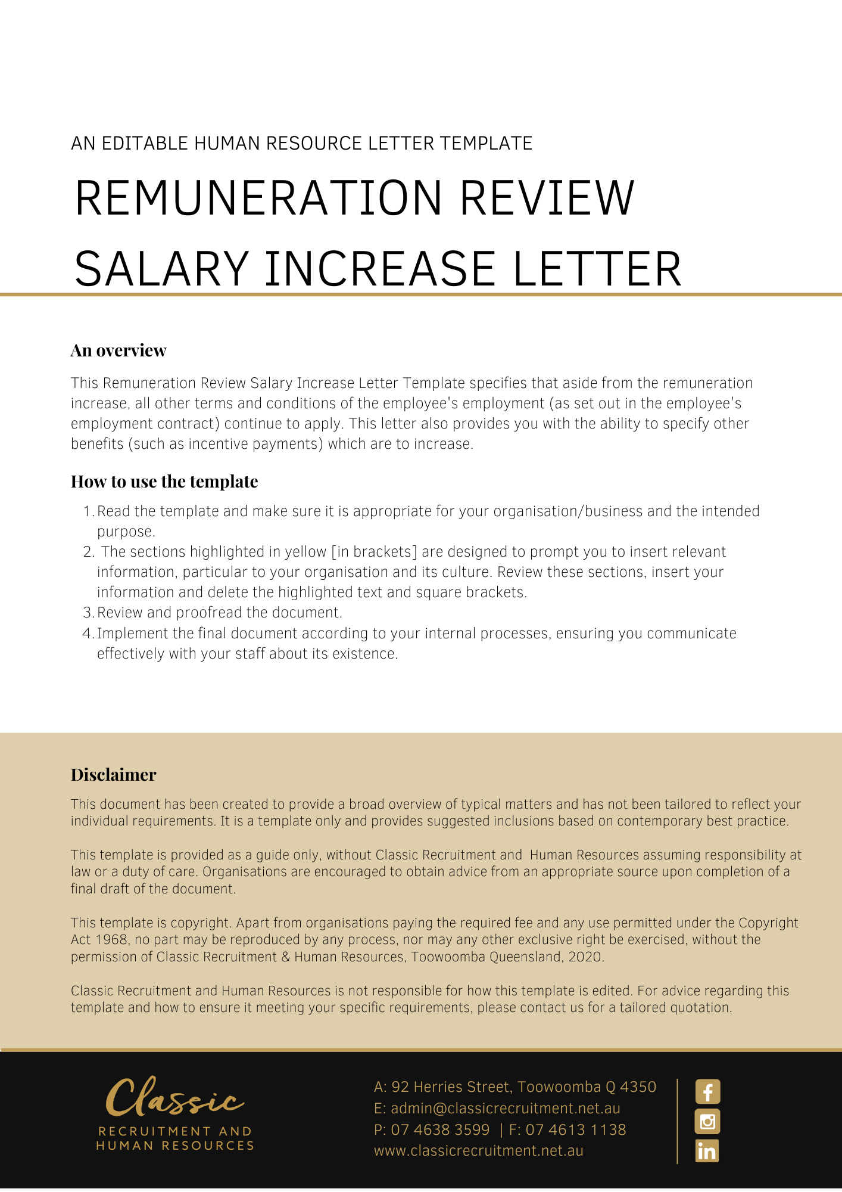
[Date]
[Employee First Name] [Employee Surname]
[Employee Address]

Remuneration Review
Dear [Employee First Name],

Your remuneration has recently been reviewed and I am pleased to inform you that your efforts in the past year are to be rewarded with a [Increase Amount].
This will result in your total [Remuneration Type] being [Total Sum] gross. The increase will be effective from [Increase Date].

This amount is inclusive of superannuation. [Delete After Reading: Adjust this if not applicable]

If you have any queries, please do not hesitate to contact [Insert Position (e.g. CEO/Director/Owner)] on [Contact Number].

[Salutations for goodbye],
[Company Name]
[Letter Signatory Name]
[Letter Signatory Position]

