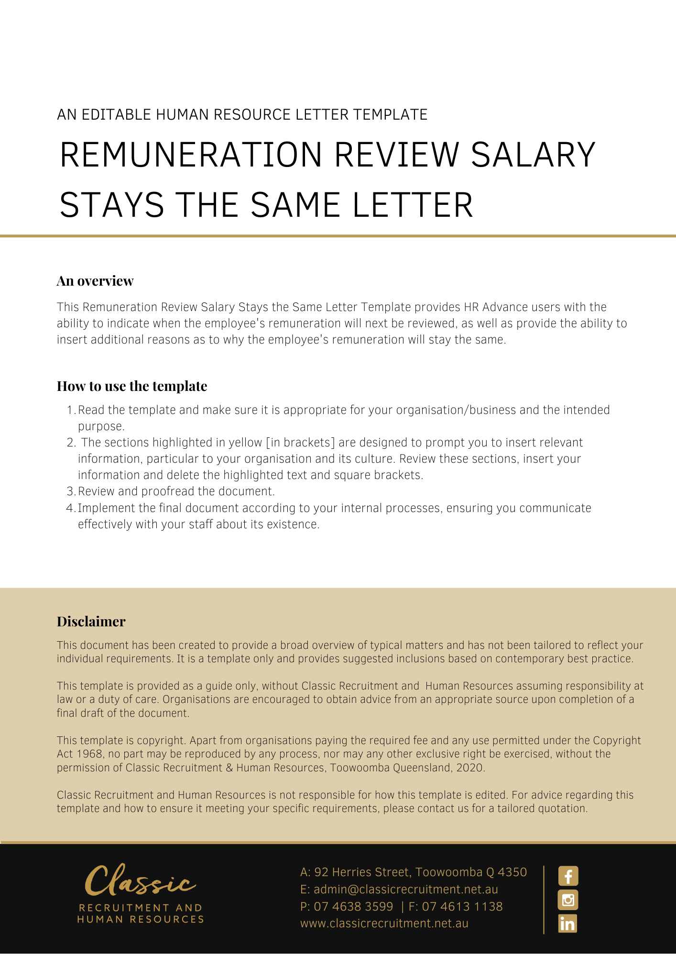
[Date]
[Employee First Name] [Employee Surname]
[Employee Address]

Remuneration Review
Dear [Employee First Name],

As you may be aware, [Company Name] has recently undertaken a remuneration review process.
Having concluded that review process, we wish to inform you that your remuneration will remain unchanged following this review.
Please understand that maintaining your remuneration at the current level does not reflect adversely on your performance. We are pleased with your work and appreciate your efforts to assist [Company Name] to operate effectively.
If you have any questions in relation to this correspondence, please feel free to contact [Insert Position (e.g. CEO/Director/Owner)] on [Contact Number] to discuss.

[Salutations for goodbye],
[Company Name]
[Letter Signatory Name]
[Letter Signatory Position]

