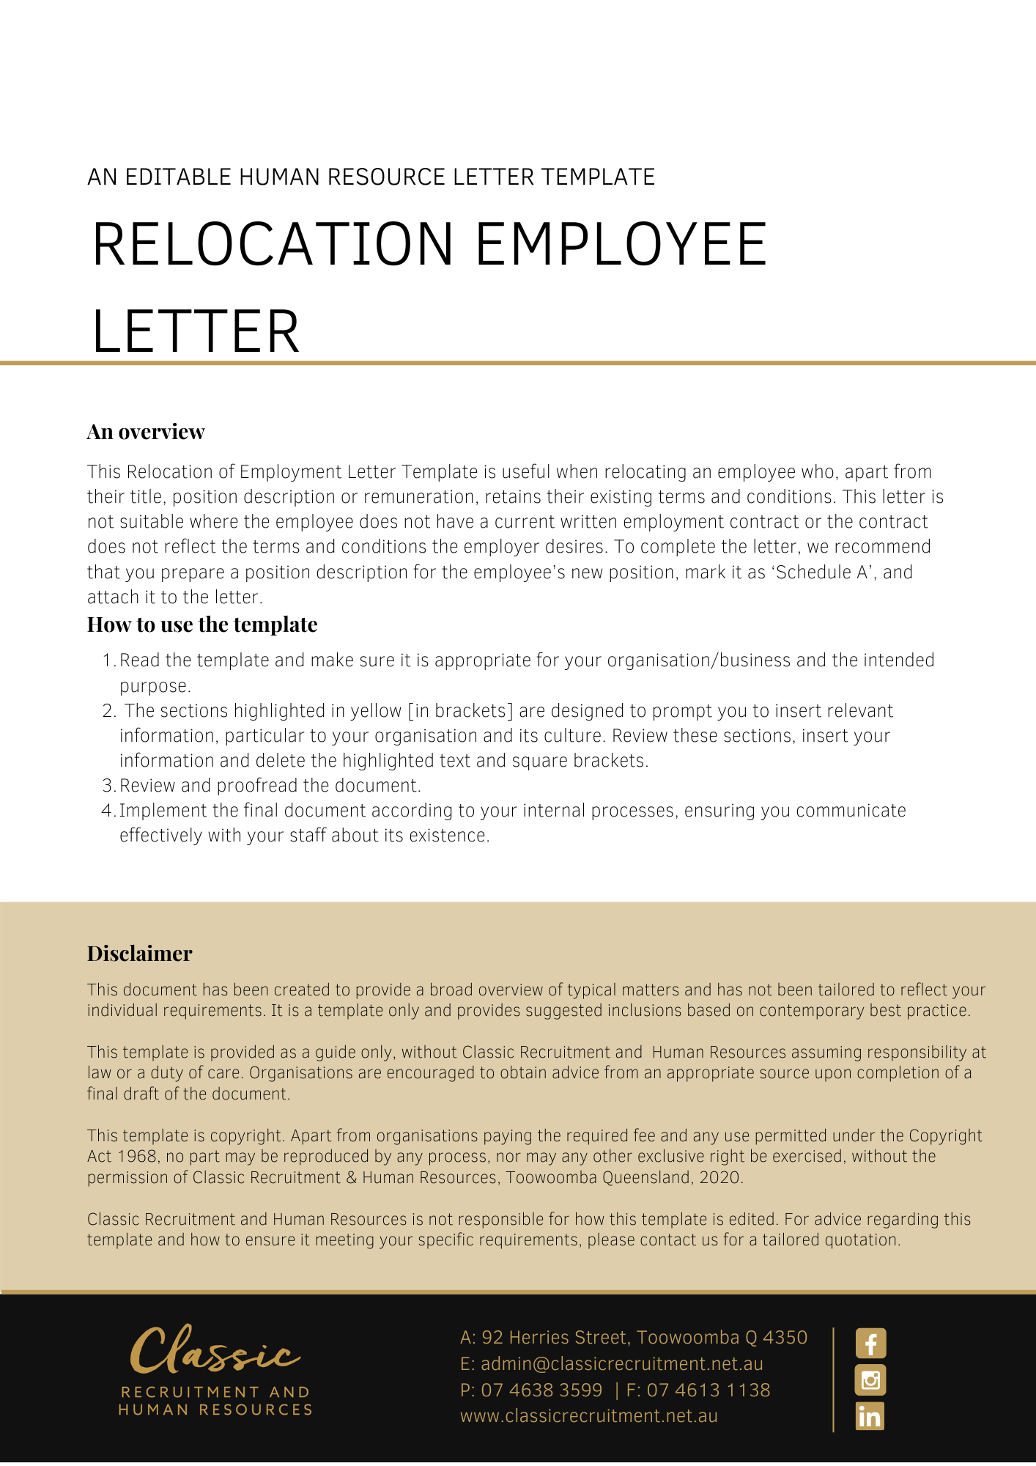
[Date]
[Employee First Name] [Employee Surname]
[Employee Address]

Relocation
Dear [Employee First Name],

As you are aware through recent discussions, we confirm that [Company Name] [Current Work Location] based premises are being closed. Accordingly, your work location will be changing from [Current Work Location] to [New Work Location]. This will occur on [Date Location Change].
Although your work location will change, your position title and duties will not change. Further, all other terms and conditions of your employment as set out in your employment contract dated [Date of Employment Contract] will continue to apply.
If you have any questions in relation to this letter, please do not hesitate to contact [Insert Position (e.g. CEO/Director/Owner)] on [Contact Number]. Thank you for your continued service to [Company Name].

[Salutations for goodbye],
[Company Name]
[Letter Signatory Name]
[Letter Signatory Position]

__________________________________________________________________________
I have read and understand this letter and accept the terms contained in it. I understand that the terms and conditions in my contract of employment dated [Date of Employment Contract] otherwise remain unchanged.
Signed: ________________________________________
[Employee Name]: _______________________________
Date: __________________________________________

