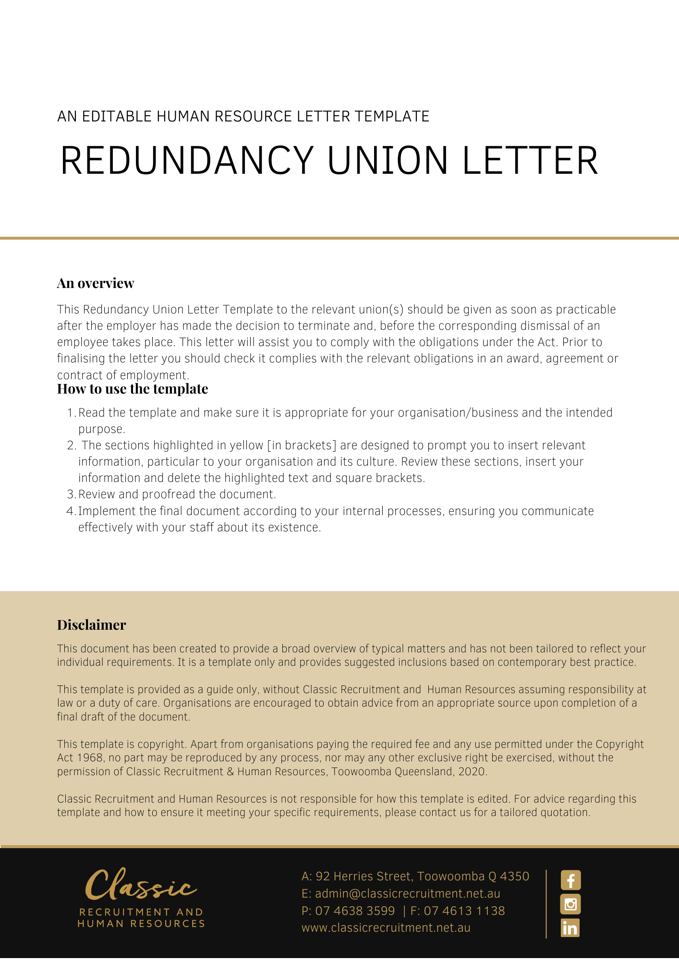
[Date]
[Employee First Name] [Employee Surname]
[Employee Address]

[Company Name] Notification of Redundancies
Dear [Secretary Name],

[Company Name] is [Reasons for Redundancy]. As a direct result of this, the positions of [Number Employees Redundant and Titles] will be made redundant. The categories of employees to be affected will be [Categories of Employees].
[Company Name] proposes, subject to consultation with you, to carry out the redundancies in accordance with [Company Name] will consider any suitable redeployment opportunities that may be available at [Company Name] or its related entities. However, if no such opportunities are available, it is proposed that the redundancies will take place.
We ask that you contact us by [Consult Date] so that we can discuss any measures to avert or minimise the proposed dismissals and to minimise the adverse effects of the dismissals. If we do not hear from you by [Consult Date] then redundancies will be carried out as outlined above.

[Salutations for goodbye],
[Company Name]
[Letter Signatory Name]
[Letter Signatory Position]

