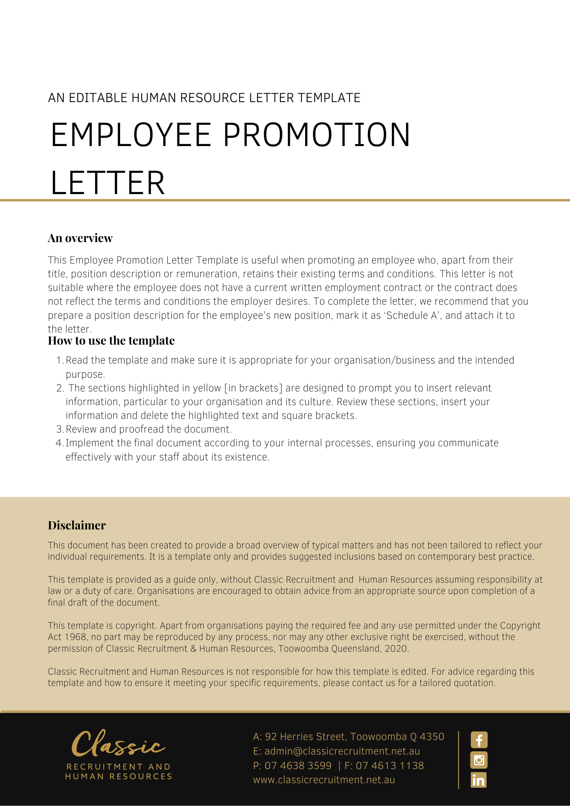
[Date]
[Employee First Name] [Employee Surname]
[Employee Address]

Promotion
Dear [Employee First Name],

We are pleased to confirm your appointment to the position of [Employee Position], effective from [Date Promotion].
The position will report to [Employee New Position], however [Company Name] may change your reporting arrangements in accordance with the needs of the business.
Your duties and responsibilities are set out in the Position Description in schedule A, attached to this letter. You are also required to carry out other duties reasonably required by [Company Name] that you are skilled and capable of performing.
Your new salary package will be [New Salary Package] gross (inclusive of superannuation) [Delete After Reading: alter if not applicable].
All other terms and conditions of your employment as contained in your employment contract dated [Date of Employment Contract] will continue to apply.

If you have any questions in relation to this letter, please do not hesitate to contact [Insert Position (e.g. CEO/Director/Owner)] on [Contact Number]. Thank you for your continued service to [Company Name].

[Salutations for goodbye],
[Company Name]
[Letter Signatory Name]
[Letter Signatory Position]

__________________________________________________________________________
I have read and understand this letter and accept the terms contained in it. I understand that the terms and conditions in my contract of employment dated [Date of Employment Contract] otherwise remain unchanged.
Signed: ________________________________________
[Employee Name]: _______________________________
Date: __________________________________________

