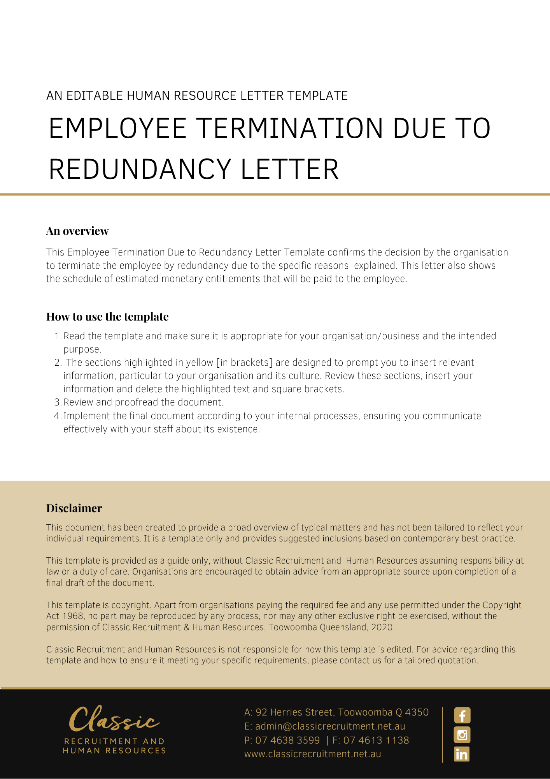
[Date]
[Employee First Name] [Employee Surname]
[Employee Address]

Notification of Termination Due to Redundancy
Dear [Employee First Name],

We refer to our recent discussions with you. As you are aware [Company Name] has made a decision to [Redundancy Reasons], resulting in your position being made redundant.
At our meeting on [Meeting Date] we discussed the redundancy process with you, alternatives to termination of your position as [Employee Position] including redeployment within [Company Name] and its related entities. We further discussed measures to mitigate the effect of the redundancy. Unfortunately, there are no alternative positions within [Company Name] and its related entities that you could reasonably be deployed to at this time and no other steps can be taken to avoid termination of your employment by reason of redundancy. Accordingly, your position will become redundant on [Redundancy Date].

Attached to this letter is a schedule of estimated monetary entitlements that will be paid to you on the termination of your employment. The amounts outlined in the schedule are subject to any changes being required to be made prior to your termination date (for example due to annual leave being taken prior to that time etc) or an error (or miscalculation) in the entitlements set out in the schedule being discovered. Tax will be deducted from these payments before the net amounts are paid to you. These payments will be deposited into your bank account by [Payment Deposit Date].
We would be grateful if you would arrange for all Employer property in your custody, possession, or control to be returned to us by [Property Return Date].
Thank you for your commitment and service to [Company Name]. We wish you all the very best in your future endeavours.

[Salutations for goodbye],
[Company Name]
[Letter Signatory Name]
[Letter Signatory Position]

Schedule of Entitlements

Description | Gross Amounts
TOTAL | $ [Insert Sum of Items]

IMPORTANT: This is a schedule of estimated monetary entitlements that will be paid to you on the termination of your employment, subject to any changes being required to be made prior to your termination date (for example, due to annual leave being taken prior to that time etc) or an error (or miscalculation) in the entitlements set out in the schedule being discovered. Tax will be deducted from these payments before the net amounts are paid to you.

