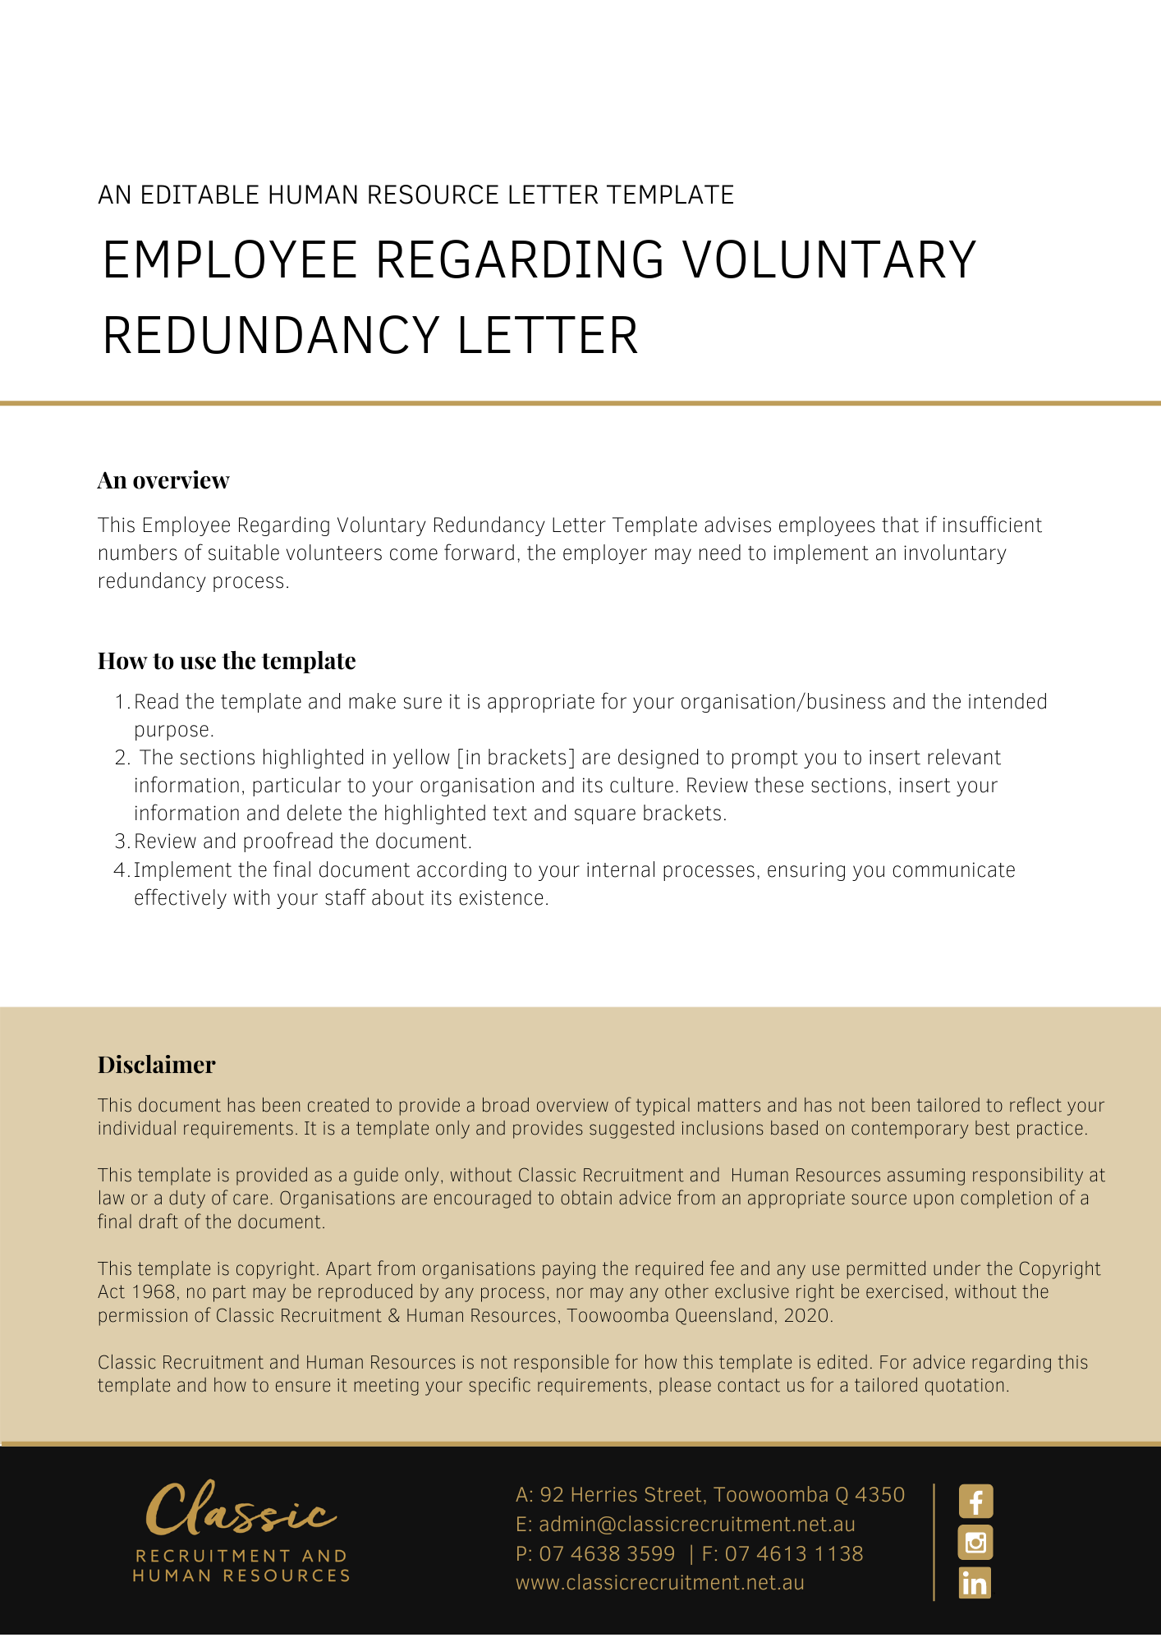
[Date]
[Employee First Name] [Employee Surname]
[Employee Address]

Applications for Voluntary Redundancy
Dear [Employee First Name],

[Company Name] is [Redundancy Reasons]. In order to address this situation, [Company Name] is considering making some positions redundant.

Process
At this stage, the company would like to know if any employees are interested in accepting voluntary redundancy. There is no guarantee that those who volunteer for redundancy will be made redundant.
In the event that there are more volunteers for voluntary redundancy than there are opportunities, selection criteria may also be used as a guide to assist in determining which employees may be made redundant. The selection criteria will be decided upon at the discretion of [Insert Position (e.g. CEO/Director/Owner)].
If there are insufficient numbers of suitable volunteers, [Company Name] may implement an involuntary redundancy process. [Company Name] may carry out the redundancies in accordance with [Insert Redundancy Policy].
The future employment of any employee who volunteers for redundancy and is not selected, will not be prejudiced by their application.

Making an Application
To apply for voluntary redundancy please complete the attached form and return it to [Insert Position (e.g. CEO/Director/Owner)] by [Return Forms Date].
If you have any questions, please do not hesitate to contact [Insert Position (e.g. CEO/Director/Owner)] on [Contact Number].

[Salutations for goodbye],
[Company Name]
[Letter Signatory Name]
[Letter Signatory Position]

Application for Voluntary Redundancy

I [Employee Name], holding the position of [Employee Position], wish to be considered for voluntary redundancy.
I understand that [Company Name] is not obliged to accept my application for redundancy.
No duress or coercion has been placed on me in making this application.

……………………………. ……………………….
Signature Date

Please return this application to [Insert Position (e.g. CEO/Director/Owner)] by [Return Forms Date].

