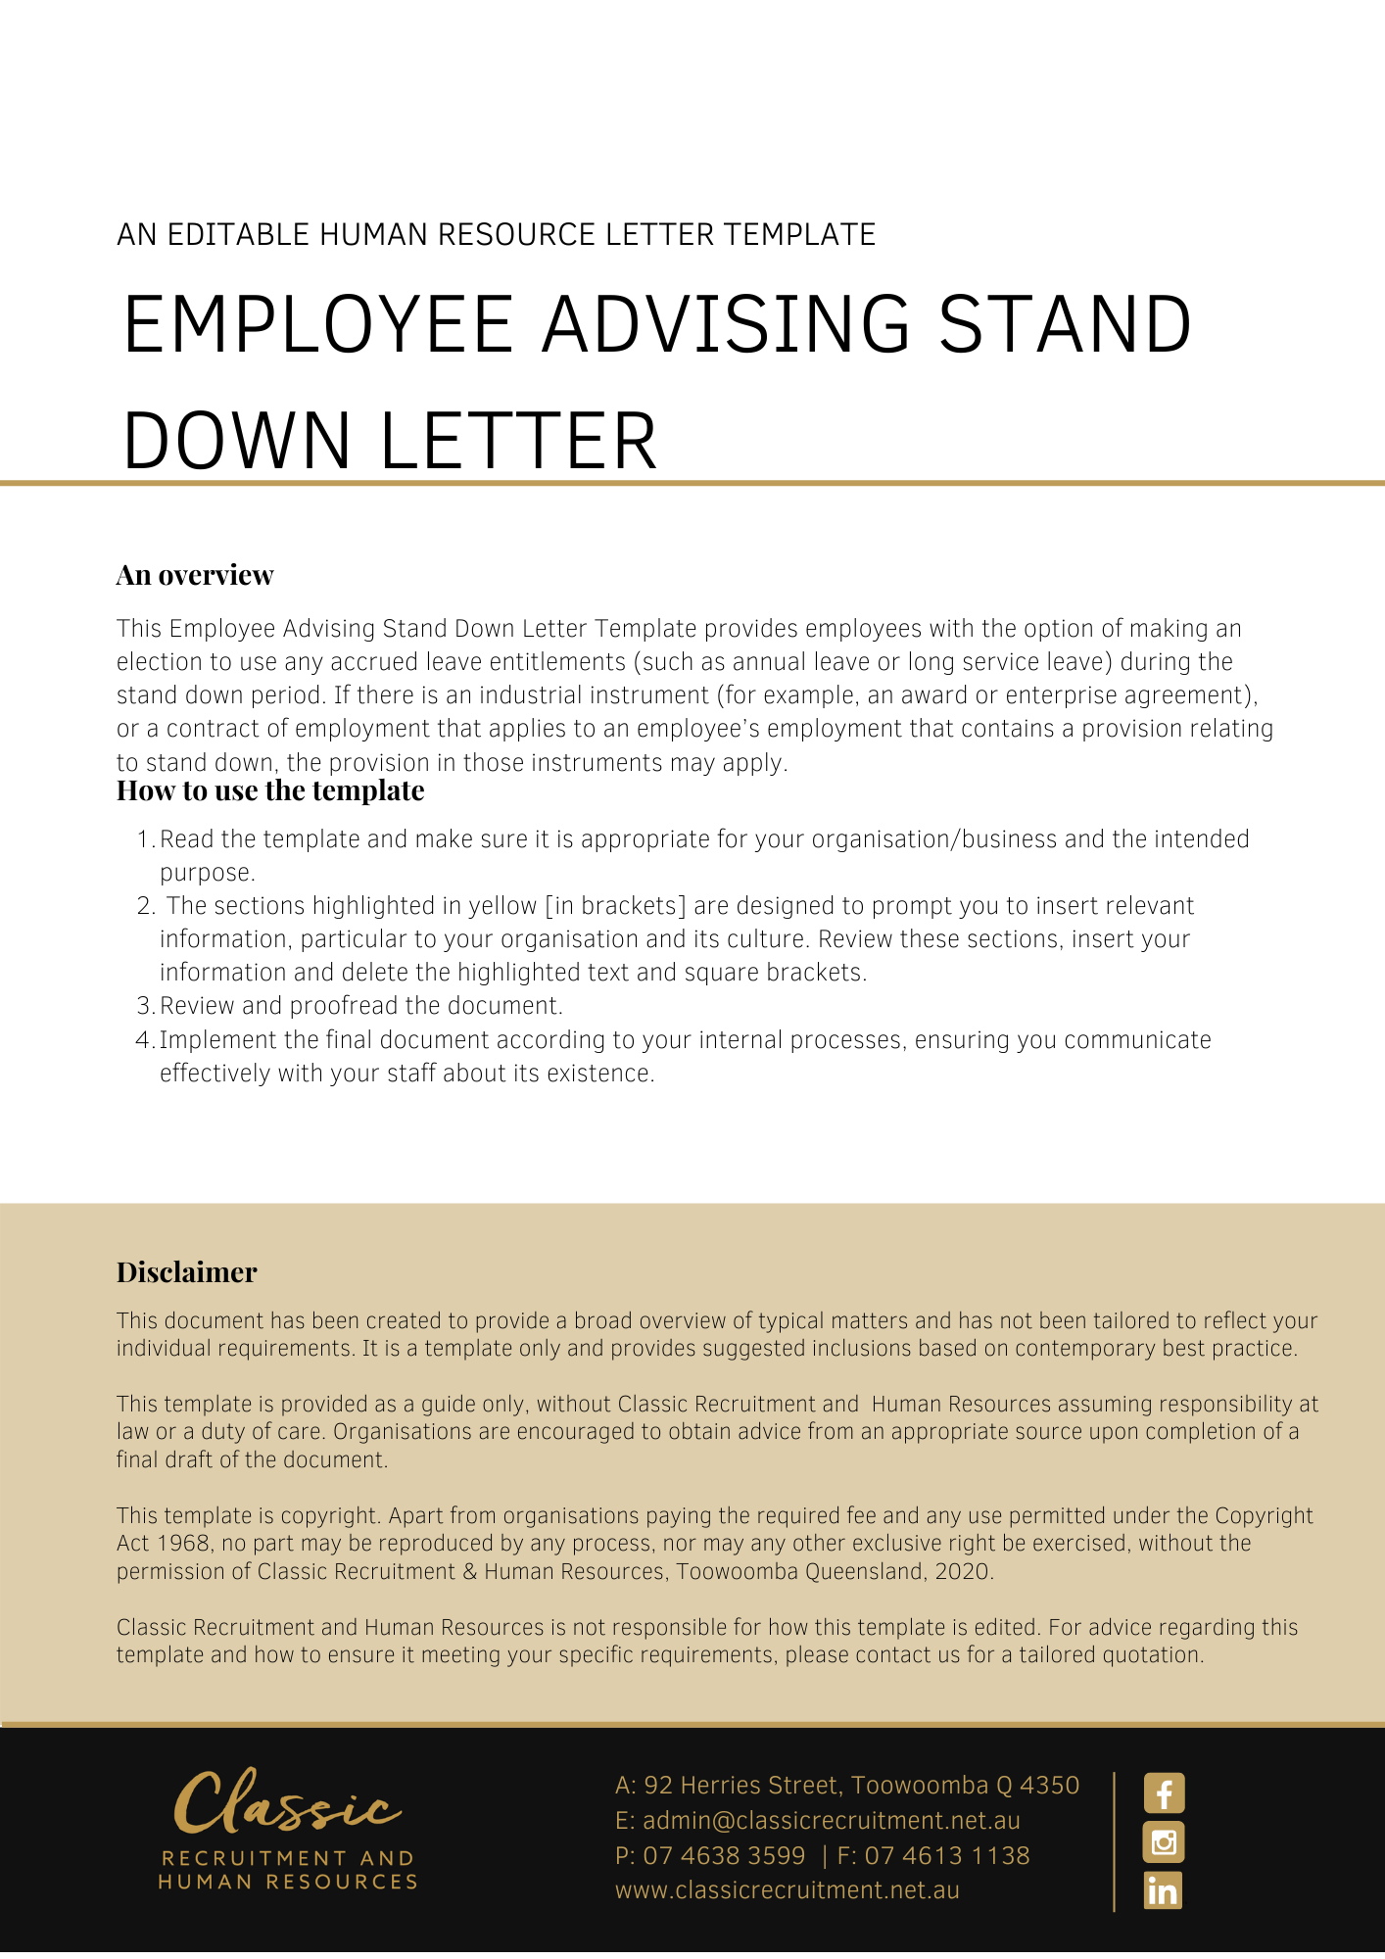
[Date]
[Employee First Name] [Employee Surname]
[Employee Address]

Stand Down from Employment
Dear [Employee First Name],

We write to inform you that, as of [Stand Down Start Date], [Company Name] is standing you down from your employment due to a stoppage of work which has arisen because of circumstances outside of its control and for which it cannot be held responsible. At this stage, you will be stood down from work for the period [Stand Down Start Date] to [Stand Down End Date] (‘the Stand Down Period’). This will be reviewed before the Stand Down Period expires and we will notify you of what we propose to do after the Stand Down Period.
The Stand Down Period is considered necessary as a result of [Stand Down Reasons], which has caused a stoppage of work at this point in time. [Company Name] has considered whether you can be ‘usefully employed’ in another way during the Stand Down Period to avoid the need to stand you down. Unfortunately, despite its best efforts, [Company Name] cannot provide you with useful employment during the Stand Down Period.
During the Stand Down Period, you may elect to take certain accrued leave entitlements, if you have any accrued and available, including annual leave or long service leave. If you wish to use this accrued leave during the Stand Down Period, you should contact [Insert Position (e.g. CEO/Director/Owner)], by no later than [Contact Date Deadline].
We understand that this is a stressful situation, and we encourage you to contact our Employee Assistance Program on [Contact Number].

Thank you for your assistance and support during this difficult time.

[Salutations for goodbye],
[Company Name]
[Letter Signatory Name]
[Letter Signatory Position]

