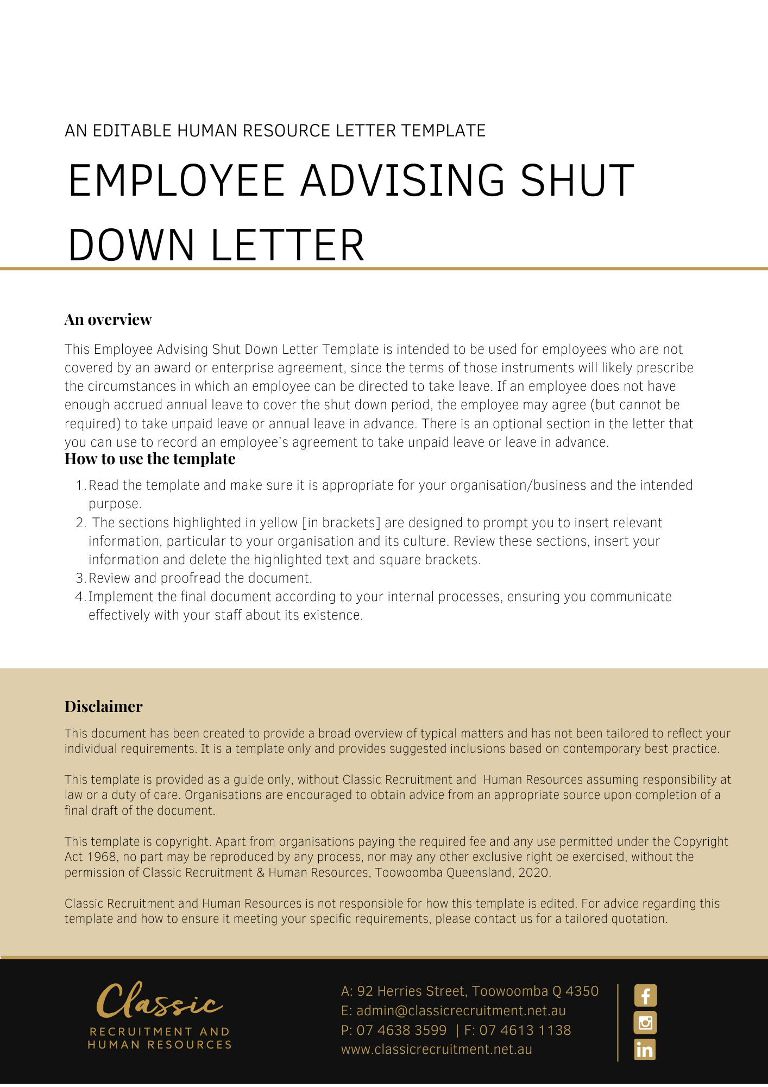
[Date]
[Employee First Name] [Employee Surname]
[Employee Address]

Proposed Notice of Shut Down
Dear [Employee First Name],

[Company Name] gives notice of a shutdown of business from [Date Begin] to [Date End] (‘the Shut Down Period’).

You are required to take annual leave from any accrued entitlement. If you do not have sufficient annual leave accrued to cover the shutdown period, you may elect to complete the form below to take unpaid leave, annual leave in advance or long service leave (if eligible).

Please contact [Insert Position (e.g. CEO/Director/Owner)] if you if you have any questions.

[Salutations for goodbye],
[Company Name]
[Letter Signatory Name]
[Letter Signatory Position]

To: [Company Name]

Attention: Payroll Department

- Part 1 - Authorisation
I, [Employee Name] understand that I do not have sufficient accrued annual leave to cover the entire period of the shutdown to occur during the period of [Date Begin] to [Date End] (inclusive) (the Shutdown).
I understand that I may:
  - Take unpaid leave; or
  - Take long service leave (if I am so entitled); or
  - Take annual leave in advance of accrual (up to a maximum of [Maximum Days] days). If I take this option, I understand that I will owe [Company Name] an amount equivalent to the leave taken in advance and that I am required to complete the authorisation detailed at Part 2 of this form.
In order to cover the period of the Shutdown, for which my accrued leave is insufficient, I would like to take the following option (please tick one) for the period of the Shutdown:
- Annual leave in advance of accrual (please complete Part 2 below)
- Unpaid leave
- Long service leave (by ticking this box I confirm that I am entitled to take long service leave under applicable State legislation)

[Employee Name]
_________________________________
[Employee Name] signature
_________________________________
Date
_________________________________

- Part 2 - Authorisation for deduction where annual leave is taken in advance

I, [Employee Name]:
  - acknowledge that I will take leave in advance of accrual during the Shutdown;
  - agree that I owe [Company Name] an amount equal to the remuneration I will receive for the leave I took in advance of accrual during the Shutdown (the Amount Owing);
  - the amount of leave to be taken in advance is [Hours/Days];
  - the leave in advance will commence on [Start Date] and end on [End Date];
  - authorise [Company Name] to deduct the Amount Owing from either:
    - my remuneration;
    - my future accrued entitlements;
    - the accrued entitlements owing to me on termination of my employment (regardless of whether the termination arises by my resignation or action taken by [Company Name]).

[Employee Name]
_________________________________
[Employee Name] signature
_________________________________
Date
_________________________________

[Delete After Reading: If the employee is under 18 years of age - include:]
Name of parent/guardian:________________________________________

Signature of parent/guardian:________________________________________

Date signed:___/___/20___

