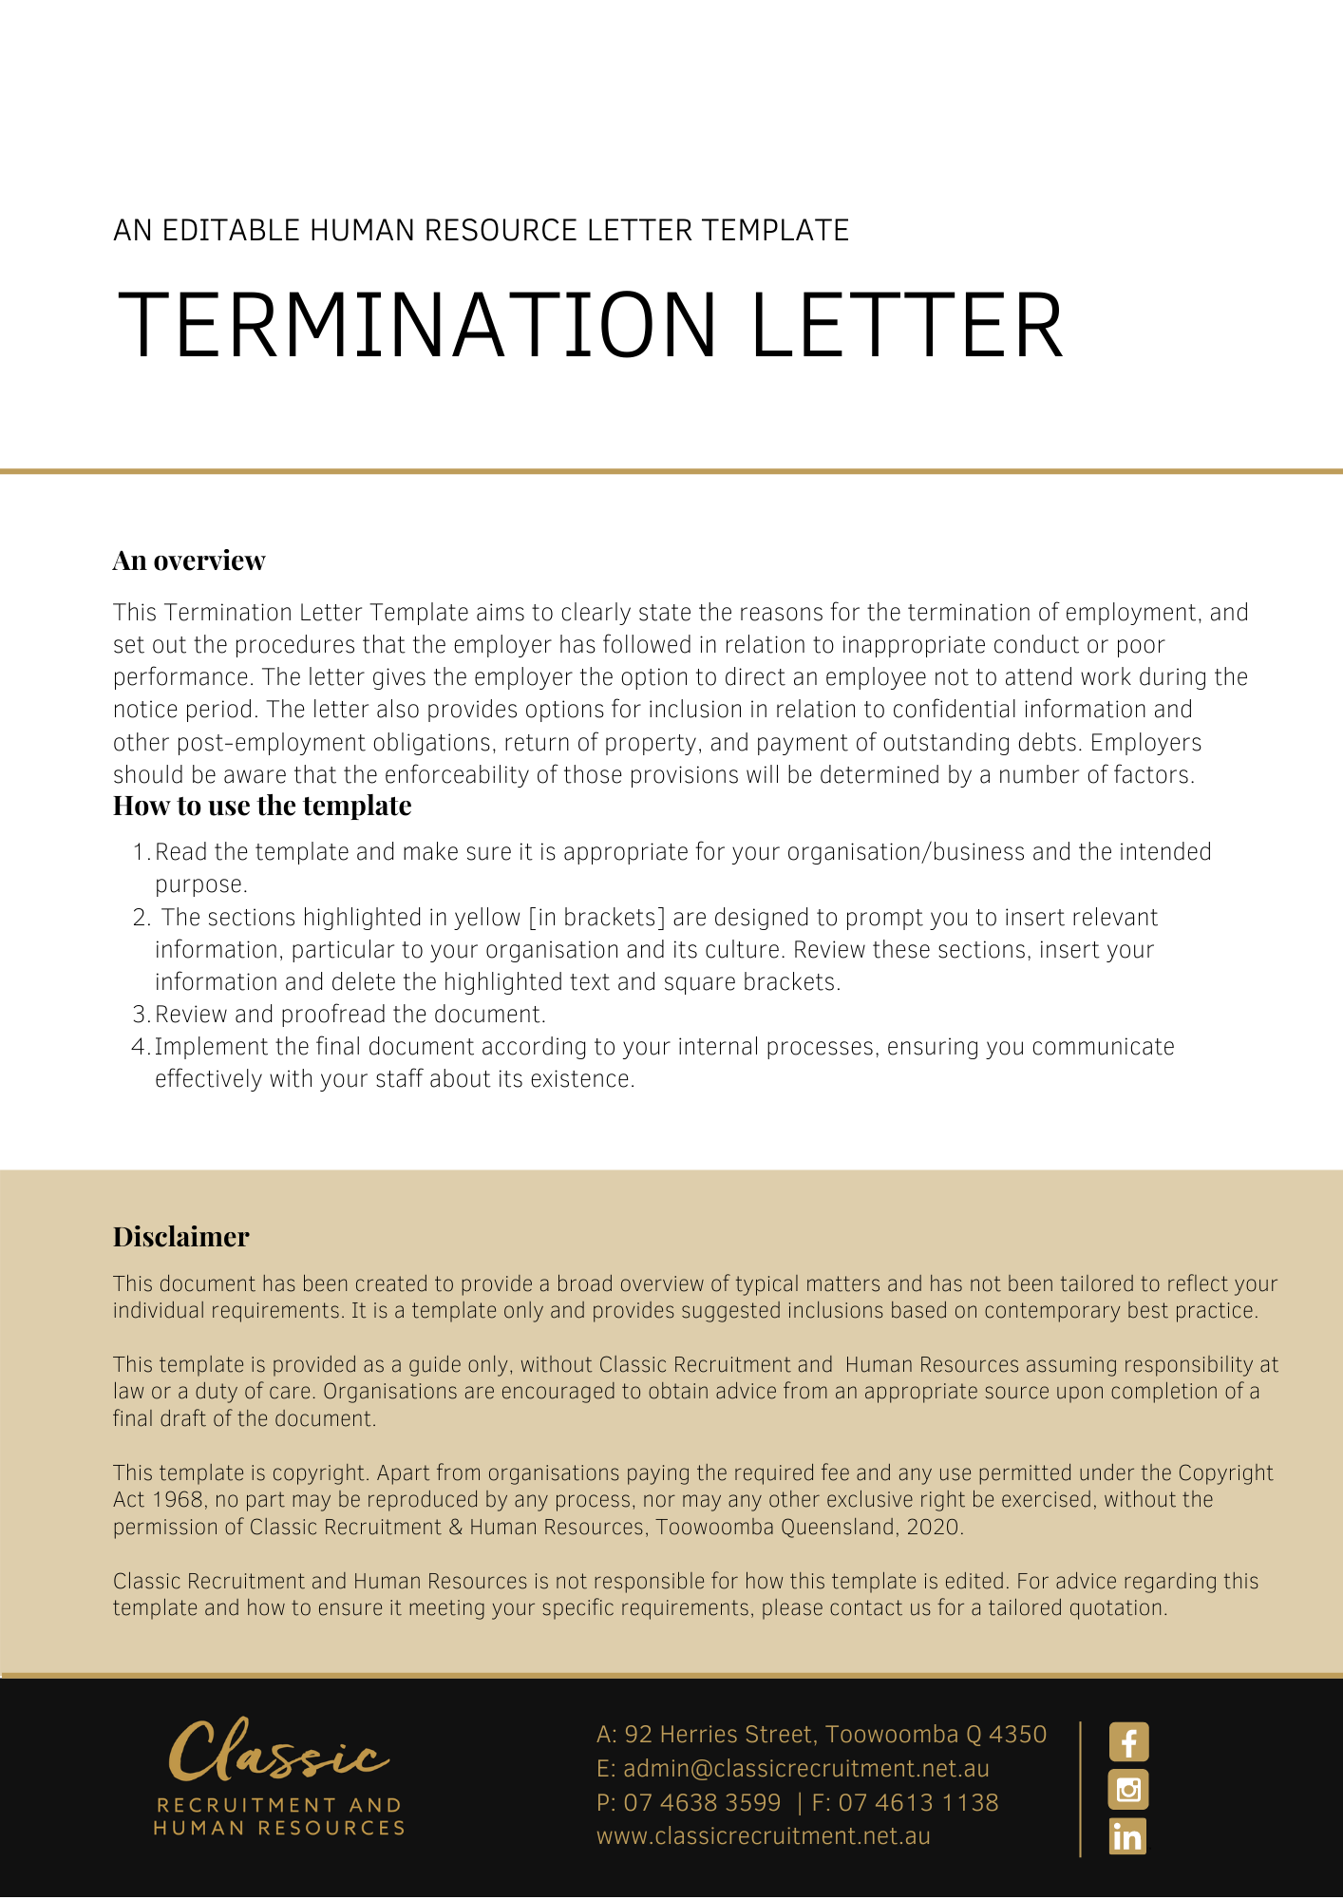
[Date]
[Employee First Name] [Employee Surname]
[Employee Address]

Termination of Your Employment
Dear [Employee First Name],

I refer to our meeting on [Last Meeting Date] at which [Last Meeting Persons Present] were also present. During this meeting, I indicated that [Company Name] continued to be concerned with your [Insert Concern]. In particular, I raised with you the following:
- [Last Meeting Matters Raised]
In response to the above concerns you indicated the following:
- [Last Meeting Employee Response]
[Company Name] has carefully considered your response to the allegations and does not find that your response explains, justifies or excuses your [Insert Concern].
There continues to be no substantive improvement in your [Insert Concern].
Accordingly, we advise of [Company Name]’s decision to terminate your employment.
[Company Name] reminds you that despite your contract with [Company Name] being terminated as of [Date Termination], you remain under a contractual obligation to refrain from disclosing, to any person or entity, or from otherwise using, confidential information gained during your employment with [Company Name], pursuant to [Insert Contract Reference] of your Contract of Employment.
Please return to [Insert Position (e.g. CEO/Director/Owner)] by [Date Return Property] all [Company Name] property and documents in your possession, custody or control and pay outstanding debts of [Debts Outstanding Details] to [Company Name] by [Date Pay Outstanding Debts].
Please do not hesitate to contact the [Insert Position (e.g. CEO/Director/Owner)] on [Employer Representative Phone Number] with any queries.

[Salutations for goodbye],
[Company Name]
[Letter Signatory Name]
[Letter Signatory Position]

