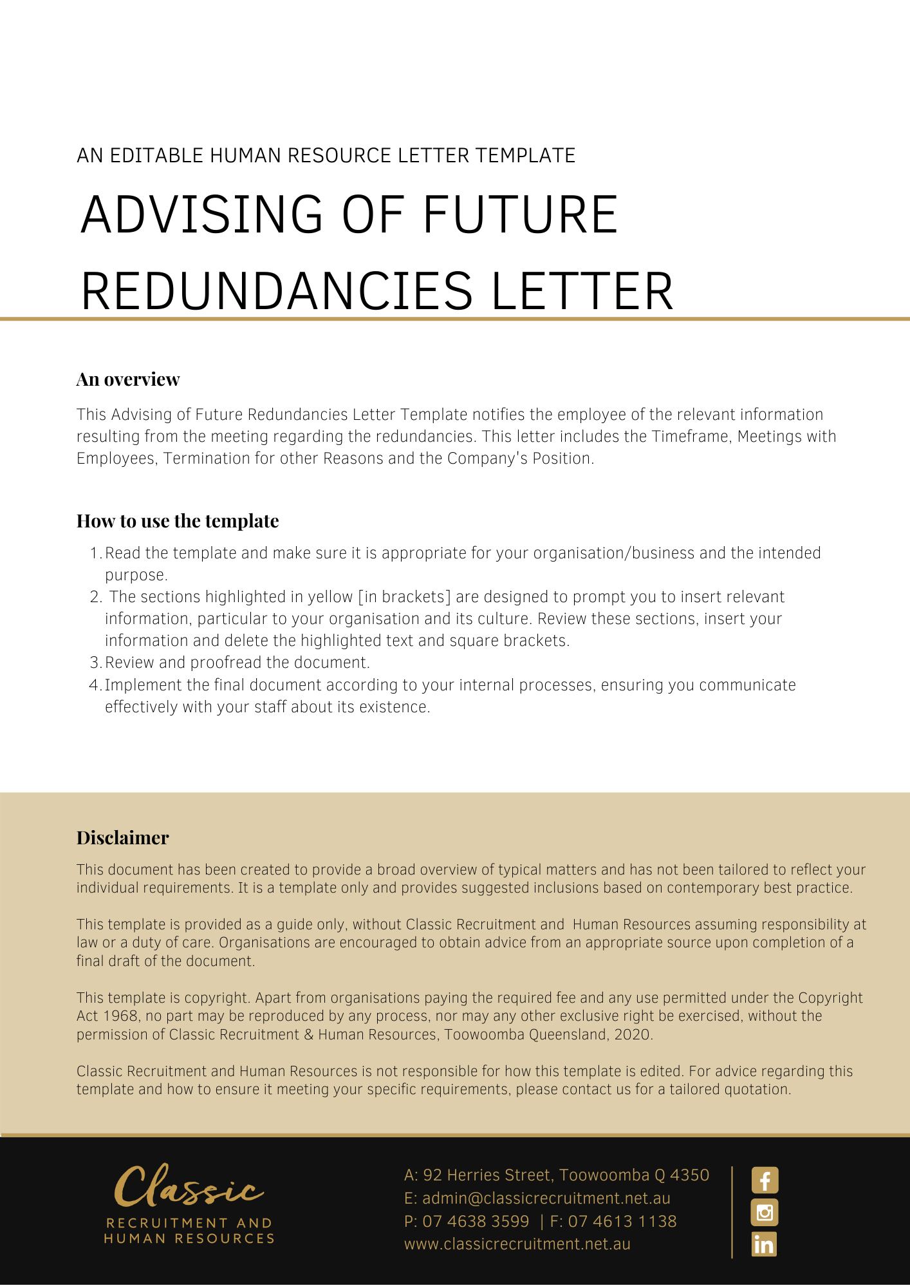
[Date]
[Employee First Name] [Employee Surname]
[Employee Address]

Notification of Redundancies
Dear [Employee First Name],

As discussed in our meeting on [Date of Meeting], [Company Name] is [Reasons for Redundancy]. As a direct result of this reorganisation, the positions of [Number Employees Redundant and Titles] will be made redundant.

Timeframe
It is proposed that the redundancy process will commence [Date].

Meetings with Employees
Representatives of [Company Name] will be meeting on an individual basis with each employee whose position may be made redundant. During these meetings, each employee will be provided with an opportunity to respond to the decision to select them for possible redundancy, raise any measures they consider might be taken to avoid their position being made redundant or mitigate its effect, and raise any possible alternatives to their employment with [Company Name] being terminated as a consequence (including any opportunities for redeployment).

Termination for Other Reasons
If an employee is terminated for reasons, other than redundancy, during the notice period, no severance payment will be payable.

Our Position
It is with sincere regret that [Company Name] has found it necessary to take this action. [Company Name] wishes to minimise the impact of any adverse effects associated with the redundancies and will provide assistance to employees where possible. Any employee wishing to discuss this matter should contact [Insert Position (e.g. CEO/Director/Owner)] on [Contact Number]. All discussions will be treated in the strictest confidence.

[Salutations for goodbye],
[Company Name]
[Letter Signatory Name]
[Letter Signatory Position]

