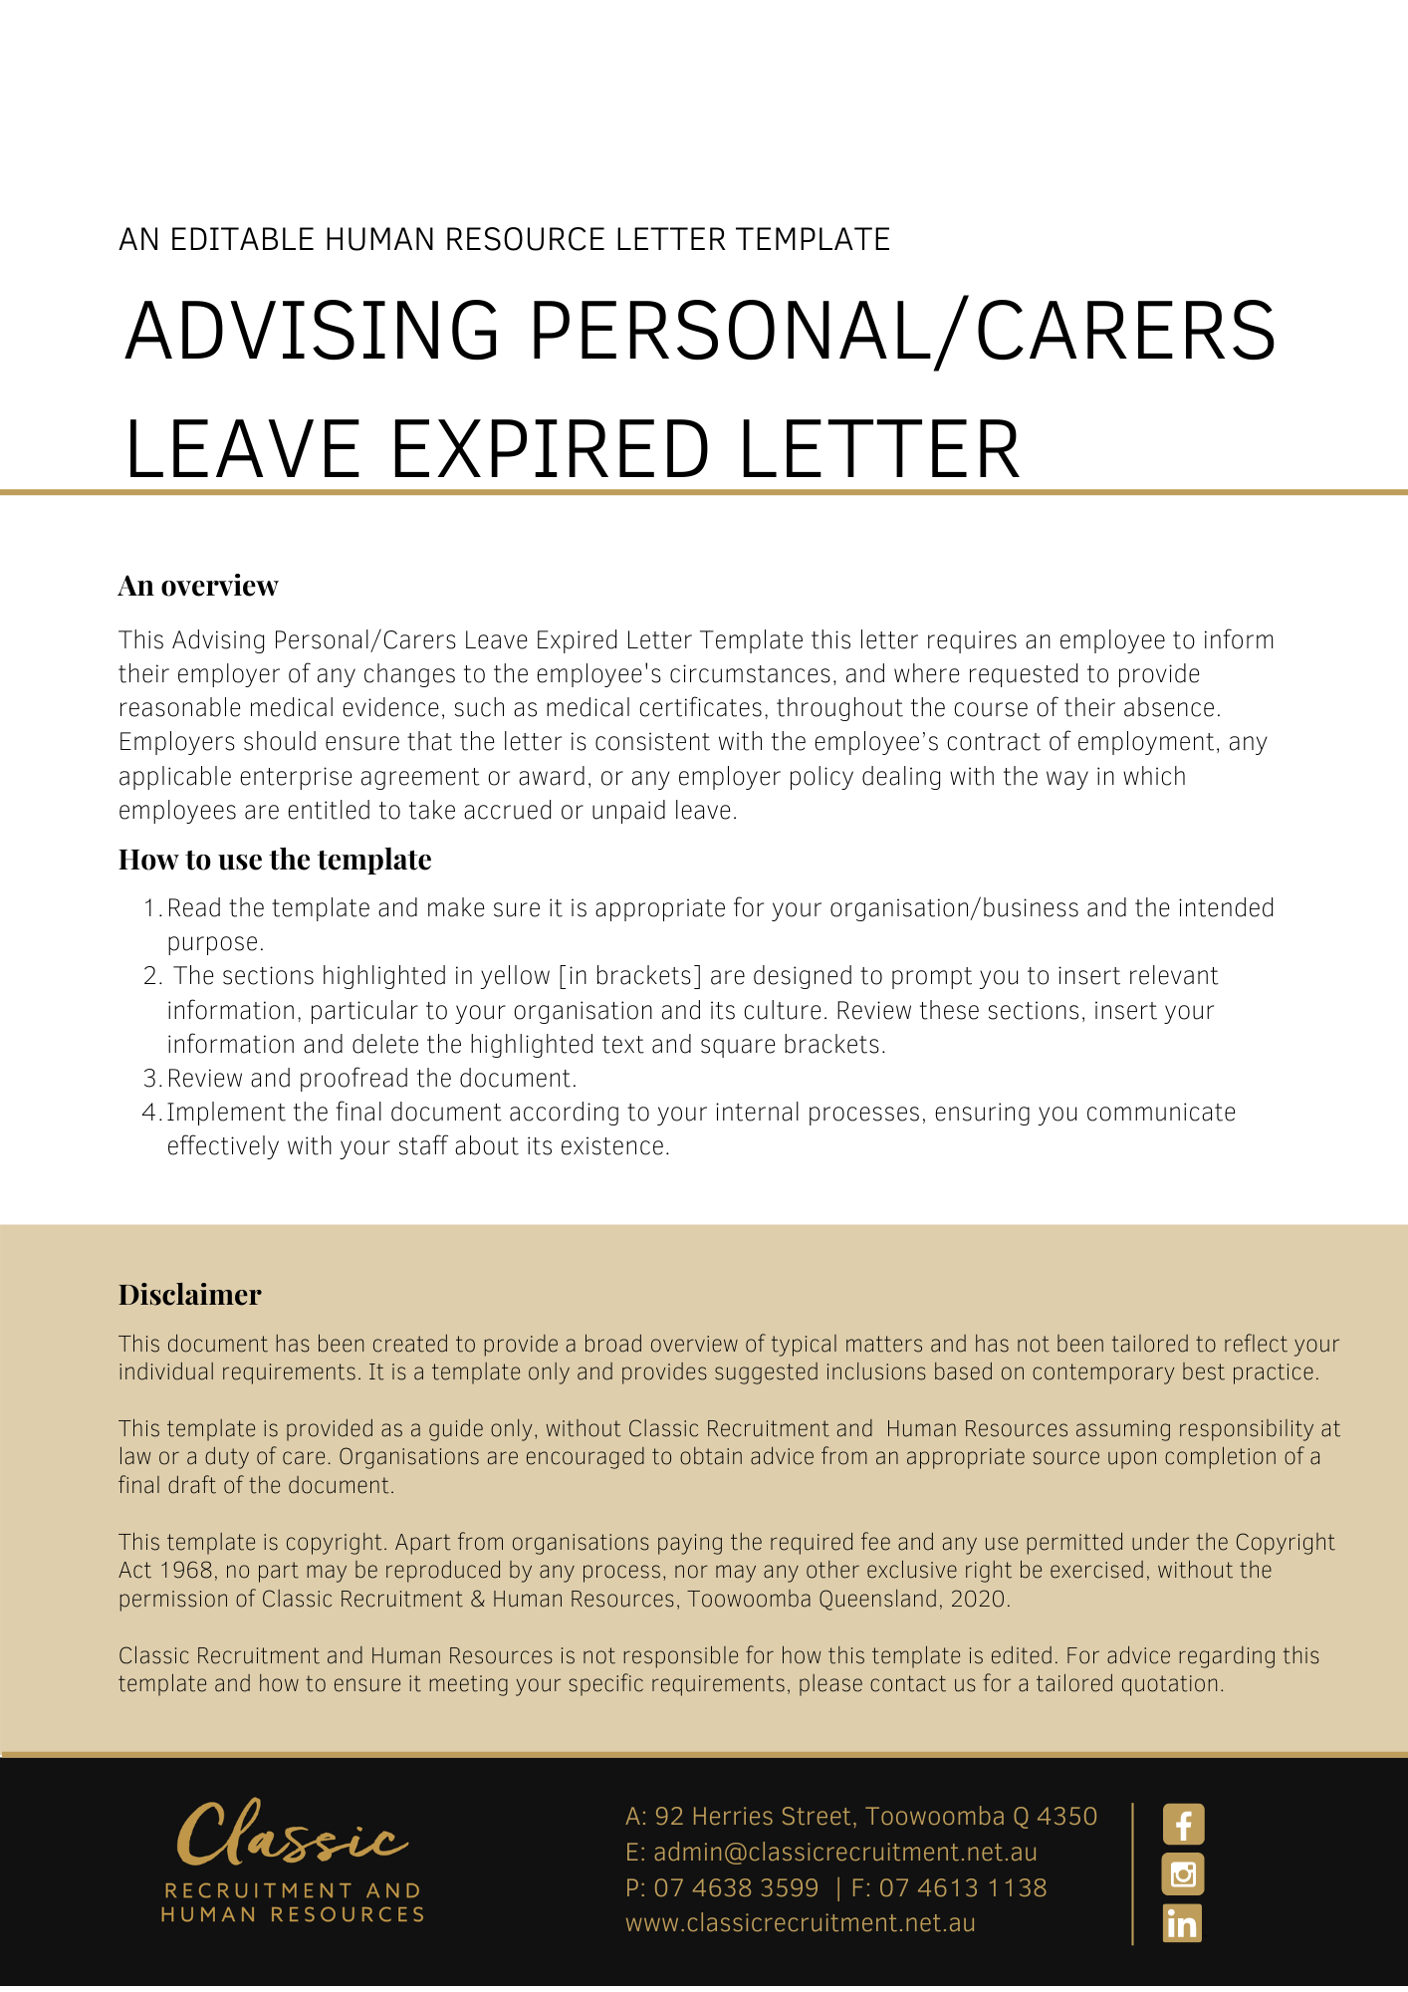
[Date]
[Employee First Name] [Employee Surname]
[Employee Address]

Personal Leave with [Company Name]
Dear [Employee First Name],

[Company Name] acknowledges that you have been on personal leave since [Date Start Leave], for which you have been receiving paid leave entitlements.
This letter is to inform you that your entitlement to paid personal leave will end on [Date Leave Expires]. At this time, you will have no accrued paid personal leave available.
On [Date Leave Expires], you have the option to continue paid leave, either using your accrued annual leave (where available) or accrued long service leave (where available). However, you will need to apply for this leave.
If you elect to take your accrued annual leave or long service leave and your period of absence extends beyond your accrued annual leave or long service leave entitlement, you will be entitled to a period of unpaid personal leave. Alternatively, if you do not elect to take your accrued annual leave or accrued long service leave from [Date Leave Expires], or elect to take any other accrued leave, [Company Name] will assume that you will be taking a period of unpaid leave.
During any period of unpaid leave, your period of absence will not count as service with [Company Name] and you will not accrue any entitlements that would otherwise be payable if you were at work or taking a period of paid leave. However, your absence will not break your continuity of service with [Company Name].
If you elect to take your accrued annual leave or accrued long service leave, or to take a period of unpaid leave after [Date Leave Expires], you are still required to continue providing [Company Name] with reasonable medical evidence (such as medical certificates) in the same manner as you have previously been required.
You will also be required to keep [Insert Position (e.g. CEO/Director/Owner)] informed of your likely period of absence, and if your circumstances change for any reason, to inform [Company Name] immediately.

Please contact [Insert Position (e.g. CEO/Director/Owner)] if you wish to discuss any detail relating to your Personal Leave or the contents of this letter.

[Salutations for goodbye],
[Company Name]
[Letter Signatory Name]
[Letter Signatory Position]

