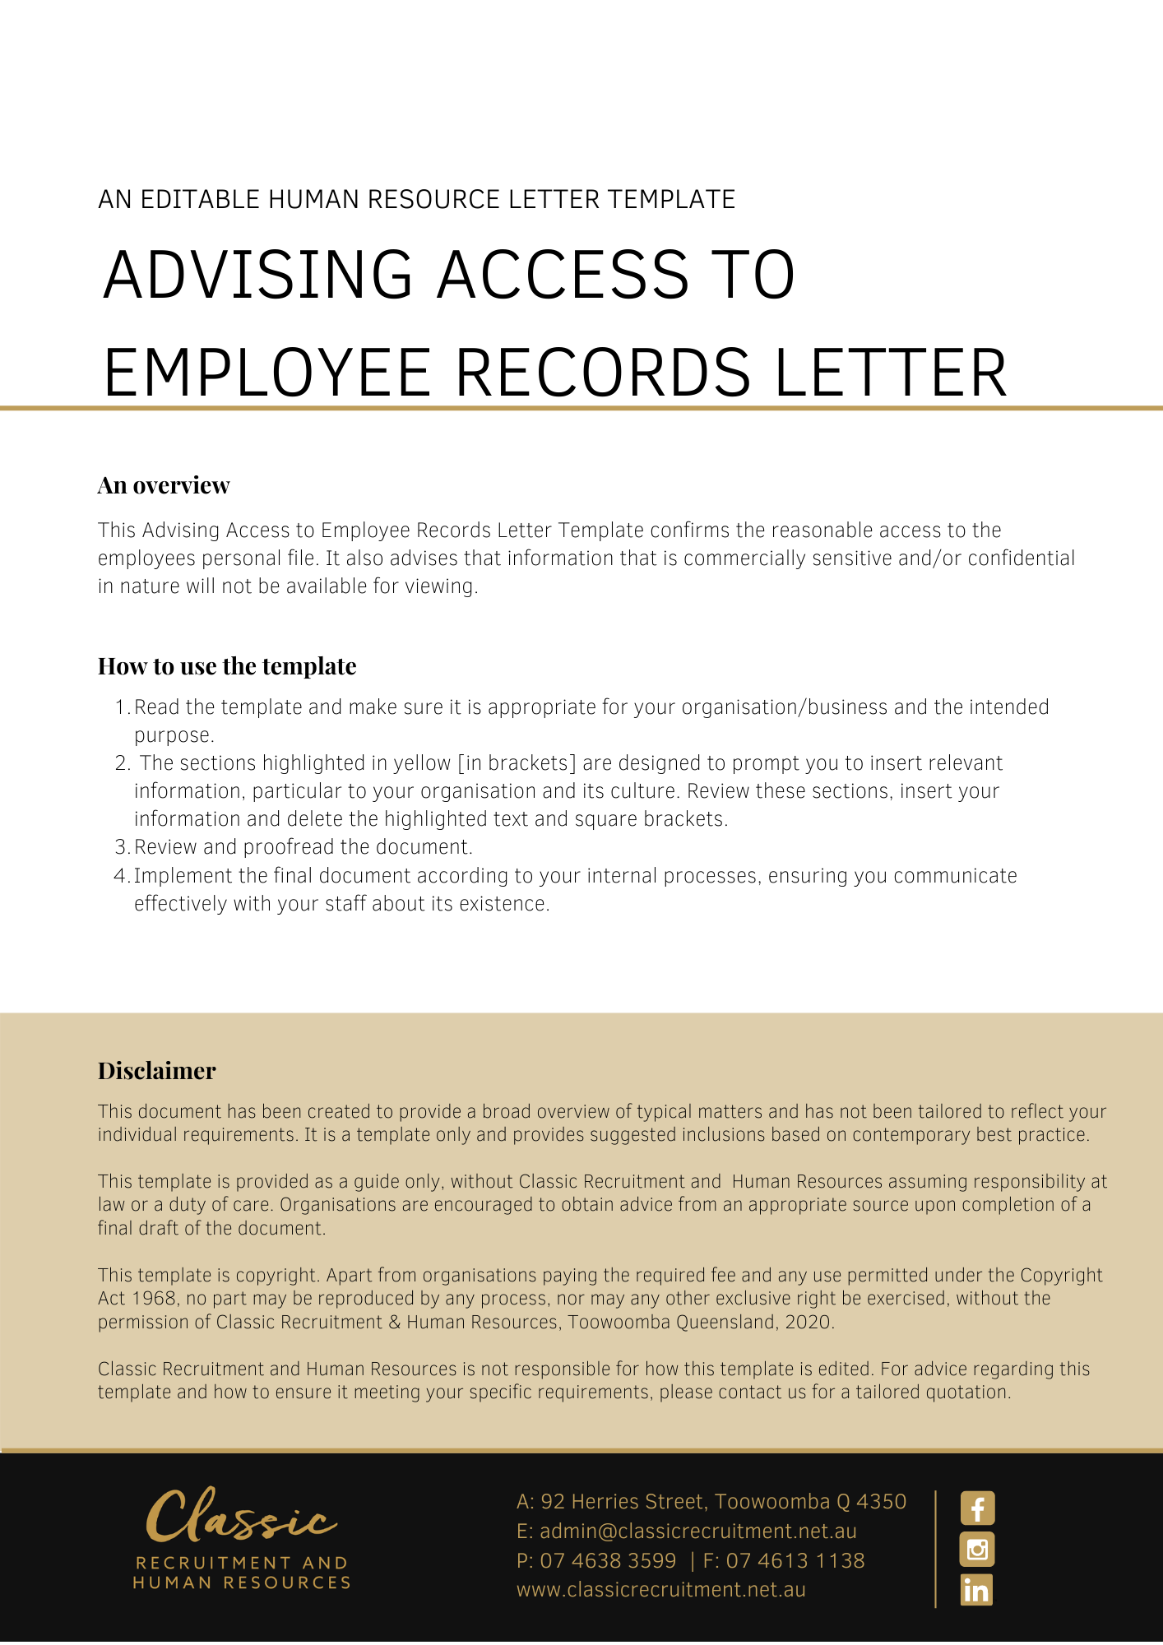
[Date]
[Employee First Name] [Employee Surname]
[Employee Address]

Letter Advising Access to Employee Records
Dear [Employee First Name],

Re: Your request for access to your HR file

In response to your request to view your HR file, [Company Name] confirms that reasonable access to your personnel file will be granted to you. Information that is commercially sensitive and/or confidential in nature will not be available for your viewing.

[Salutations for goodbye],
[Company Name]
[Letter Signatory Name]
[Letter Signatory Position]

