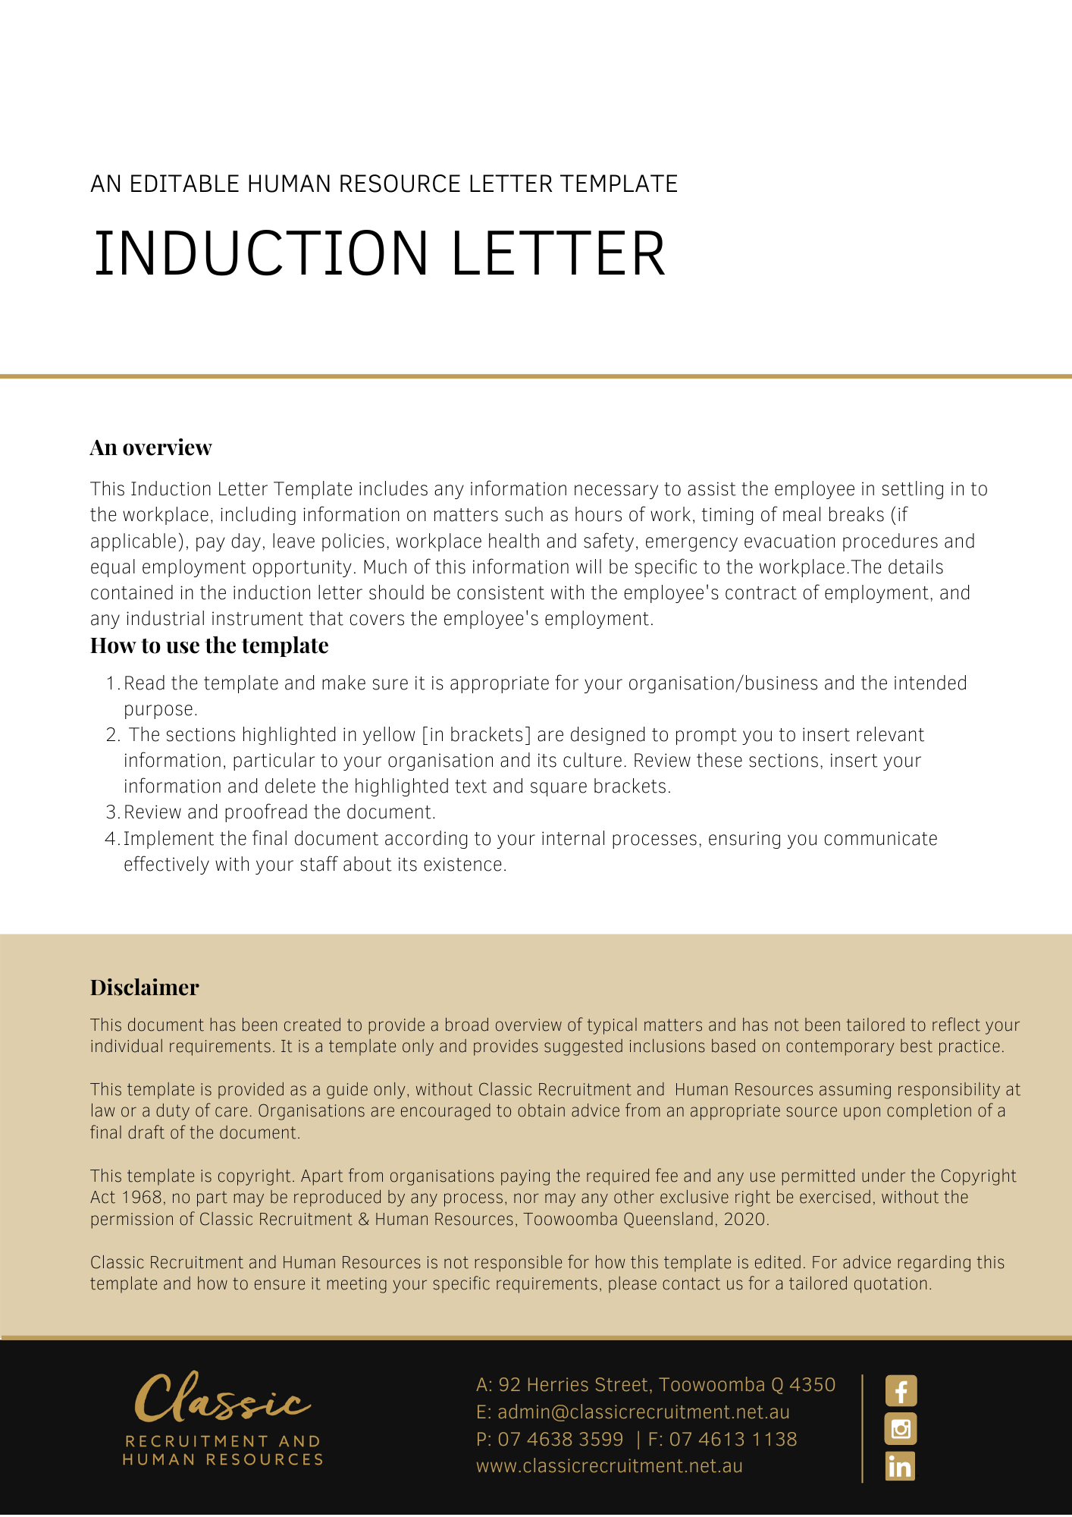
[Date]
[Employee First Name] [Employee Surname]
[Employee Address]

Induction Letter
Dear [Employee First Name],

Welcome to [Company Name]. We are very pleased to have you as part of our team and trust that you will make a great contribution to our success.
The terms and conditions of your employment are contained in your letter of appointment. You should also read and comply with [Company Name]’s policies and procedures as they relate to your employment. Such policies and procedures do not form part of your contract of employment.
We understand that there is a lot of information to take in on the first day, so we have provided the following details about working at [Company Name] to assist you to settle in as quickly as possible.
- Hours of Work
  - As stated in your letter of appointment, [Company Name]’s business hours are from [Business Hours Start] to [Business Hours End].
- Meal Breaks
2.1 [Insert Information Regarding Meal Breaks, i.e. Paid, Unpaid, Time Limit, etc.]
- Pay Day
  - Pay day is [Pay Day]. Your pay will be deposited into your nominated account at any bank or other acceptable financial institution. You should fill out the attached form to provide your account details.
- Emergency Evacuation
  - The Fire Warden in your area is indicated on the staff notice board. In the case of a fire or other emergency evacuation, you should assemble outside the building/worksite in accordance with the Fire Drill procedure. This procedure is located on the notice board.
- Workplace Health and Safety
  - [Company Name] supports a positive approach to workplace health and safety and is required by law to ensure high standards of workplace health and safety in the workplace. We have a number of workplace health and safety policies which you will be trained in. In addition, your supervisor will instruct you in the specific workplace health and safety requirements of your position. Please refer to the Workplace Health and Safety General Policy and any relevant operating procedures for further information.
  - Should you incur an injury in the workplace, you must report it to the Occupational Health and Safety Officer.
- Equal Employment Opportunity
  - [Company Name] is an equal opportunity employer. This means that you are expected to take all reasonable steps to prevent discrimination and harassment in the workplace.
  - Please refer to the Anti-discrimination and Equal Employment Opportunity Policy contained in the policies manual, as it is important that you understand what your rights and responsibilities are in this area.
This document does not form part of your contract of employment.
If you have any further queries, do not hesitate to contact me.

[Salutations for goodbye],
[Company Name]
[Letter Signatory Name]
[Letter Signatory Position]

