[Date]

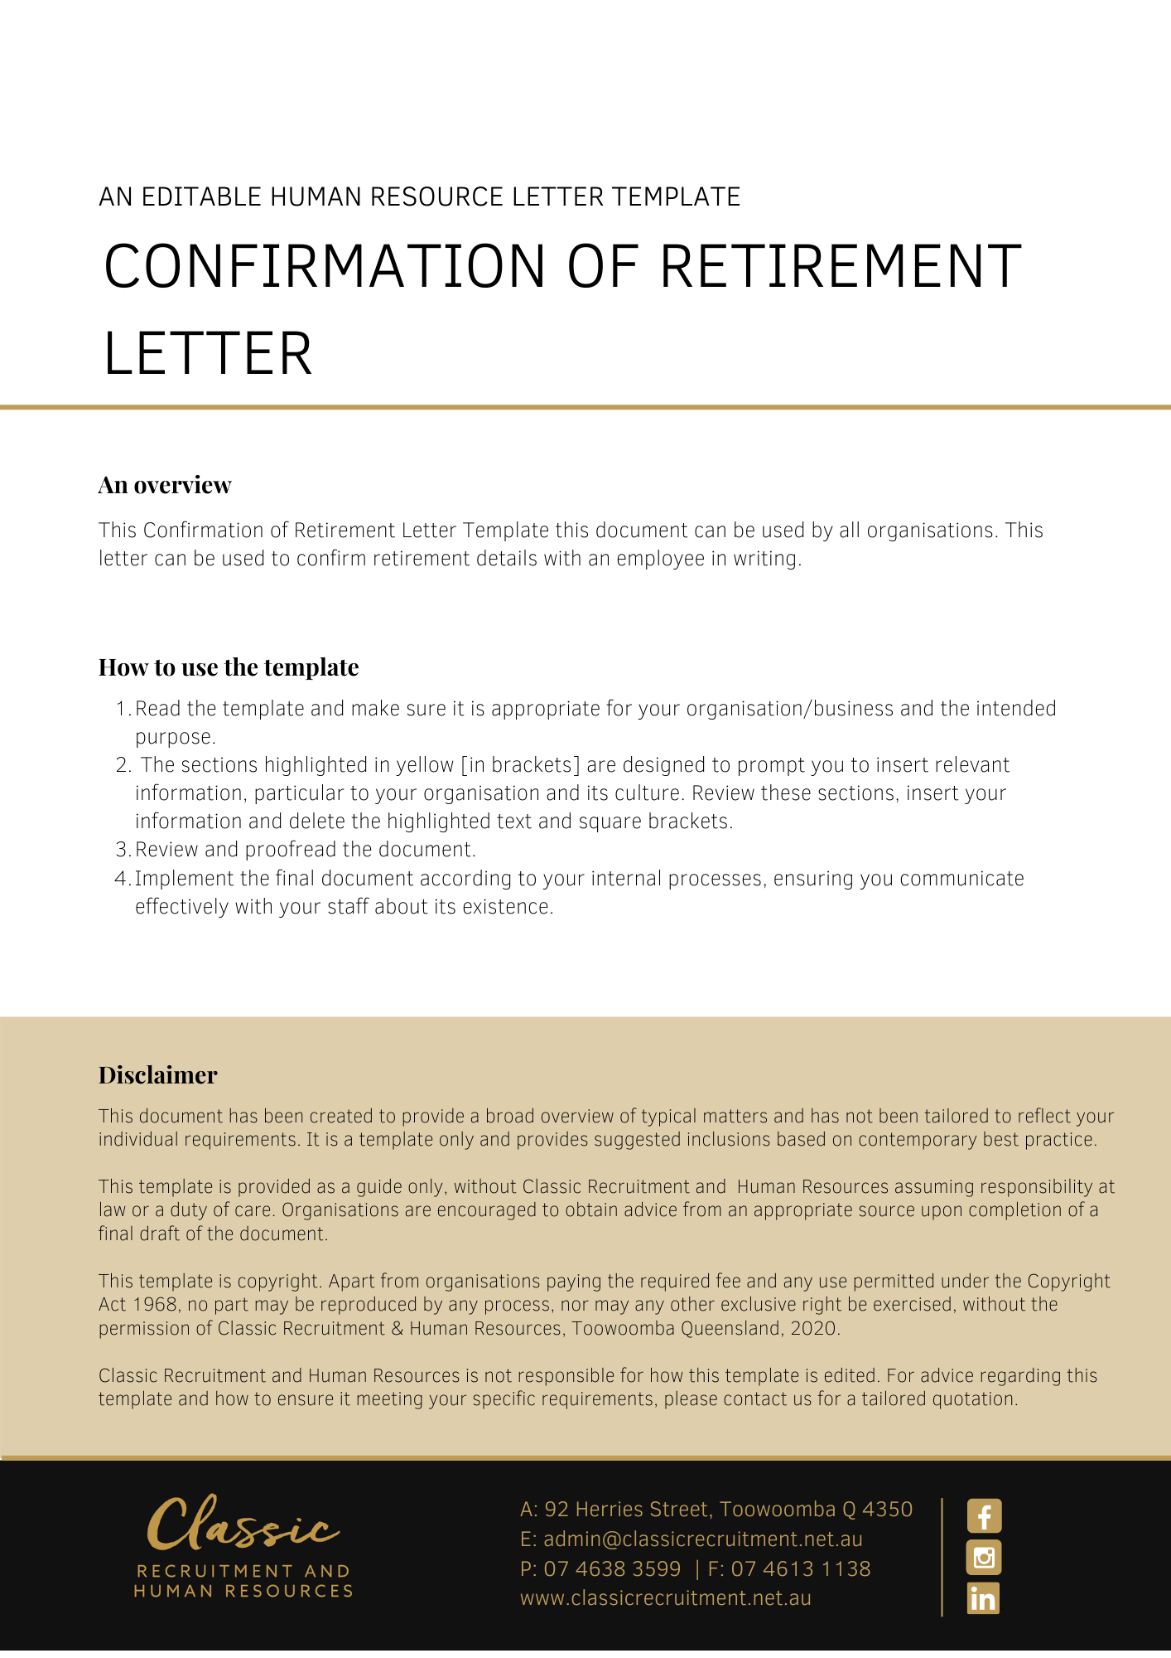

[Employee First Name] [Employee Surname]

[Employee Address]

**Confirmation of Retirement Letter**

Dear [Employee First Name],

On retirement you will receive payment for any accrued but untaken long service leave or annual leave entitlements you may have. We will also inform the relevant Superannuation Fund of your retirement and we expect they will be in touch with you.

I would like to take this opportunity to thank you for your services to [Company Name]. We wish you well in your retirement.

[Salutations for goodbye],

[Company Name]

[Letter Signatory Name]

[Letter Signatory Position]