[Date]

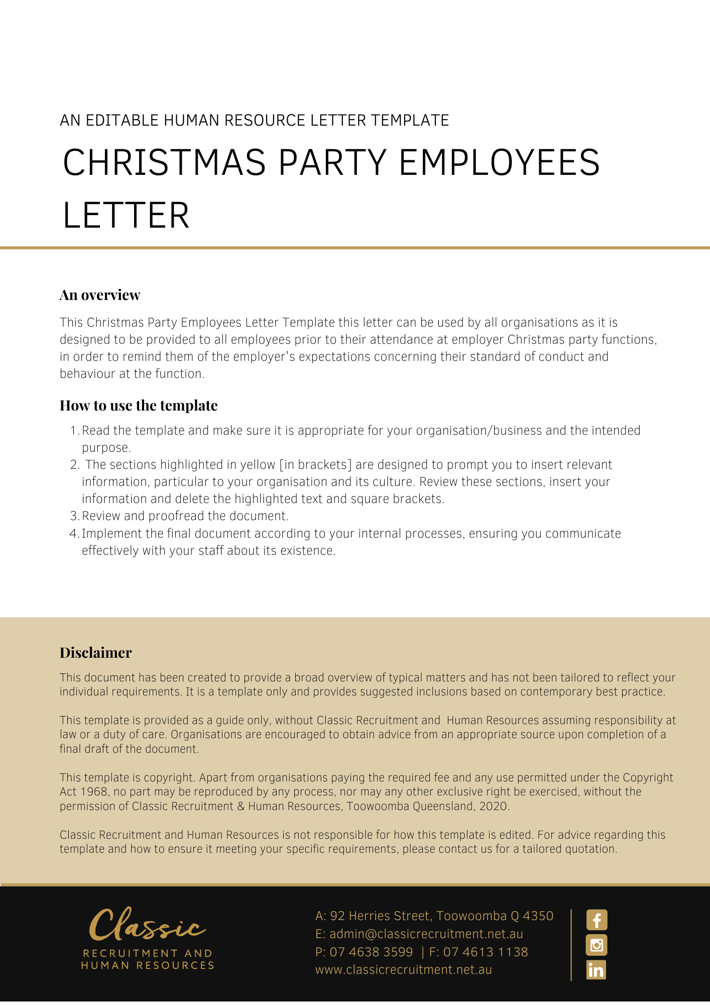

Important — All Employees Must Read

As you are aware the [Company Name] Staff Christmas party is upon us. It is being held at [Location] on [Date] from [Time]. This is a time for us to celebrate the festive season and enjoy each other’s company socially. Please remember however, that it is a work function, and an appropriate standard of behaviour and conduct is expected.

## *Drugs & Alcohol*

[Company Name] will provide food and drinks at the Christmas party including alcoholic beverages. If you choose to drink alcohol, you must ensure that you drink responsibly. Drinking responsibly involves not drinking excessively to become ‘drunk’ and eating enough to ensure the effects of alcohol are reduced. If you have any special dietary requirements in relation to food or drink, please let [Insert Position (e.g. CEO/Director/Owner)] know as soon as possible.

[Company Name]’s [Drugs Policy Name] applies to the Christmas party as a work function. We remind you that the use of illegal drugs and excessive consumption of alcohol is prohibited at all times during the Christmas party. [Company Name] reserves the right to require the venue to refuse service of alcohol to any member of staff who is, in the view of [Insert Position (e.g. CEO/Director/Owner)], behaving inappropriately.

## *Behaviour at the Party*

The Christmas party is an opportunity to celebrate and enjoy ourselves. However, please remember the party is a work function and accordingly, you must behave appropriately. [Company Name] Christmas party is governed by the [Insert Policy Name] and we remind you that these Policies apply to the Christmas party. If any issues arise during the party, please contact one of the Contact Persons listed below for assistance.

If you have not received the policies referred to above, please contact us as soon as possible. You should ensure that you have read and understood the policies, as well as the standard of conduct expected of you at the party. If you have any questions in relation to the policies, please contact one of the Contact Persons listed below for further information.

## *Not Required to Return to Work After Party*

The Christmas party will end at [CompletionTime]. It is a private matter whether you choose to continue socialising with work colleagues after the party. However, if you are able to be identified as a representative of [Company Name], and/or you remain in the company of work colleagues from [Company Name], please remember that you are required to conduct yourself appropriately.

## *Transport*

If you are drinking alcohol at the Christmas party, you should not drive. The following transport arrangements will apply to assist with your safe travel to and from the Christmas party:

* As the location of the Christmas party is close to public transport, parties are expected to make their own arrangements via public transport for travel to and from the Christmas party. However, if you become too intoxicated, unwell or are not able to safely use public transport, please make arrangements with a taxi service or contact one of the Contact Persons listed below who will arrange an alternative means of safe transport.
* Buses will collect staff from outside [Company Name]’s office at [Bus Pickup Time] and take you to the Christmas party. If you normally drive to work, you can leave your car at work overnight or take public transport to work on the morning of the Christmas party.
* After the Christmas party, buses will transport staff to a number of central public transport hubs. The bus will also return to [Company Name]’s office. You should not however, drive home if you have been drinking alcohol. If you wish to drive other staff members in the car, please contact one as soon as possible to register your carpool arrangements. Registration is essential for health and safety reasons.

[Delete After Reading: if any of these travel arrangements are inaccurate, please alter as required]

## *Contact Persons*

There will be a number of Contact Persons attending the Christmas party to deal with any issues that may arise during the course of the party. These Contact Persons are:

* [Insert Position (e.g. CEO/Director/Owner)] [Insert Contact Details]
* [Insert Position (e.g. CEO/Director/Owner)] [Insert Contact Details]
* [Insert Position (e.g. CEO/Director/Owner)] [Insert Contact Details]

[Delete After Reading: please alter amount of contact persons as required]

**Enjoy the party and Merry Christmas**