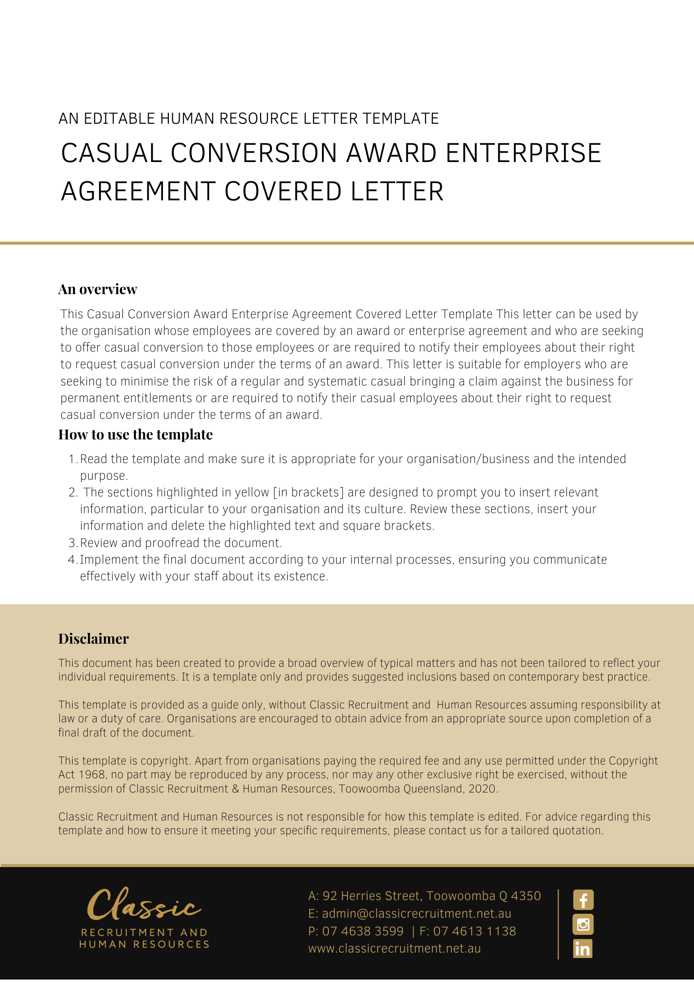

[Date]
[Employee First Name] [Employee Surname]
[Employee Address]

Casual Employment Conversion Letter

Dear [Employee First Name],

I refer to our recent discussions and confirm that, as you have been employed by [Company Name] as a casual employee on a regular basis. In accordance with the [Insert Award and Class/Grade] that your covered under, [Company Name] would like to offer you the opportunity to have your employment converted to permanent [Delete after reading: choose either Full-Time or Part-Time] employment.

As you are aware, you are currently paid a casual rate of [Insert current hourly pay rate] per hour, which includes a 25% casual loading. If your employment is converted to permanent [Delete after reading: choose either Full-Time or Part-Time] employment, you will no longer be eligible to receive a casual loading, which means that your rate of pay will be reduced to [Insert permanent hourly pay rate] per hour.

As a [Delete after reading: choose either Full-Time or Part-Time] employee, you would be entitled to the benefits associated with [Delete after reading: choose either Full-Time or Part-Time] employment, including paid annual leave and personal leave in accordance with the relevant legislation.

You have [Delete after reading: insert the required amount of time required e.g. four weeks] from the date of this letter in which to decide whether you wish to have your employment converted to permanent employment. Please complete the enclosed election form and return this to us by [Return Date].

If you do not elect to convert to [Delete after reading: choose either Full-Time or Part-Time] employment during this time, you will be deemed to have elected against any such conversion.

If you do elect to convert to [Delete after reading: choose either Full-Time or Part-Time] employment, you will then be asked to sign a [Delete after reading: choose either Full-Time or Part-Time] employment agreement.

Please contact [Insert Position (e.g. CEO/Director/Owner)] if you wish to discuss these matters further.

[Salutations for goodbye],
[Company Name]
[Letter Signatory Name]
[Letter Signatory Position]

Casual Conversion Election Form

I, ___________________________________________, acknowledge that I:
^{Employee Name}

- have received a letter from [Company Name] on [Date Letter Received] in relation to the opportunity for me to elect to have my regular and systematic casual employment converted to [Delete after reading: choose either Full-Time or Part-Time] permanent employment;

- have had the opportunity to seek any necessary advice in relation to this matter;

- understand that if I elect to remain a casual employee, I will not be entitled to the benefits associated with permanent employment, including paid annual leave and personal leave; and

- make the following election in relation to my employment without coercion or duress.

I wish to have my employment converted to [Delete after reading: choose either Full-Time or Part-Time] permanent employment
I wish to remain a casual employee

Employee Signature: ______________________________

Employee Name: ______________________________

Date: ______________________________

