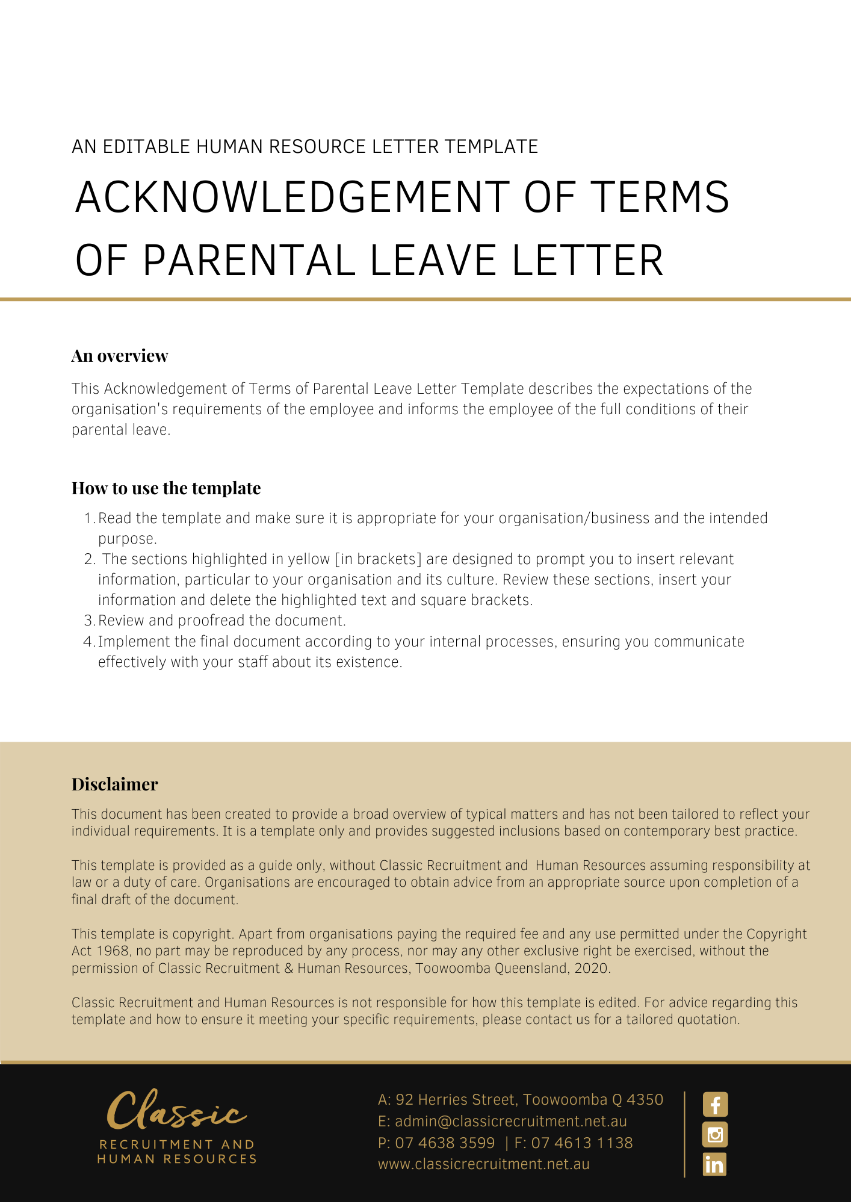
[Date]
[Employee First Name] [Employee Surname]
[Employee Address]

Acknowledgment of Terms of Parental Leave
Dear [Employee First Name],

[Company Name] has received your application for time off work for parental leave and we are happy to advise that your leave request has been granted subject to your compliance with the below conditions.

Conditions of parental leave
Your request for parental leave has been granted subject to your compliance with the following points:
- Your parental leave is due to commence on [Parental Leave Start Date] as you stated in your application form.
- Your proposed date of return to work is [Parental Leave End Date]. You must confirm with your [Insert Position (e.g. CEO/Director/Owner)] in writing 4 weeks’ prior to [Parental Leave End Date] whether you will be returning to work.
- If you wish to return to work earlier than the previously agreed date or extend your period of parental leave, you should contact [Insert Position (e.g. CEO/Director/Owner)]. You should provide no less than 4 weeks’ notice of the proposed change and specify the new end date for the leave. That request will then be assessed, and you will be notified in due course.
- During any period of your parental leave, which is unpaid, you must make alternative arrangements for any regular payroll deductions.
- [Company Name]’s contributions to your superannuation cease during any period of unpaid parental leave, although you may elect to continue personal contributions.
- You must immediately advise [Company Name] if you cease to be the primary care giver of your child during the period of parental leave.
- Your absence can be approved up to a maximum of 12 months and may consist of annual leave, long service leave (if applicable) and unpaid parental leave.
- [Company Name] may need to consult with you while you are on parental leave about significant work matters that may directly impact on you. Accordingly, you must inform [Company Name] of your contact details no less than 2 weeks before [Parental Leave Start Date] and as and when those details change during your period of parental leave.
- You are entitled to submit a request in writing to [Company Name] no less than 4 weeks before [Parental Leave End Date] to extend your period of parental leave beyond the initial 12 months period by up to another 12 months. [Company Name] will consider your request and advise you whether it has been granted or refused.
- The relevant terms and conditions of your contract of employment continue to apply to you during your period of leave.

We wish you all the best for your parental leave.

Please contact [Insert Position (e.g. CEO/Director/Owner)] if you wish to discuss any detail relating to your parental leave or the contents of this letter.

[Salutations for goodbye],
[Company Name]
[Letter Signatory Name]
[Letter Signatory Position]

