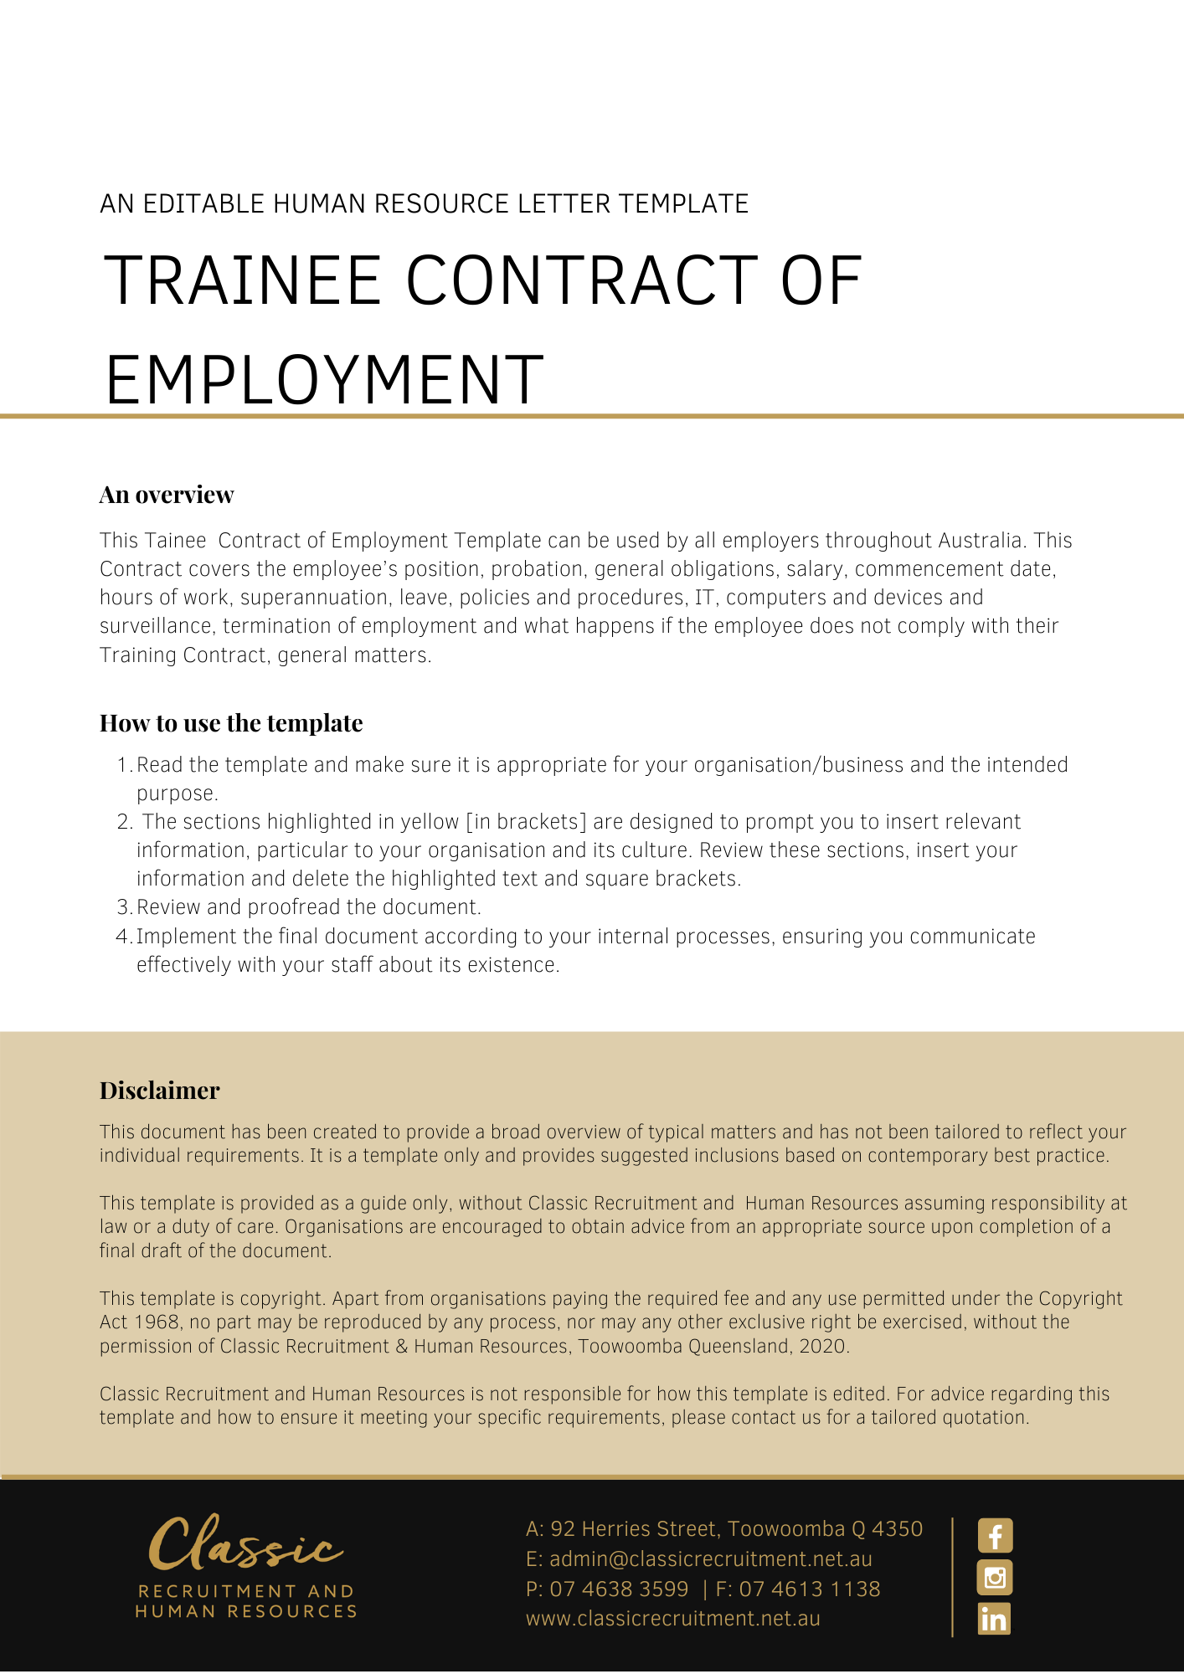
Contract of Employment - Trainee

[Date]
[Employee First Name] [Employee Surname]
[Employee Address]

PRIVATE AND CONFIDENTIAL
Dear [Employee First Name],

Re: Offer of employment with [Company Name]

I am pleased to confirm our offer of employment as set out in the attached employment agreement. I look forward to you joining the team and wish you every success in your new role.

[Salutations for goodbye],
[Company Name]
[Letter Signatory Name]
[Letter Signatory Position]

ACCEPTANCE OF THIS OFFER OF EMPLOYMENT
I accept this offer of employment and agree to be bound by the terms and conditions set out in the attached Employment Agreement.

SIGNATURE |  | DATE

EMPLOYMENT AGREEMENT

Key Details
The Key Details are set out in the table below:

Employee | [Employee First Name] [Employee Surname]

The Business | [Company Name]

The Position | [Insert Position]

Position Status | Full time traineeship

Wages | [Insert Wage]

Start Date | [Start Date]

Location | [Work Location]

Wages Instalments | [Pay Basis]

Position, Probation and Employment-Related Legislation
You will be employed in the Position set out in the Key Details.
This Position’s Status is set out in the Key Details.

The first [Probation Period Length] months of your employment will constitute a probationary period. Your continued employment with the Business is dependent on you completing the probationary period to the Business’ satisfaction.
Your employment with the Business is also governed by a formal Training Contract that is agreed between you, the Business and Queensland.
Your employment may also be governed by the provisions of an applicable industrial instrument such as an award or enterprise agreement or other employment related legislation. Any such industrial instrument or employment related legislation does not form part of and is not incorporated into this Employment Agreement for any purposes.

General Obligations
During your employment, you must perform your work and anything connected with it:
- with due care and skill and in a proper, thorough and co-operative manner;
- safely, and in accordance with the Business’s safety requirements (including attending for work free from the risks associated with taking alcohol and/or other drugs at, or prior to attending, work);
- in accordance with any day-to-day directions given by the Business;
- in accordance with any written direction, procedure or other specifications provided by the Business to you (relating to the performance of your work or anything connected with it);
- by avoiding conflicts of interest, without acting (directly or indirectly) in competition with or against the Business without prior written consent from the Business;
- attending the relevant Registered Training Organisation to complete the theoretical components of your traineeship;
- performing any duties which are necessary or incidental to completing your traineeship;
- in accordance with the Business’ values;
- using best efforts to promote the Business;
- without jeopardising or damaging the Business;
- by maintaining confidentiality; and
- in compliance with all relevant laws.

Remuneration
You will initially be paid the Wages set out in the Key Details.
Your Wages will be paid into an account of a recognised financial institution of your choice which will be paid to you in the Wages Instalments set out in the Key Details.

Commencement
You will commence your employment with the Business on the Start Date and the Location set out in the Key Details.

Hours of Work
Your ordinary hours of work will be an average of 38 hours per week, starting when you commence your employment with the Business.
You may be required to work reasonable additional hours Monday to Sunday to meet operational needs.
These hours include attendance at the relevant Registered Training Organisation to complete the theoretical components of your traineeship. The hours of the Registered Training Organisation may differ to those of the Business.

Superannuation
The Business will, when required, make superannuation contributions on your behalf in accordance with the relevant legislation and/or industrial instrument in force from time to time.

Leave
Any entitlement you have to leave, including annual leave, personal/carers leave, compassionate leave and long service leave is regulated by applicable employment related legislation.

Policies and Procedures
As an employee of the Business, you are required to comply with the Business policies and procedures as they relate to your employment as varied from time to time at the Business’ discretion. Such policies and procedures are not incorporated into, and do not form part of, this Employment Agreement.

IT, Computers and Devices
The Business may engage in:

- computer surveillance of all its information technology systems, including email usage, internet usage and any other usage of information technology supplied by the Business. This surveillance may be carried out on a continuous and ongoing basis and may be ongoing from the commencement of your employment;
- camera surveillance by way of closed circuit television cameras. The surveillance may be continuous and ongoing. For the purposes of your employment with the Business and exposure to the surveillance, it may effectively start upon your commencement. Access to the recorded material will be strictly limited to authorised personnel; and
- tracking surveillance by means of an electronic device the primary purpose of which is to monitor or record geographical location or movement (such as a Global Positioning System tracking device). The surveillance may be continuous and ongoing. For the purposes of your employment with the Business and exposure to the surveillance, it may effectively starts upon your commencement. Access to the recorded material will be strictly limited to authorised personnel.
You consent to this surveillance.

Termination

Termination upon completion of traineeship
Unless terminated earlier in accordance with other provisions of this employment agreement, your employment and this Employment Agreement with the Business will automatically terminate upon:
- the cancellation of your Training Contract (for any reason); or
- the completion of your traineeship
whichever is the earlier.
Termination and notice prior to completion of traineeship

During the probationary period as stated in the applicable Training Contract, either party may terminate your employment and this Employment Agreement by:
- notifying Queensland;
- cancelling the Training Contract; and

The Business may, upon application Queensland, extend the probationary period by up to 3 months prior to the original Probation Period expiring.
Outside of the probationary period, the Business may terminate your employment and this Employment Agreement at any time by:
- notifying Queensland;
- cancelling the Training Contract; and
- providing you the period of written notice required by the National Employment Standards (NES).
Outside of the probationary period, you may terminate your employment and this Employment Agreement at any time by:
- notifying Queensland;
- cancelling the Training Contract; and
- providing an equivalent amount of notice to that required of the Business under the NES, unless a modern award or enterprise agreement provides otherwise in which case the modern award or enterprise agreement provision will apply.
The Business may, at its discretion, make payment in lieu of part or all of the notice period.
The Business may otherwise terminate your employment and this Employment Agreement immediately and without notice in the event you are found to have engaged in serious misconduct, subject to first contacting Queensland and cancelling the Training Contract.

General Matters
This Contract supersedes and replaces all prior representations, contracts and agreements (whether oral or in writing) concerning your employment with the Business, but does not override the terms of the Training Contract.If you are under 18 years of age and under the care and control of a parent or legal guardian, your parent or legal guardian must be a party to the Training Contract and ensure that you adhere to the responsibilities attached to the Training Contract.
Each provision of this Employment Agreement is severable from the others and the severance of a provision does not affect the remainder of this Employment Agreement.
Where, at any time a law and/or industrial instrument (including a modern award or enterprise agreement) applies to your employment, while any instrument is not incorporated into, and does not form part of, this Employment Agreement, your salary covers all monetary amounts that the Business might otherwise have to pay arising under a law and/or industrial instrument (including wages, overtime, allowances, penalties and loadings) and compensates you for all hours worked.
The Business may alter your Position, work location, reporting arrangements, position description and responsibilities in accordance with the needs of the Business. You agree that irrespective of any such changes, the terms and conditions of this Employment Agreement continue to apply unless varied in writing.
The Business also reserves the right to apply to Queensland to suspend the Training Contract if necessary in the circumstances.

Shift Work

The Business may direct you to work shift work whenever it so requires to meet its operational need.

