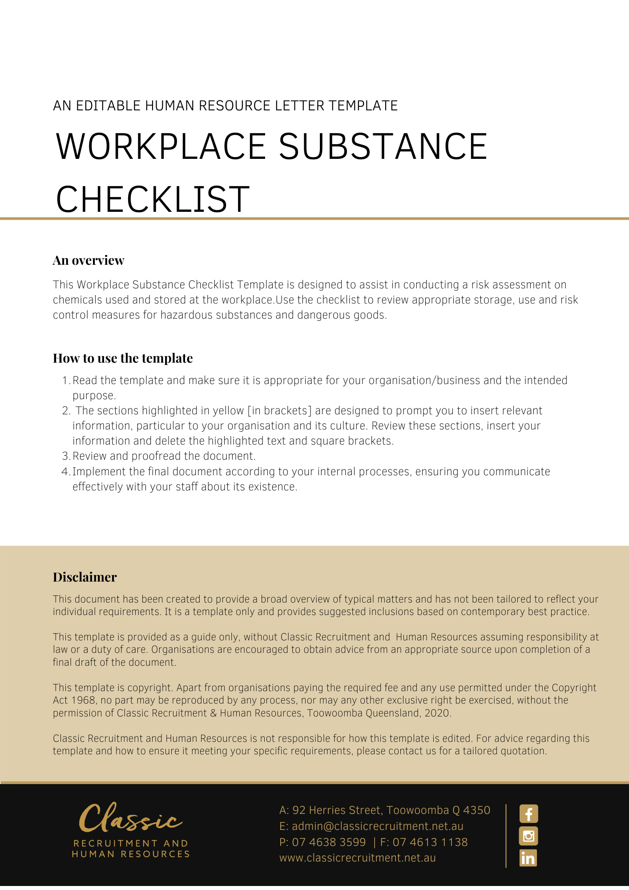
Workplace Substances Checklist

 |  | Product name: |  |  |  |  |  | Generic name:
 |  | Position title: |  |  |  |  |  | Company:
 |  | Date checklist completed |  |  |  |  |  | Date for review
 |  | Name of person completing checklist
 |  | What is the product used for (outline the work activity):
 |  | The name of the company supplying this product:
 |  |  |  |  |  |  |  |  |  |  |  | YES |  |  |  |  | NO
 |  | - Is the product clearly labelled?
 |  | - Is an MSDS/SDS needed for this product? (Check with your supplier if uncertain)
 |  | - Does the workplace have the MSDS/SDS for this product?
 |  | - Is the MSDS/SDS recorded in the Hazardous Substances Register?
 |  | - Do employees know about the MSDS/SDS and have access to it at all times?
- Hazardous Nature of the Chemicals (Refer to the MSDS/SDS)
 |  | Corrosive |  | Acute toxicity |  |  |  |  | Dangerous when wet (DG Class 4.3)
 |  | Mutagen |  | Reproductive effects |  |  |  |  | Oxidizer (DG Class 5)
 |  | Irritant |  | Explosive |  |  |  |  | Harmful to the environment
 |  | Sensitiser |  | Radioactive |  |  |  |  | Asphyxiant
 |  | Carcinogen |  | Flammable |  |  |  |  | Spontaneously combustible (DG Class 4.2)
 |  | - Exposure to the Substance
 |  | How often is this work activity performed (duration)?
 |  | Level of exposure (with existing controls) |  |  |  |  | High |  |  |  | Uncertain
 |  |  |  |  |  |  | Medium |  |  |  | Not significant
 |  |  |  |  |  |  | Low
 |  | Likely routes of exposure (with existing controls) |  |  |  |  | Inhalation |  |  |  | skin
 |  |  |  |  |  |  | Ingestion |  |  |  | eyes
 |  |  |  |  |  |  | Injection
 |  | 8. ESTIMATED RISK |  |  |  | Exposure risks not significant
 |  |  |  |  |  | Exposure risks significant, but well controlled at present
 |  |  |  |  |  | Exposure risks not effectively controlled
 |  | - RISK CONTROL |  |  |  |  |  |  |  |  |  |  | YES |  |  |  |  | NO
 |  | How can I improve safety? (Control measures to be implemented to reduce the risk of exposure during this work activity)
 |  | Is a safer product available?
Can I minimise risks by:
Buying smaller quantities to avoid decanting, spillage, splashes etc?
 |  | Using a lesser concentration?
 |  | Can engineering controls be used?
 |  | Is ventilation adequate?
 |  | Emergency procedures and equipment in place (e.g. Spill kits, emergency showers, eye wash stations, first aid kit)
 |  | Training provided to employees?
 |  | Wastes disposed of safely
 |  | Safe work procedures in place?
 |  | Are employees/workers:
 | Checked if they are high risk (e.g. pregnant; prone to allergies)?
 |  | Consulted about the use of the product?
 |  | Aware of any harmful effects?
 |  | Provided with the correct safety equipment?
 |  | Trained in its storage, use, disposal and emergency procedures?
 |  | Does the workplace have appropriate first aid to deal with splashes or other incidents?
 |  | Action Required:

Date actions completed:
Name: | Position:
Signature:

Return Completed form to: [Insert Position (e.g. CEO/Director/Owner)]

