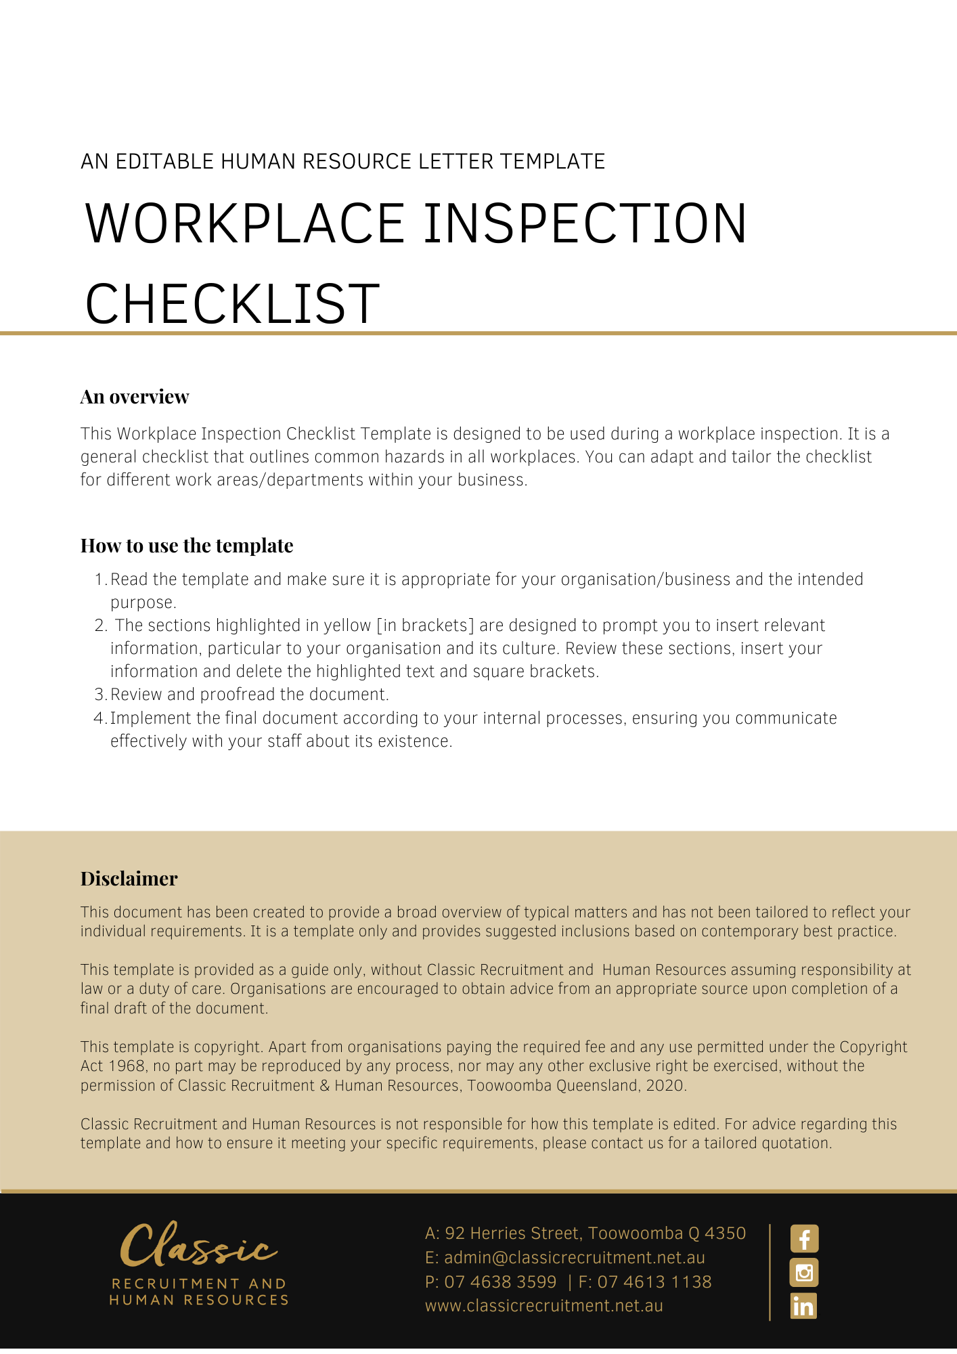
Workplace Inspection Checklist

Date of inspection |  | Time of inspection
Area inspected:
Inspected by:

Issue | Yes | No | Action To Be Taken | Date Completed
1. Work Environment
Work areas clean
Floors clean, dry and free of refuse
Stairs clean, dry and free of refuse
Bins available and emptied regularly
Is the work height/position awkward or difficult (ergonomic)?
Passageways stairways clear of obstructions
Floors of an even surface
Is there adequate working space?
2. Lighting
Is there adequate lighting for tasks performed?
Is task lighting required?
Are light covers in place and clean?
3. First Aid Facilities
Are adequate first aid facilities provided (eg first aid kit, first aid room)?
Are first aid facilities clearly labeled?
List of current first aiders and contact details
First aid reporting form available
Emergency numbers displayed
4. Emergency Response
Are emergency response procedures displayed and up to date?
Are staff trained in emergency procedures?
Is there a designated assembly point ?
Exit signs and directions to exits
Exit doors easily opened from the inside
Emergency exits, fire extinguishers and hoses unobstructed
Extinguishers in place, clearly marked for the type of fire, and serviced 6 monthly
Regular emergency drills performed
Staff trained in the use of fire extinguishers
No smoking signs displayed
List of fire wardens displayed
5. Stacking and Storage
Adequate storage facilities
Storage racks — secure and bolted
Storage racking checked regularly
Pallets in good condition

Issue | Yes | No | Action To Be Taken | Date Completed
6. Electrical Installations
Adequate wiring, well insulated
Fuses provided
Fire hazards checked
Electrical danger signs posted
Correct fire extinguishers available
Power points free of obvious defects
Clear space in front of switchboards of at least 1 metre
Switchboard door capable of being locked to prevent unauthorised access
Electrical installations and electrical equipment inspected, tested and maintained. Refer to AS/NZS 3760.
7. Portable Electrical Equipment
Plugs, cables, sockets, switches in good condition
Extension leads and power boards in a safe operating condition
Portable outlet devices suitable (double adaptors & piggy back plugs not recommended)
Electrical equipment inspected, tested and tagged in accordance with AS/NZS 3760
Electrical leads positioned to avoid tripping and damage risks
Are earth leakage circuit breakers installed?
Are safety switches used?
8. Ladders
Ladders inspected and in good condition
No splicing or repairs
Properly secured — top and bottom
Non slip feet fitted
Extend past landings by 1 metre
Constructed of sound materials
Located on firm footing
Free of debris and materials
Metal ladders not used for electrical tasks
Step ladders fully open when in use
9. Plant Safety
Prescribed plant is registered
Machine guards in place
Plant risk assessments conducted
Machinery in good condition
Safe operating procedures displayed
Are out of service/danger tags available?
Plant regularly maintained
Are records of inspections, maintenance and repairs kept?
Personal Protective Equipment provided
Safety signs displayed
Plant operators have national certification (where needed)

Issue | Yes | No | Action To Be Taken | Date Completed
10. Gas Cylinders
Stored upright
Maintenance/Inspection up to date
Stored in fire resistant and well ventilated areas
Clear separation between full and empty cylinders
11. Workplace Substances
Containers clearly identified
Chemicals safely stored
Spill trays provided
Proper types and number of fire extinguishers
Personal protective Equipment available
Personal Protective Equipment provided
Material Safety Data Sheets/Safety Data Sheets available
Workplace substance register available
Staff trained in chemical safety
Spill kits available

Issue | Yes | No | Action To Be Taken | Date Completed
Staff Facilities
Toilets, washrooms accessible and clean
Washroom consumables available for good hygiene practices
Meal areas accessible, comfortable, clean and hygienic
Potable water is readily available
Meal areas sufficiently removed from workplace activities
Lighting sufficient
Other issues identified:

Return Completed form to [Insert Position (e.g. CEO/Director/Owner)]

