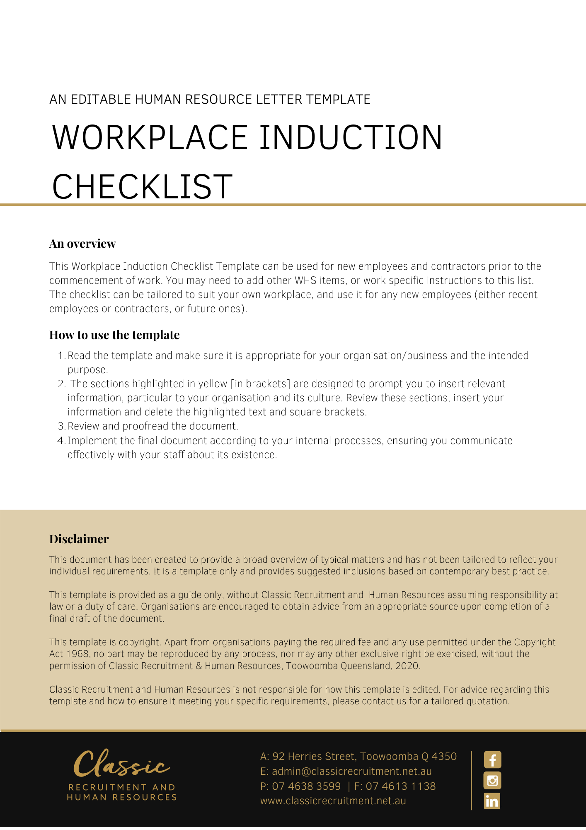
Workplace Induction Checklist

Worker name: |  |  |  |  |  | Date of commencement:
Position: |  |  |  |  |  | Date of induction:
Supervisor name:
Name of person conducting the induction:
Please tick |  |  |  | Yes |  |  | No | Comments
Welcome worker
Introduce worker to management and supervisors
Introduce worker to co-workers
Work hours/meal breaks and overtime
Explain work tasks and provide job description
Tour of the workplace
Location of toilets/amenities
First aid kits and names of first aiders
Manager’s office/location
Noticeboards & WHS information/signs
Exit points and evacuation instructions
Location of nearest WHS manual & safe work procedures
Explain WHS/OHS management and procedures
WHS policy
WHS responsibilities
Consultation mechanism and issue resolution
Hazard & injury reporting procedure
Workers compensation claims procedure (where relevant)
Return to work program (where relevant)
Hazardous substance procedure
Personal Protective Equipment [PPE] — location & storage
Training program
Evacuation procedure
Manual handling procedures
Training and competency needs assessment conducted based on WHS risks in specific job tasks:
Additional training required;
List:
Traffic Management (safety working around forklifts & other vehicles)
Safe working at heights
Signed - [Insert Position (e.g. CEO/Director/Owner)] |  |  |  |  | Signature:  worker
Date |  |  |  |  | Date

