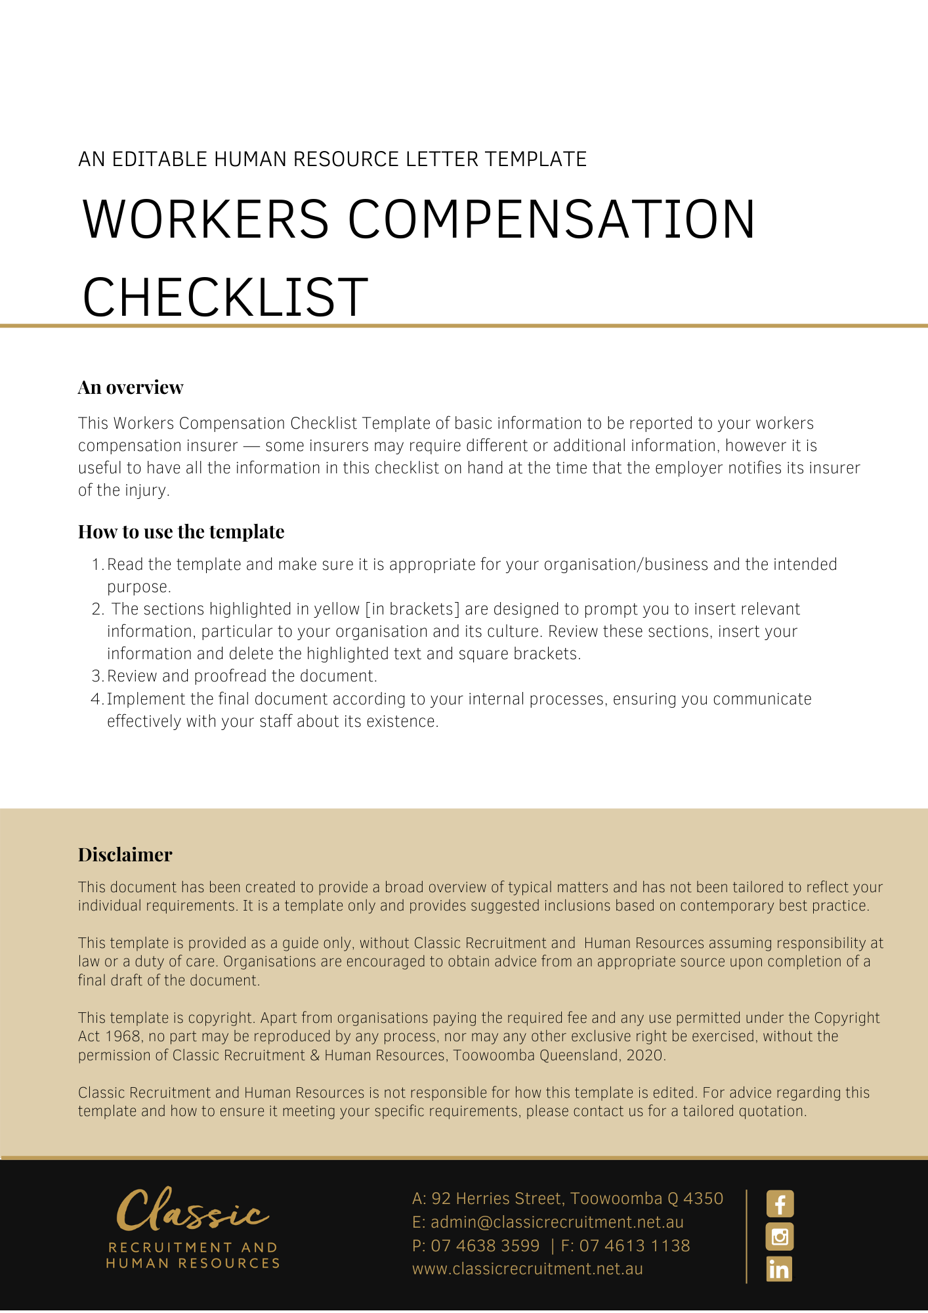
Workers Compensation Checklists

Basic checklist of what to provide the injured worker with, if there is an injury in the workplace | Complete
First aid and/or transport to medical treatment
Name of the insurer/scheme agent
Employer name and employer contact details
A claim form, if requested by the worker

Checklist of basic information to be reported to your insurer/scheme agent

Notify incident to the insurer/scheme agent within the required timeframe
Your workers compensation policy number
The injured employee’s name, contact telephone number, address, date of birth and if an interpreter is required
Injury details including the date, time, location and description of the injury, and details of how it happened
Confirm the name and contact details of the employer and provide the name, position and contact details of the person making the initial notification
Name of the treating doctor and/or name of the hospital if the worker is hospitalised
Contact details of any witnesses
Relevant medical certificate(s), if provided by the injured worker should be sent to the insurer within seven days
Ongoing medical certificates, receipts and accounts for medical or other treatment should be sent to the insurer within seven days of receipt
The insurer/scheme agent should provide you with an incident/reference number and you should keep this number for your records.
Some insurers have a telephone reporting service. When basic information on a claim is provided over the telephone, they may send you a partially completed claim form and a claim form for the injured worker to complete, based on the information provided.
Issues of liability have been considered and insured informed.

Checklist for creating an injury reporting plan

Prepare lists of potential concerned persons in advance, by considering:
Who secures the work site?
Who liaises with affected employees?
Who liaises with the WHS/OHS statutory authority, the police and other emergency service organisations?
Who prepares and controls any relevant documents?
Who gathers the facts about the incident?
Who liaises with the media and other agencies?
Include home addresses and mobile phone numbers in each case
Remember that many other parties may be affected by the incident: employees, their families and relatives, police, other emergency service organisations, WHS/OHS statutory authority, contractors, consultants (such as engineers cognisant with the work equipment/plan in question), the media and unions (who may insist on right of entry to the workplace).

Checklist for conducting an internal investigation

The essential outcome must be a clear statement of the injury and the cause
Consider appointment of legal representation so that investigation is subject to legal professional privilege
Interview the injured worker and record the events that led to the injury and how the injured worker says the injury occurred
Interview any witnesses to the injury
Consider closely the statements collected and identify any agreed facts and any dispute on the facts. If there are any disputed facts, gather statements from other witnesses and other relevant evidence to resolve the dispute.
Identify and examine the causal factor(s)
Separate the facts from speculation and opinions
Be impartial and objective, avoiding judgment and blaming
Ensure communication is clear and careful
Find out what documents are relevant
Ascertain whether WHS reporting requirements have been implemented
Ascertain whether a breach of employer policy or procedure has occurred
Make a finding as to how the injury occurred and what caused the injury
Make recommendations as to corrective outcomes, that is focus on how future similar incidents can be prevented
Implement the recommendations

Checklist for notifying your State’s WHS Statutory Authority

Check the statutory period for notifying your WHS Authority, which depending on circumstances will sometimes be immediate. Online notification is available in many jurisdictions but should not be used where immediate notification is required for ‘serious incidents’.
WHS Authority inspectors have powers that are broader than police powers in respect of workplaces. They can include the power to:
Enter and search workplaces — the inspector must carry a permit and you should ask to see it
Inspect, measure, test and photograph objects, etc
Take objects, materials or samples of them away for analysis
Require people to produce documents, give evidence and answer questions
Issue notices under the relevant State’s WHS Act, for example giving details of the types of documents they require
Consider legal advice - contact Workplace Advice Line with 24/7 access to WHS lawyers

Checklist for documents which may be requested

Where documents are requested, ask that the request be made in writing and be specific. Whilst inspectors can seek documents without putting their request in writing, explain that you want to provide accurate and relevant information and may need some time to collate it.
Keep copies of any documents you give to the WHS Authority inspector. For example, in New South Wales, the Statutory Authority —SafeWork may elect to prosecute an employer up to two years after an incident occurs. This in turn could take a year or so to reach the court. Recollections after almost a three-year period can be difficult, so get the facts on record at the time and keep a record.
Legal privilege: in some instances a document can be withheld from the WHS/OHS Statutory Authority on the ground of legal professional privilege. This is not often the case, but where the document has been created in order to obtain legal advice, or in preparation for litigation, before providing it, seek advice.

Other

Complete your workplace register of injuries as soon as possible
Request employee to provide a medical certificate supporting any absences and opining a cause for the injury/illness
Maintain a workers compensation insurance policy
Do not dismiss an injured employee without first seeking legal advice and consulting with your insurer
Provide all requested documents to your insurer
Liaise with the employee’s return to work co-ordinator
Endeavour to return the employee to work
Keep records of the employees’ absences from work
Continue to obtain up-to-date medical certificates indicating the employee’s capacity to work and restrictions

