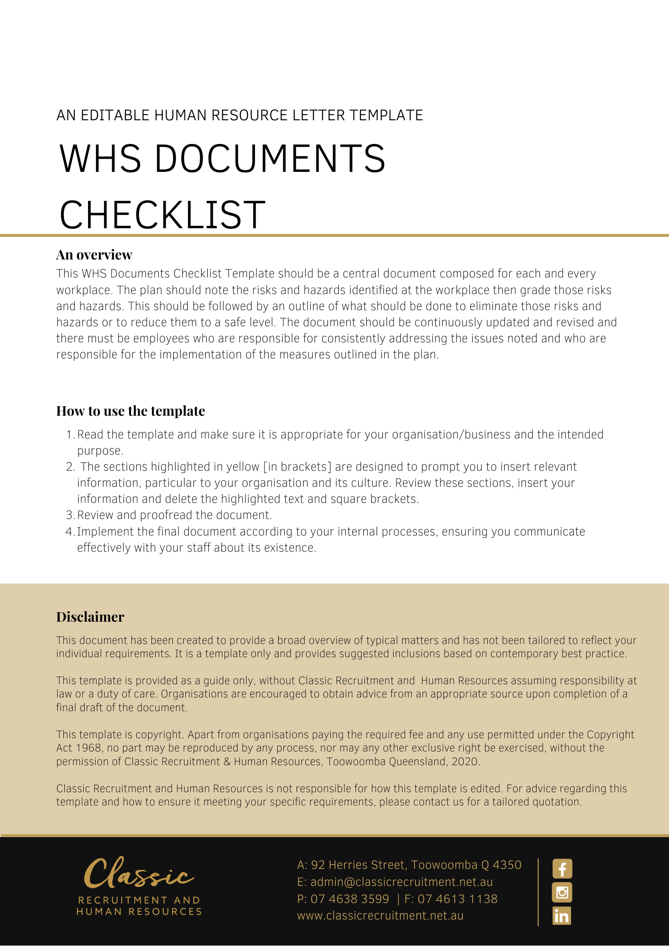
WHS Documents Checklist

Document | Yes | No
Audit of risks/hazards at the workplace — inventory
Assessment of risks/hazards at the workplace
Risk/hazard management plan
Induction list — WHS issues to emphasise
Policies and procedures on WHS
Relevant material safety data sheets
Accident records, including notifications of accidents to the relevant safety authority (e.g. WorkCover, SafeWork etc)
Records of near-misses
Overall WHS training plan
Confirmation of training (e.g. relevant training documents and training plans)
Relevant reports from consultants
Reports from employee representatives, committees and HSRs (if any)
Reports on consultation and actions arising from these reports
Workers compensation reports of injuries/claims to insurer
Rehabilitation report
Intelligence gathering documents — WHS information particularly relevant to the business

